
Applying the Bioeconomy to your own Environment
Pack 2

2
Contents
Introduction 3
What is the Bioeconomy? 3
What is in the Packs? (inc download links) 4
Objectives: What will students learn? 4
NC and SDG Links 5
How do I Use Them? 6
Recommended Reading/Resources 6
The Bioeconomy Knowledge Organiser 7
Exposure Vocabulary 8
Lesson 1: Is your School a Bioeconomy? 9
Activity Sheet A: Tally Chart 13
Activity Sheet B: Rating Charts 14
Activity Sheet C: Vertical Bar Chart 15
Activity Sheet D: Pie Chart 16
Lesson 2: So what are you going to do about it? 17
Mapping the Soil and Space 18
Activity Sheet A: Data Recorder 21
Actvity Sheet B: pH Power! 22
Activity Sheet C: The Soil Sausage 24
Activity Sheet D: Throwing Shade? 25
Making Informed Decisions: What works best where? 27
Worm Power 30
It’s Getting Hot in Here: Build your own Compost Bin 35
Why Wildflowers? Bees, Butterflies and
the Bioeconomy 38
Hügelkultur: Making mountains (of food) out of
molehills 40
Fart in a Bottle: Homemade Biogas 43
Next Steps 46
Acknowledgements 47


Introduction

3
Humans’ overconsumption of Earth’s natural resources is putting the planet under rapidly increasing stress. Our reliance on fossil fuels for energy, heating, the powering of vehicles and factories, and the production of many household materials (such as plastic) is significantly contributing towards the depletion of the planet’s resources, as well as towards climate change. By 2050, nearly 10 billion humans will live on Earth. They will consume 40% more energy, 50% more food and demand more consumer goods than ever before. If we are to prevent such things from running out, and if we are to put a halt to climate change, it is imperative we reduce both consumption and waste, and find alternatives to these resources.

Fortunately, there are many things that scientists, businesses, schools, communities, children and the general public as a whole can do to prevent the bleak predictions often seen in news headlines. Many of these solutions are a part of the Bioeconomy. Pack 1 introduced you and your students to the concept of the Bioeconomy; Pack 2 encourages you to apply these concepts to your institutional environment.

What is the Bioeconomy?

To break it down, the term bio refers to any living thing; while economy means the making and usage of goods and services by those within a country or region. So, the Bioeconomy is an economy based on renewable biological resources. By using living things instead of those that are non-renewable, humans can grow more to replace diminishing reserves.

This might be as simple as replacing single-use plastic coffee cups with the increasingly popular reusable bamboo ones, that can be reused over and over before composting back into the environment. It could be repurposing food waste to heat homes, or growing algae to create shoes! By making these switches, we not only lessen our reliance on fossil fuels and other finite resources, but we can reduce overall waste and CO2 emissions. The answer doesn’t lie in just one of these options however, and instead it takes a concerted and collective effort, with sustainability at the forefront.

What is in the packs?

Pack 1 introduced these concepts, making direct links to the National Curriculum and UN Sustainable Development Goals (SDGs), and can be downloaded from the University of Hull’s THYME Education Resources website*. If not already used, we recommend consulting Pack 1 before using Pack 2, in order to provide the foregrounding required for Pack 2.

In this pack, students will critically assess the sustainability of their school/home/youth group/etc. Drawing upon many geographical skills, children will identify both barriers and opportunities to employing the principles of the Bioeconomy in such a location.
Download the presentation for KS3 Resource Pack 2 Lesson 1 Powerpoint - Is your school a Bioeconomy?

After this, students democratically decide from a toolkit of ideas, how they might best increase the bio-economic value of their school/home/youth group/etc. These activities utilise outdoor learning and experiential learning, and is not exhaustive. It is hoped that students will identify their own opportunities, and find innovative ways to implement them.

Objectives: What will students learn?

By the end of these packs, students will have a critical and informed knowledge base from which they can make sustainable consumer choices; considering economic, environmental and societal impacts to various decisions. They will have developed their skills in formulating coherent and balanced arguments and will have applied their knowledge to improve their own surroundings. They will have gained an understanding of the types of jobs that exist within the Bioeconomy, and how it maps to their futures.

In this pack especially, students will be getting outside and getting their hands dirty. There is strong scientific evidence that suggests children who spend time outdoors are more likely to make environmentally conscious decisions, and their overall wellbeing is improved. We want to foster a love of the outdoors and natural environment in this pack, so we suggest adults make it as fun and as student led as possible. By engaging in outdoor activities that require teamwork and engagement with nature, their social and emotional development will be enhanced, and hopefully, their care and love
for the environment increased!

4
*https://www.hull.ac.uk/work-with-us/research/institutes/energy-and-environment-institute/our-work/thyme-education-resources
Geography
Understand:
- Economic activity in the primary, secondary, tertiary and quaternary sectors
- How human and physical processes interact to influence change in environments
- How to use geographical models to enrich environmental understanding
- Increasingly complex geographical systems in the world around them.

National Curriculum and SDG Links

Science
- Ask questions and develop a line of enquiry based on observations of the real world, alongside prior knowledge and experience
- Make predictions using scientific knowledge and understanding
- Select, plan and carry out the most appropriate types of scientific enquiries to test predictions
- Use appropriate techniques, apparatus, and materials during fieldwork and laboratory work, paying attention to health and safety
- Make and record observations and measurements using a range of methods for different investigations; and evaluate the reliability of methods and suggest possible improvements
- Apply sampling techniques.

English
- Use discussion in order to learn; able to elaborate and explain clearly their understanding and ideas
- Understand the difference between fact and opinion
- Competent in the arts of speaking and listening, making formal presentations, demonstrating to others and participating in debate
- Use Standard English confidently in a range of formal and informal contexts, including classroom discussion.

Citizenship
- Understand ways in which citizens work together to improve their communities, including opportunities to participate in school-based activities
- Recognise responsibilities in the community
- Build and support the ethos and value system of the school
- Skills and knowledge to explore political and social issues critically, to weigh evidence, debate and make reasoned arguments
- Prepared to take their place in society as responsible citizens
- Equipped with the skills to think. critically.

Maths
- Fluency in the fundamentals of mathematics through frequent practise.
- The ability to reason mathematically, following a line of enquiry and providing proof.
- The ability to solve problems by applying mathematical knowledge with increasing sophistication.

5
How do I use them?

These packs are all flexible, and have purposely been created on editable templates for teachers/ educators to adapt to local contexts and the needs/abilities of students. We recommend conducting the packs in numerical order. Where possible we have provided a time estimate for activities, however we suggest teachers use their own initiative to chop, change, shorten or lengthen activities based on their students.


6

This pack is best conducted with outdoor space, though it can be adapted to almost any setting.

Recommended Reading/Resources

The Bioeconomy is a multifaceted topic that enables the exploration of multiple points of view, and many societal, environmental and economic issues. In order for students to get the maximum benefit from these packs, we offer teacher guidance throughout. However, there exist many external and brilliant resources we recommend that teachers explore, to increase their own knowledge and understanding before conducting the activities.

We personally recommend the below resources:

https://sdgs.un.org/goals
http://www.fao.org/3/ca4352en/ca4352en.pdf

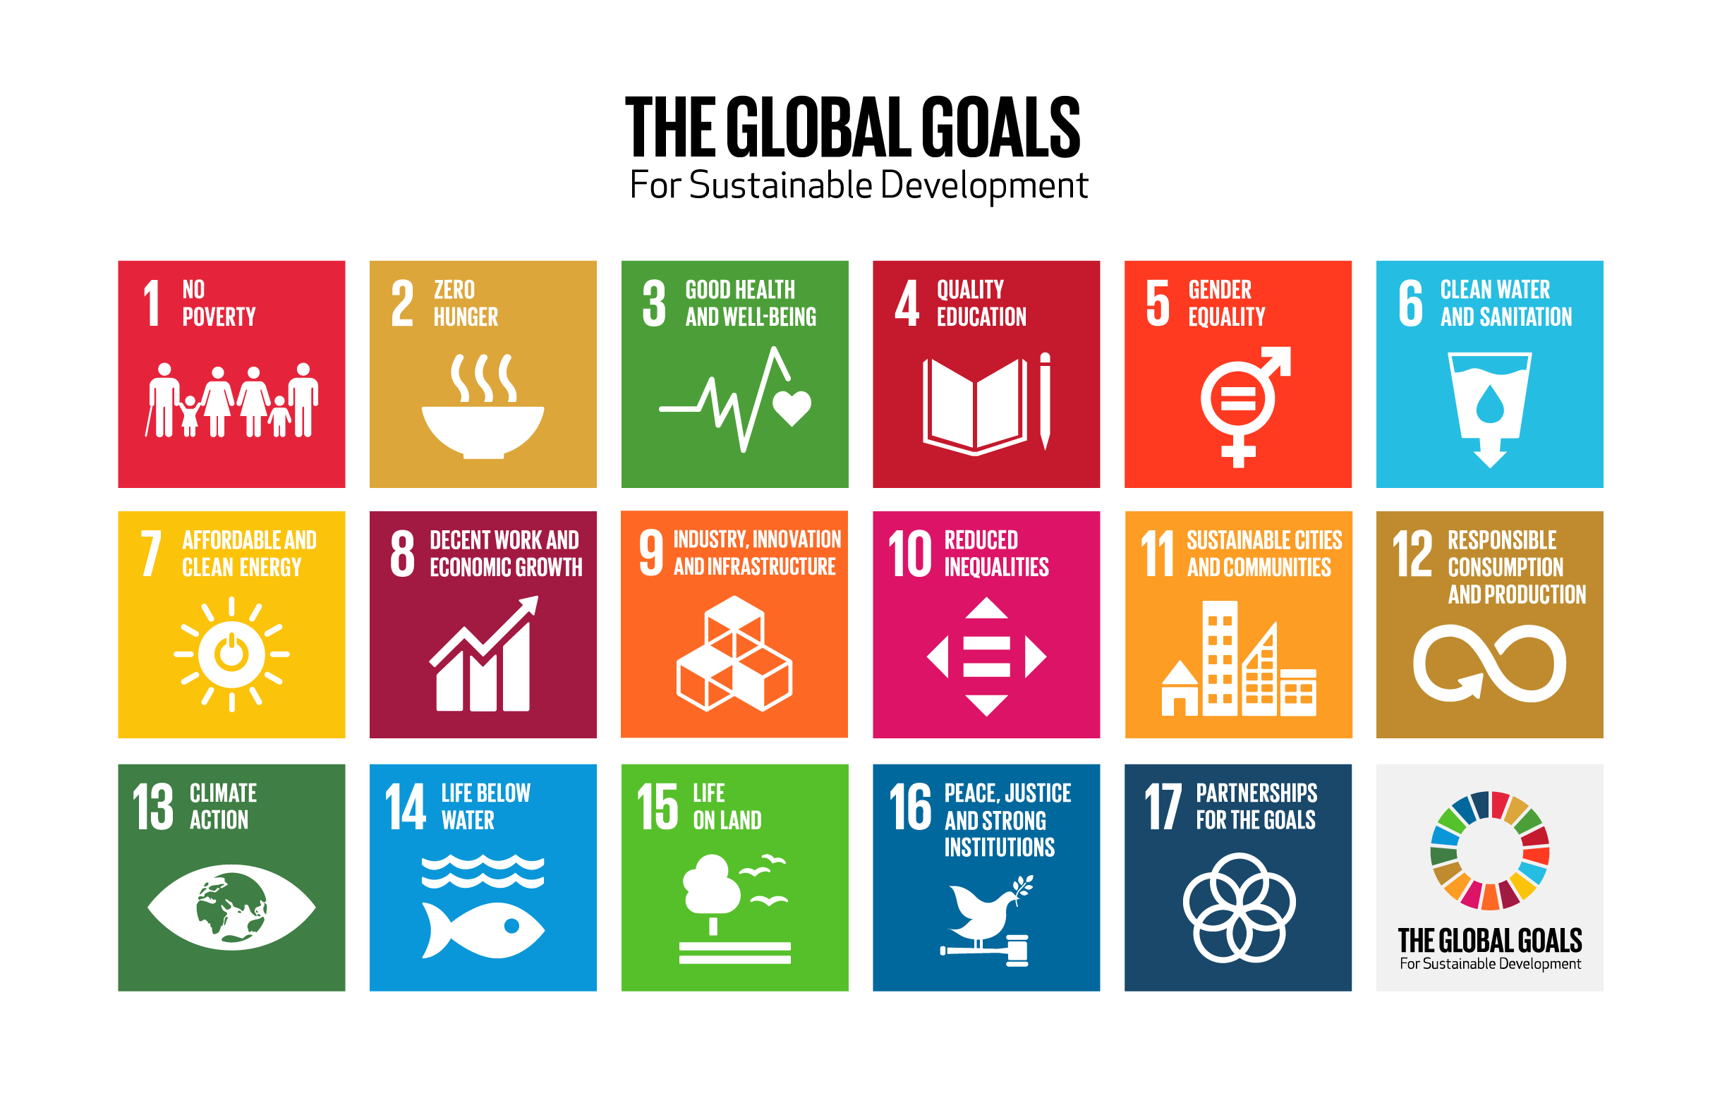



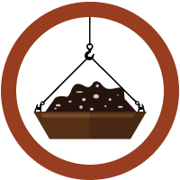









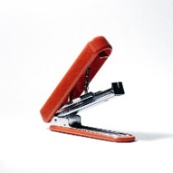

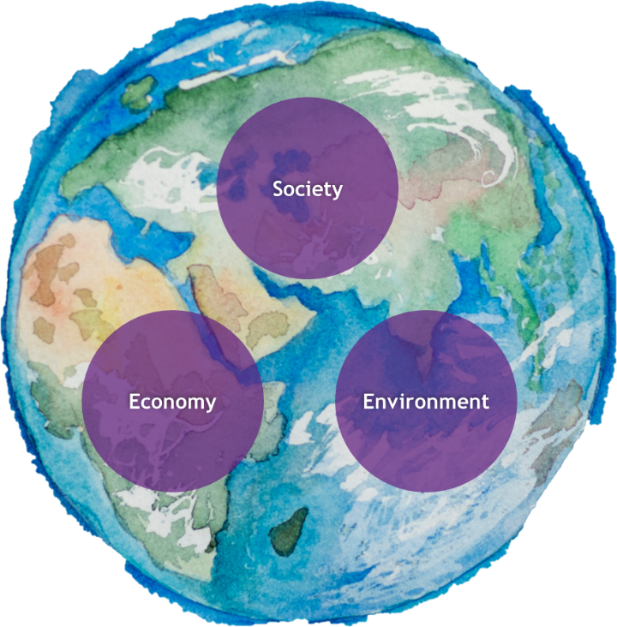
What is the Bioeconomy?
The term bio refers to any living thing, while economy means the making and usage of goods and services by those within a country or region. So, the Bioeconomy is an economy based on renewable biological resources. These resources may be converted into food, feed (the food we give animals), bio-based products (like biodegradable bags, coffee cups, chairs, clothes) or bioenergy.

The Bioeconomy Knowledge Organiser

Concept Digram: How are Earth’s resources made?
Energy
Living things
Millions of Years
Grown bio-based resources
Mined non bio-based resources
Earth’s natural resources are either grown or mined. Whilst those mined (such as fossil fuels), originally come from dead plants and animals from millions of years ago, these are considered inorganic, or non-bio. Those that are grown, are known as organic, or bio-based resources, like plants, animals and microbes, and are created much faster than non-bio resources. This means that if grown sustainably, they can be renewable resources. We need to reduce our useage of mined resources (especially fossil fuels) as they are running out, and contribute to climate change!

The Bioeconomy can help achieve many of the above SDGs. Equally, for the Bioeconomy to work, it must be sustainable. Sustainability means ‘to meet the needs of the present without compromising the ability of future generations to meet their own needs’. Sustainability requires society, the environment and the economy to work together.

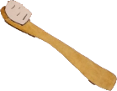
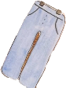
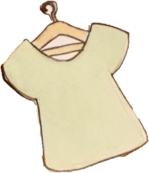
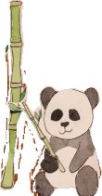
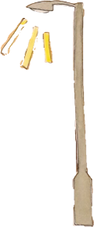
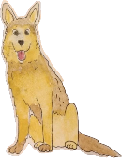
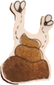
7
Examples of the Bioeconomy
Electricity from bio-waste
(like poop and food!)

Everyday products from
bamboo, seaweed
and coffee beans!

Word

Bioeconomy
(n)

Renewable

Fossil Fuel

Sustainable

Biomass

Biogas

Biodegrade

Organic/bio-based

Products

Services

Greenwashing

Carbon Footprint

The word in context

The main reason the Bioeconomy is gaining attention, is because existing production practices contribute to serious environmental and climate problems.

There is an increasing number of renewable options nowadays, for both energy and products.

Governments are now realising that we can’t keep relying on fossil fuels to keep our economy going.

Humans’ current transport practices are not sustainable.

An anaerobic digester uses biomass to create energy.

We can make biogas from all kinds of things, like animal manure, food, and sewage!

Whilst plastic does break down over time, it does not biodegrade or decay.

You can improve the soil quality by adding organic/bio-based matter.

Seagrown have launched a new range of products made from seaweed.

Some of the biggest energy providers have reduced their reliance on coal to provide heating and electricity services.

Many high-profile fashion brands have been criticised for greenwashing.

Many people are now considering the carbon footprint and air-miles that come with their food as they make their consumer choices.
My understanding/Class definition

Exposure Vocabulary Grid

8



Lesson 1:
Is your school a Bioeconomy?

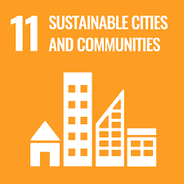
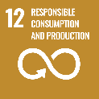
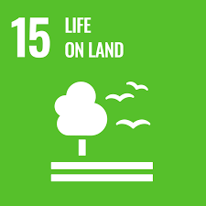

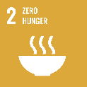
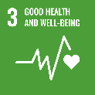



10
Curriculum Links
Geography
- Geological timescales linked to natural resource usage
- The use of natural resources in economic activity
- How human activity relies on effective functioning of natural systems.
English
- Use discussion in order to learn, elaborate and explain clearly their understanding and ideas
- Understand the difference between fact and opinion.

Science
- Working “Scientifically”: seek answers to questions through collecting, analysing and presenting data
- Living organisms and the means of transferring energy
- How organisms affect, and are affected by, their environment
- Earth as a source of limited resources and the efficacy of recycling
- The production of carbon dioxide by human activity and the impact on climate.

Preparation
This session will utilise the school/youth group/home grounds, both indoors and out. Consider where students can or cannot explore, laying out clear rules to the students. Consider group sizes and arrangements, and ensure students are suitably prepared for the weather. Gather ample resources for the students, such as clipboards, writing materials, and
print out relevant resources. Consider the support of another adult to
help supervise students. Slide 6 will be most effective if you are able to replace the image with an aerial shot of your premises.
Resources Required:
- PowerPoint Slides for “Is your school a Bioeconomy”,
- Activity Sheet print outs A-D,
- Clipboards, pencils/pens,
- Outdoor space,
- Suitable outdoor clothing
The Lesson:
Is your School a Bioeconomy?
Lesson Outcomes
- Discuss various examples of the Bioeconomy in the context of own environment
- Be able to critically analyse observations, and seek out practical opportunities for the Bioeconomy
- Be able to apply geographical fieldwork techniques to collect data
- Be able to analyse and present data in a meaningful and targeted way, and use this to make coherent arguments.

Lesson Objectives
- Develop and apply geographical fieldwork techniques
- Develop capabilities in presenting geographical data
- Understand how societies can become more sustainable and move towards a Bioeconomy
- Develop decision making and debate competencies, particularly in relation to complex issues such as sustainability.

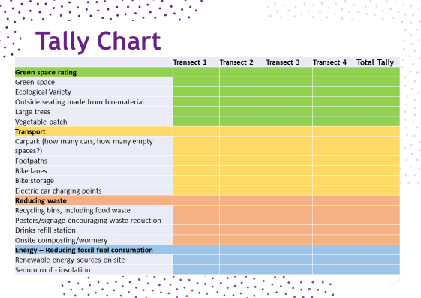
11
Main Activity: Slide 6
With children in their groups, either provide students with an aerial print out of the grounds or ask them to draw their own. Dividing the map into as many sections as there is groups, assign each group an area to explore.

Ask each group to plot a transect walk through their zone. Alternatively, allow them to explore their zone without a transect walk. Students can then plot and tally the things they see on the chart (to the right) within their zone. A print out for this tally is provided (Activity sheet A on page 13).
Previous Learning
In Pack 1, students have covered a wider range of world issues centred on sustainability and the Bioeconomy as a tool to combat many of these issues. They have drawn on scientific investigation to solve problems, which will come in useful here. Students will likely have covered mapping and other geographical skills that will be applied in this lesson. They will have also covered tallies, and representing numerical data in maths. This lesson will develop those skills.

The Lesson
This lesson follows PowerPoint Presentation Pack 2: Lesson 1: Is your school a Bioeconomy? More detailed guidance is provided in the notes section within it.

Starter activity: After introducing the lesson aims and objectives, start by showing the students the image on Slide 4, asking them to consider how this image is supporting the Bioeconomy. This will allow you to gauge if/how students apply their previous learning to real world scenarios. After a few minutes, encourage students to share their answers with one another – either in pairs, groups, or as a whole class. Encourage students to consider answers to the challenge.

Slide 5 provides the space for you to introduce the main activity. Explain the core aims, and organise students into groups:
- We are going to investigate the Bioeconomy rating of our school site using a range of fieldwork skills.
- We will analyse the data collected from our site survey to reach conclusions and rate the Bioeconomy status of our school.
- We will suggest a range of strategies to increase the Bioeconomy rating of our school.

12
Slides 8-12 can be done inside or outside. This is where students take their tallies, the tallies of other groups, and their own knowledge of the site, to give a “rating” to various elements of the grounds and the practices on them; Green Space, Transport; Reducing Waste and Energy. They will use a bipolar scale to rate these areas (guidance provided on the slide, and additional print out activity sheet B is on page 14).

The time dedicated to this section is up to the teacher, but we suggest allowing students to interview other members of the site community (i.e. head chef to understand what happens to the food waste, or the head teacher to find out about energy use). This will command more time, but in return it will develop their analytical and data gathering skills. There are question prompts and detailed guidance on the slide comments to support this extended approach.

On slide 13, students will use mathematics and percentage calculations to work out the overall bio-economic rating of the site. Support your students as appropriate.

Slide 14 gives students the opportunity to present their findings to the rest of the group. Ask students to turn their collected data into something that would make sense to someone with no prior knowledge. They must think about representing it visually, with a graph or something similar. Examples are provided on slides 15-18, and for those students requiring extra support, print out activity sheets C and D are on pages 15 and 16.

Round it up on slide 19. On the final slide, students reflect on their findings. Pose questions such as:

- Which area of your school supports the Bioeconomy the most?
- Which area of your school has the fewest elements of the Bioeconomy?
- Describe the element that supports the Bioeconomy the most.
- Explain how this element supports the Bioeconomy the most.
- Remember the SDGs? Can you link them to any of your findings?

This can be done in pairs, groups, or as part of classroom discussions. For assessment and evidence purposes, students can write something to support their visual representation that incorporates the above questions. Leave students on the consideration: what could be done to improve the Bioeconomy rating of your school?

own Environment

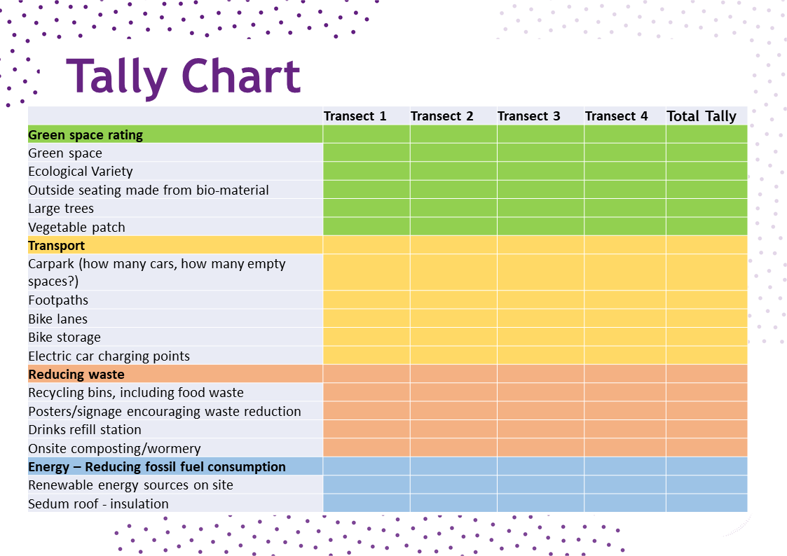
Activity Sheet A

13
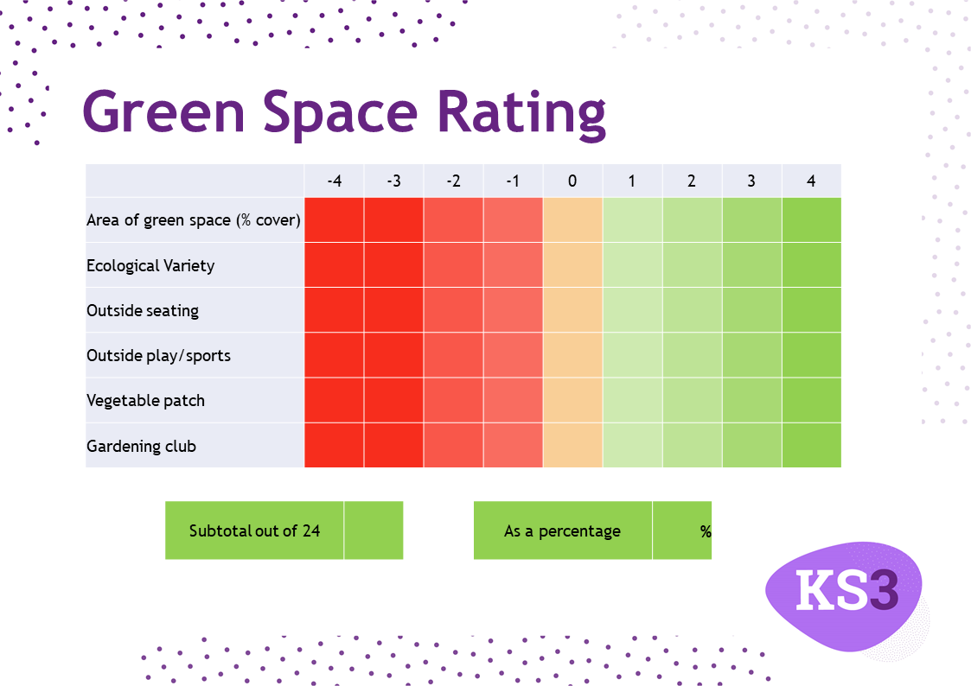
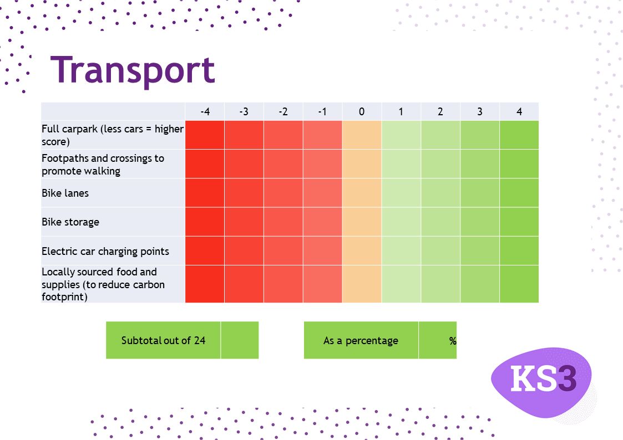
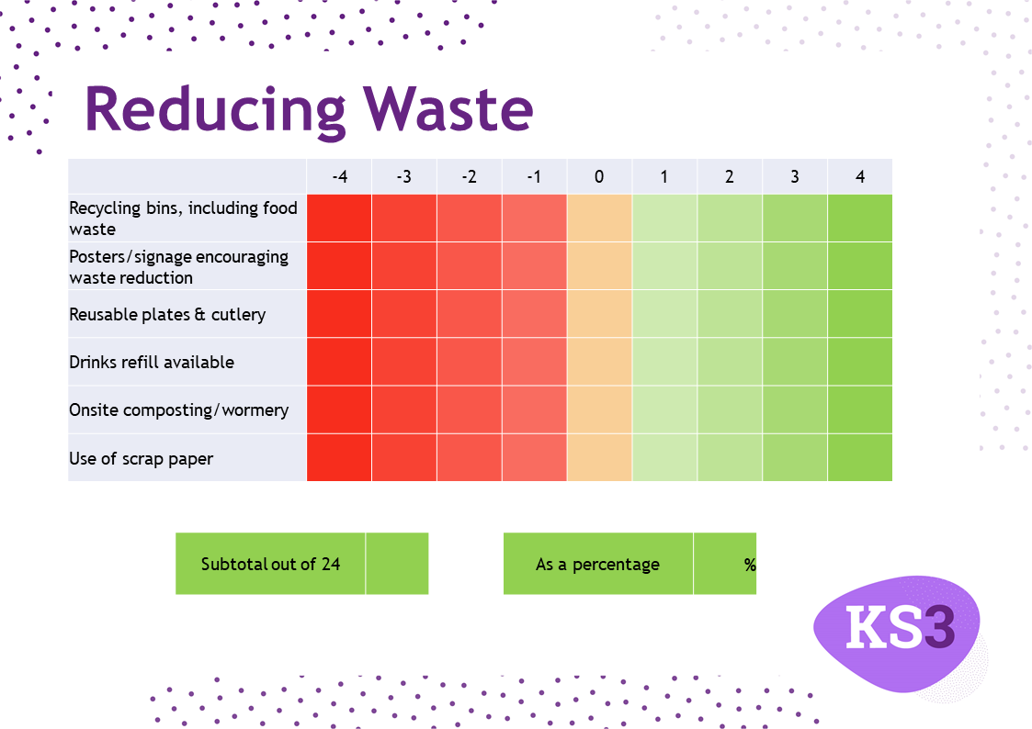
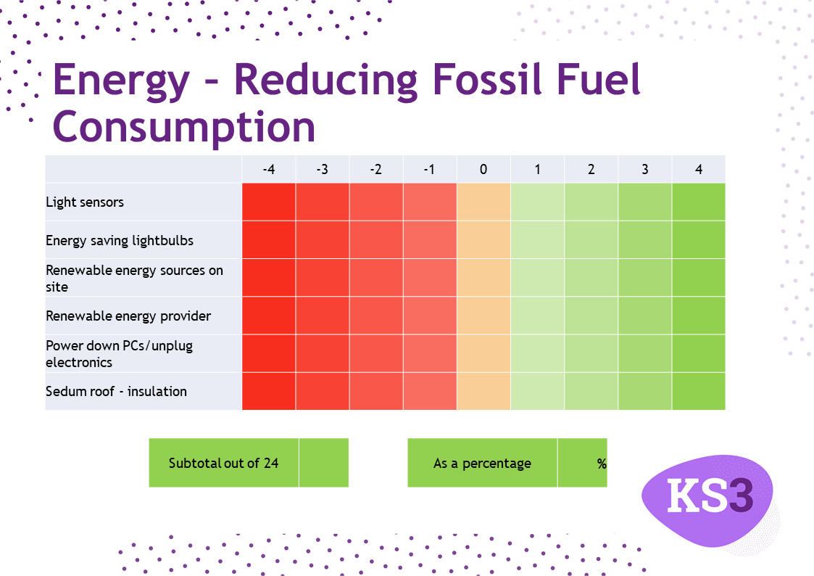
Activity Sheet B

14
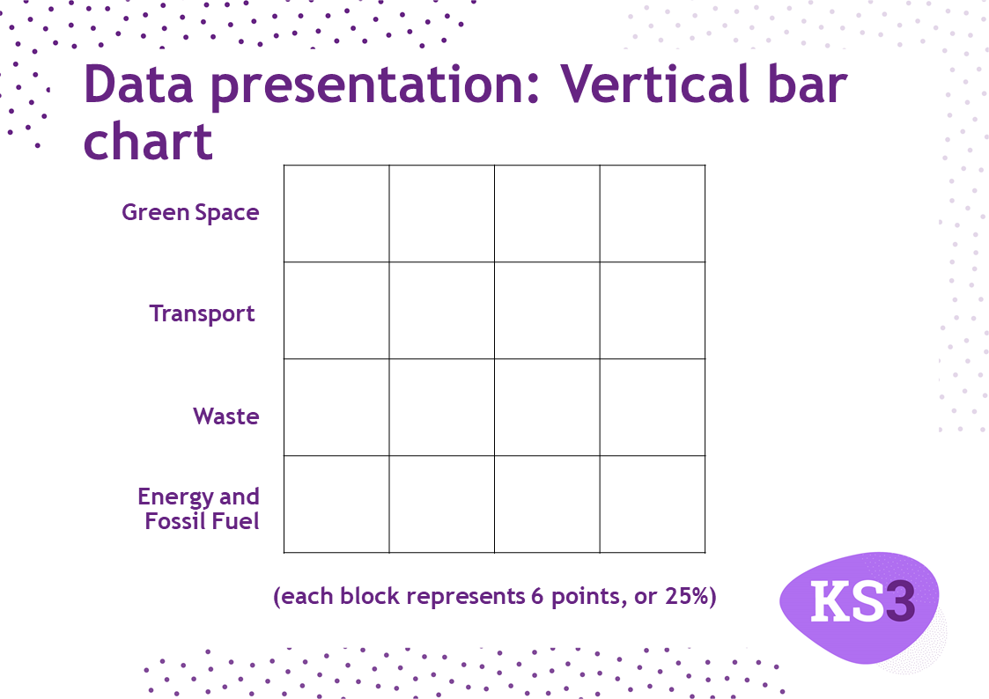
Activity Sheet C

15
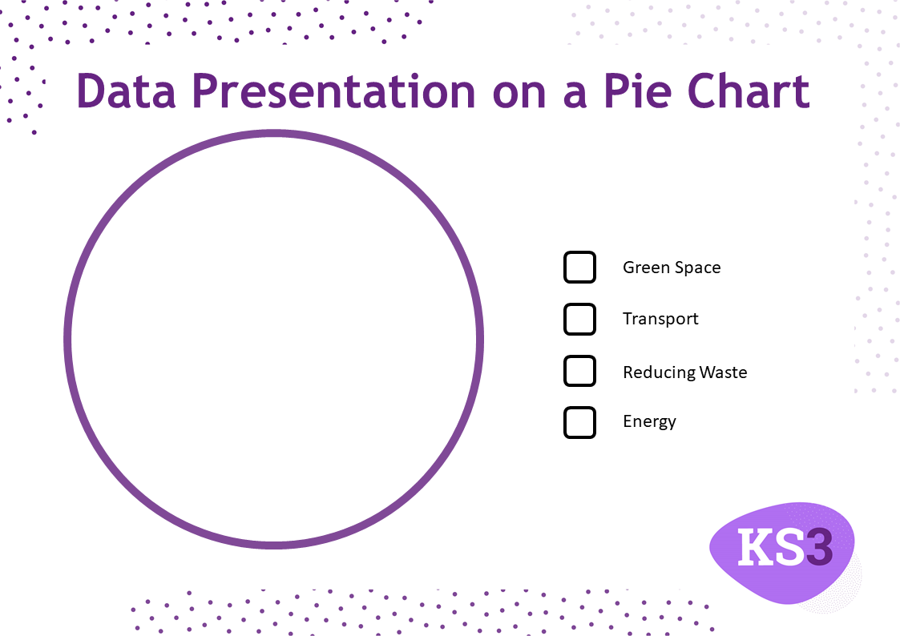
Activity Sheet D

16

Lesson 2:
So, what are you going to do about it?

Resources Required:
- Trowels/spoons
- Beakers with lid
- pH indicator strips
- Water
- Activity print outs (pages 21-25)
- Clipboard
- Writing tools
Mapping the Soil and Space

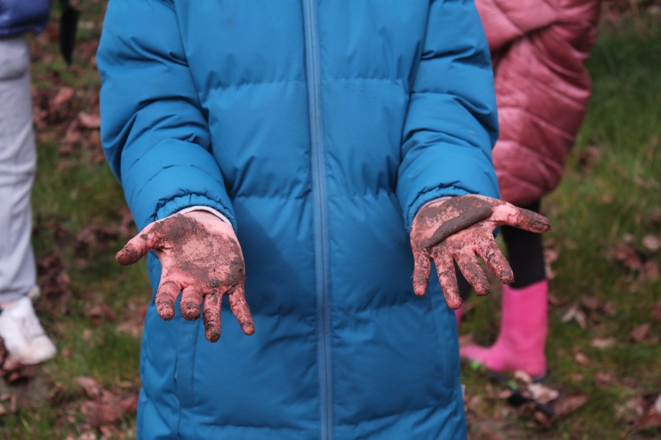

A lot of small scale and local solutions to the Bioeconomy rely on the notion of growing your own. But we all have varying spaces and resources available. Without carefully considering the spaces, the amount of moisture and sunlight they receive, and the types of plants and soils already in the area, we may end up planting things that don’t suit the conditions available, and actually end up wasting precious bio-resources and time! This collection of activities will support you in mapping the spaces you have, leading you to make more informed decisions in terms of what is suitable for your grounds, and what to put where.

If you don’t have much outdoor space, that doesn’t mean this pack isn’t for you. Everything in this pack can be scaled up or down, they utilise available space and some activities can even be done inside if required.

18
Lesson Objectives
- Understand how a location’s characteristics influence plant growth
- Understand that different plants require different conditions
- Understand the complexities of creating a Bioeconomy with limited resources.

Lesson Outcomes
- Conduct an analysis on the available site, considering light and moisture availability – as well as the soil conditions
- Consider how this will impact specific plants
- Apply this to make informed decisions in terms of what will go where.

Geography
- Weathering and soils
- Understand how human and physical processes interact to influence, and change landscapes, environments and the climate; and how human activity relies on effective functioning of natural systems
- Develop greater competence in using geographical knowledge, approaches and concepts [such as models and theories] and geographical skills in analysing and interpreting different data sources.

Citizenship
- Use and apply their knowledge and understanding while developing skills to research and interrogate evidence, debate and evaluate viewpoints, present reasoned arguments and take informed action.

Curriculum Links

Science
- Working “scientifically”
- Seek answers to questions through collecting, analysing and presenting data
- Relate scientific explanations to phenomena in the world around them and start to use modelling and abstract ideas to develop and evaluate explanations
- Understand how organisms affect, and are affected by, their environment, including the accumulation of toxic materials
- The Carbon Cycle
- Understand Earth as a source of limited resources and the efficacy of recycling
- The interdependence of organisms in an ecosystem, including food webs and insect pollinated crops.

Preparation
Before taking the children out, consider yourself the spaces available on your site. You will need to ensure you have all the equipment. If able, we recommend buying a soil sensor. These can be purchased online for around £20. You will also need pH indicator test strips, beakers with a lid, spoons or trowels, water, clipboards, writing tools, and the printed activity sheets.
Previous Learning
Students will have covered the lifecycle of a plant in science. This will take this further and apply it to environmental planning. Their knowledge from previous sessions using the THYME resources will also inform their decisions.

19

How to use?

The following pages (21–25) contain print outs to guide students through soil and space analysis. These activities are flexible, though we recommend students conduct the range of experiments in groups, with each group focussing on a specific area of the site (give each area a number or name so it can be referenced as the data is amalgamated). Once each group has collected their data, bring students back together to discuss and share their findings. This will allow all students a voice in deciding what is to go where on the site.

The activity is closely linked to the work of a Surveyor, Landscaper, Environmental Auditor, and Environmental Planner. Refer to this to instil real world career prospects into the activities. An overview of each activity sheet is provided below:

Activity Sheet A: Mapping the Soil and Space
This is an overview sheet for students to complete as they map their area. It can be completed in any order.

Activity Sheet B: Measuring pH
Simple to follow instructions for students to gather information about soil pH. Additional information for what this means for various plants can be found in the Making Informed Decisions – what works best where table (pages 27-29).

Activity Sheet C: Measuring Soil Texture
Flow diagram that helps students determine the soil texture. This has an impact on nutrient content and soil drainage, and impacts what can grow there.

Activity Sheet D: Measuring Sunlight
This is best done over the course of a full day, which may not fit to students’ timetables. As the educator, you can adapt and fill in the blanks on their behalf as you see fit.

20
Mapping the Soil and Space: Data recorder

Use the following space to record your observations/findings.
Activity Sheet A

Location Description:
Soil Description/Type:
Soil Moisture Level:
Soil pH Level:
Sunlight Level:

21

Measuring soil pH tells us how acidic the soil is. This is important because some plants like acidic soils, whist others prefer more alkaline soils. By measuring this, we can find out what will grow best where!
pH Power!

Activity Sheet B

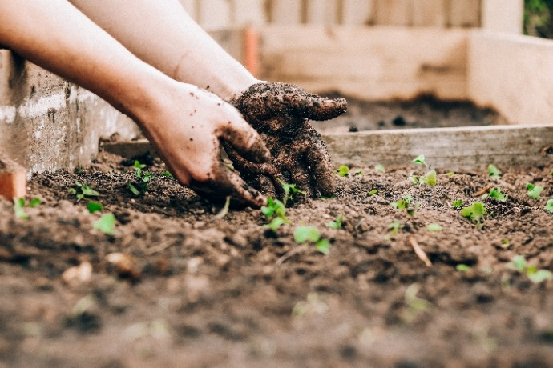
- Take a small sample (a few teaspoons worth) of soil from your chosen area and add it to the plastic beaker provided. Make sure there are no rocks, stones or vegetation in the sample. Try not to add any soil that has touched your hands, as this might alter the results.

- Fill the beaker with water until it is about 50 percent soil, 50 percent water.

- Shake the beaker whilst holding the lid in place for approximately 20-30 seconds.

- Take the provided litmus pH testing paper and dip it into the soil/water solution. Only the very end needs to touch the mixture. You will see the colour changing on the strip. Hold it there for around 45 seconds, or until it stops changing colour.

- Take the strip out the mixture. Focus on the colour just above the part covered in the soil solution.

- Compare this colour to the colour chart below! This will tell you how acidic or alkaline your soil is! Record your findings on the sheet provided.

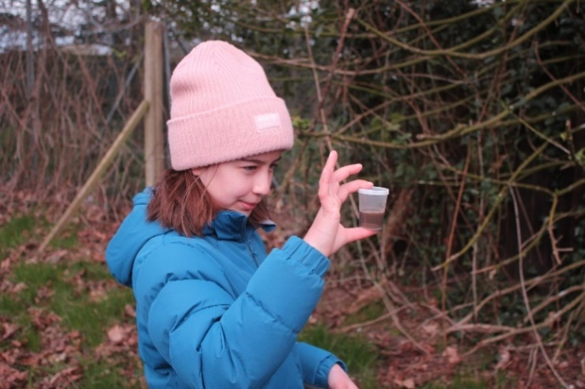

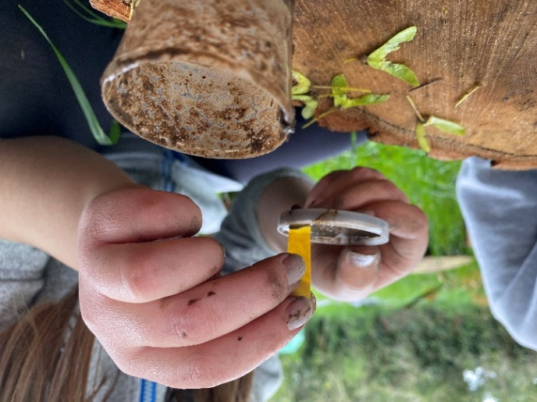
.
22
Q1) Why might the soil touching your hands change the pH reading?
Q2) What might happen if a plant is placed in an alkaline soil, when it prefers a more acidic soil?

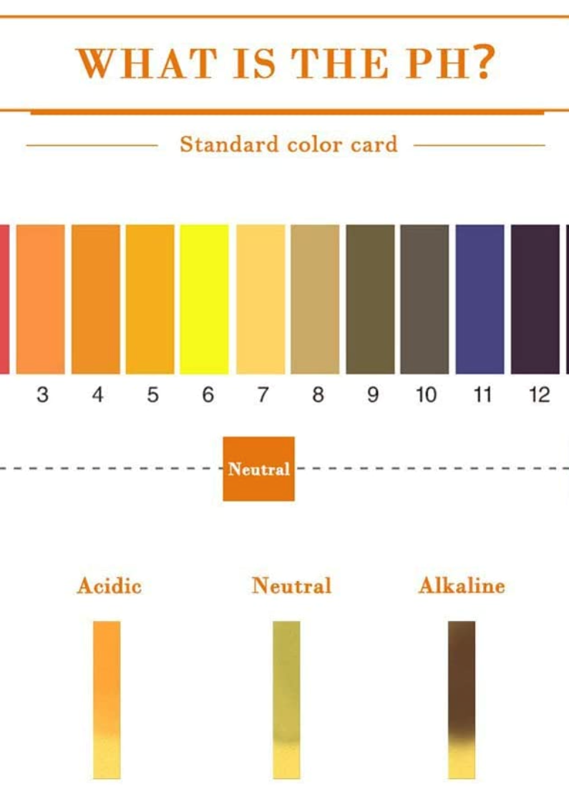

ack 2: Applying the Bioeconomy to your

23
The Soil Sausage
Activity Sheet C
There are several ways to figure out what type of soil you have, but the best way is to have a good play! Mix up some of the soil you want to test with a small amount of water, and follow the below guidance to work out what you’ve got!


Sand
Can you make the U-shape into a ring?
Continue rolling – can you make a sausage 14cm long?
Can you make a sausage 6-7 cm long?
Can you make a ball?
No

Yes


Sandy Loam
No

Yes


Silty Loam
No

Yes

Loam
No
Can you fold to sausage to make a U-shape?

Yes

Clay Loam
No

Yes

Heavy Clay
No
Does the ring have cracks on the surface?

Yes
24
Fine Clay
Activity Sheet D
Throwing Shade? Measuring Sunlight for the Bioeconomy

Plants need sunlight to photosynthesise (this is where plants make their own food from carbon dioxide, water and light). Too much sun however, can damage some plants. Plants are considered either “shade avoiders” or “shade tolerators”. Measuring sunlight helps us decide which plants will grow best where. Getting it wrong can quickly and easily stop a plant from growing, or kill it altogether.

Sunlight is best measured over the course of a full day. Unfortunately, this is not always possible. However, we can measure sunlight for the time that we do have, and make educated estimations based on what we already know about light, shade and the sun.

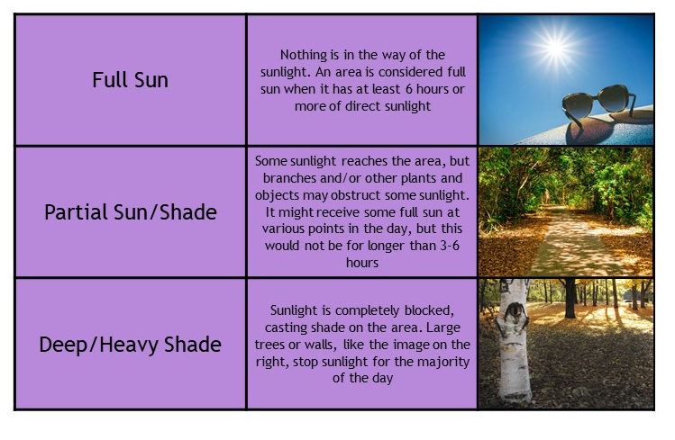

25
Step 1: Go to the place you are investigating and observe how much sun it is receiving. You can use the table above to help you decide if you are unsure. Record your findings in the table below. Make sure you remember to record the time and location.

Step 2: Check the location(s) every hour, and add your findings to the table.

Step 3: Remember that many things will affect the amount of sunlight a plant gets; the time of year, the suns position in the sky, the other plants and buildings around it, clouds, and so on. Consider what you already know and ask yourself the following questions:

- Where is the sun rising and setting?
- What might obstruct the sun and cast shade as the suns position in the sky changes?
- How will the amount of sunlight change at different times of the year?
Record your answers in the box labelled Findings below.

Step 4: Use the information you have gathered to make an estimation as to how much sun the space gets every day. Describe what you have found, and add this to the Findings box below.

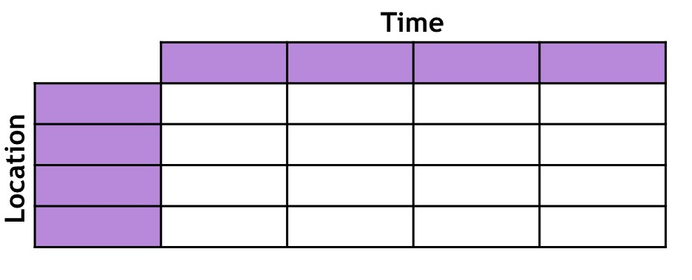

Findings:

26

2727

28

29

Worm Power

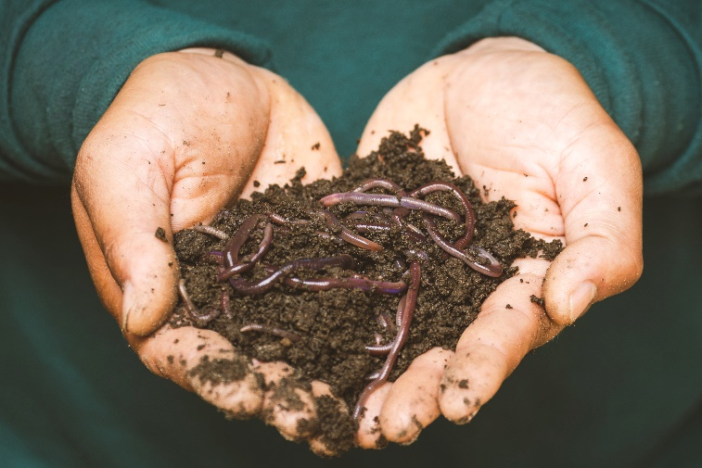

Why build a wormery?

A wormery is the perfect way to incorporate components of the Bioeconomy into your home or school. Organic waste is the largest waste category above any other kind, with the majority of it going to landfill. However, worms are magnificent creatures with the power to turn your kitchen food waste into nutritious compost and worm tea for your garden. By building a wormery (basically a home for composting worms to do this job), you can not only help new plants grow with the end product, but significantly reduce your organic waste and help save the planet!

It is different to a compost bin as it
uses special worms to break down the
organic material. It is quicker and
tends to create more nutrient rich
compost than a traditional compost
heap too. However, a wormery cannot
process as much waste as a compost heap.
It is important not to overfeed
the worms! They cannot eat
everything either, so make sure you
only add the things on the list below
that they can eat.

The following instructions will show you how to make a vertical migration wormery from wood. A vertical wormery starts in the bottom tray, and as you add your organic waste, the worms will turn it into compost. Once the bottom tray is filled, you can start to add your leftovers to the second tray. The worms will eventually move through the mesh and up into this tray, leaving behind lots of worm free fertile compost.

There are loads of other options available. You can easily make one from old plastic storage boxes and other materials around the home/school. The
best thing to do is to use materials you already have that would have
gone to waste anyway.

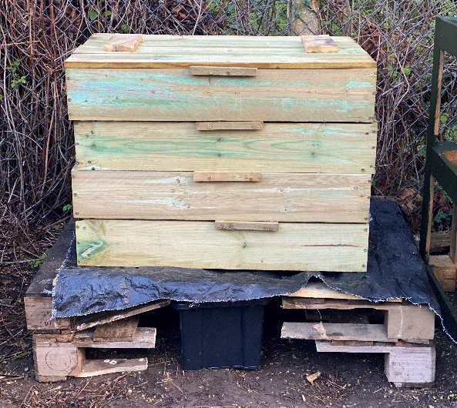

30
The size of your wormery should be based on the amount of waste you have, though remember you need to be able to lift it when filled with compost, so make sure not to make it too big. The below instructions will show you how to build a 3-foot by 2-foot wormery. Prefer a video? Then take a look here* to watch a short film explaining how to make a wormery!

To get started, you will need:

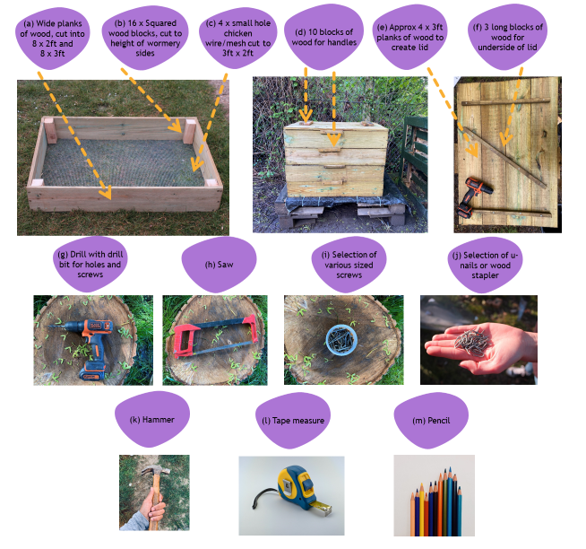

Base
- Sturdy wood
- Bucket
- Enough waterproof tarpaulin (or similar material) to cover the base and stop the bottom rotting
- Scissors
Once the wormery is built:
- Composting worms (purchased from a local breeder or online - do not use earth worms!)
- Newspaper/Cardboard
- Soil
- Food waste!

*https://www.youtube.com/watch?v=3E7mhyrPFLg

31
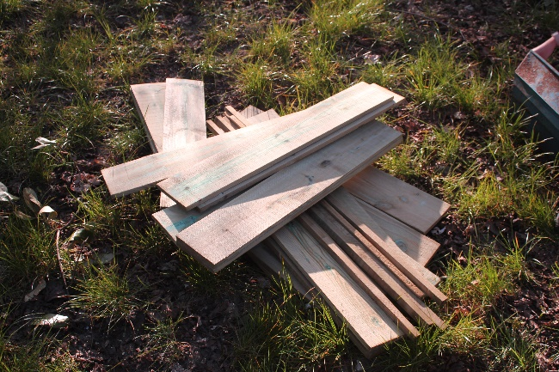
Step by Step

- First of all, if you’ve not already done so, you need to cut the walls of the wormery down to size. Remember this depends entirely on how much waste you want to feed your worms. Adjust as necessary.

- Once you’ve got your 16 planks of wood cut, you can begin to put them together. Line up the shorter piece at a right angle on the inside, NOT the end, of the longer piece of wood. Drill in several screws to secure them together, making sure the screws are long enough to go through both planks of wood, but not so long that it sticks out the other end! Repeat on the other side, ensuring that it is lined up the same way. Then add the longer piece to the opposite end running parallel.

- Take 4 internal support blocks that have been cut to size, and use a drill to secure with screws. Make sure they don’t clash with the existing screws! These supports will make the wormery much more stable and secure.

- Using a hammer and u-nail, or a heavy-duty staple gun, secure the wire mesh (that is already cut to size) around the edges of what will be the base of the box. Try to do this at a slight angle, so that when the wormery is full, the weight of the compost doesn’t make the mesh slide off when you lift it.

- On the end of each box, take a small block of wood. Line this up with the top of the box, and ensure a very small overhang. This overhang will help prevent the boxes from sliding around! Secure with two screws. Repeat this on the other side. Finally, drill some air holes around the top of the box. These don’t need to be big, but will ensure proper ventilation for your worms.

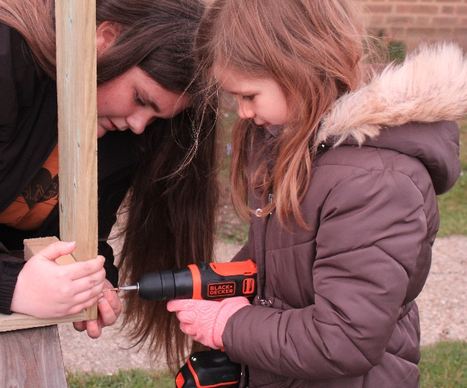

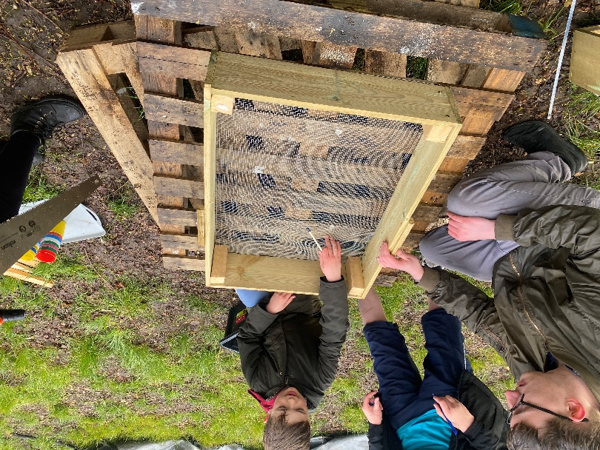

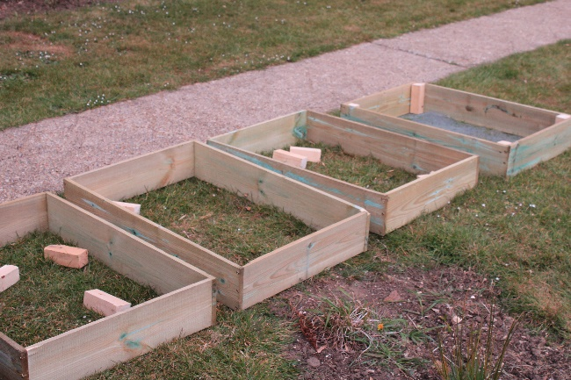

32
- Repeat this whole process 4 times to get your 4 trays.

- To make a lid, take 4 planks of wood that have been cut down to size. Lay them on a flat surface and place a length of wood that spans the four planks, but that leaves an inch or so either side to ensure it can still fit inside. Secure the thin length of wood with a screw in each plank, ensuring they are firmly together without any gaps. Repeat on the other side. For extra support, add a diagonal support across the centre, as seen here, again securing to all 4 planks. Flip the lid over. We added two grips, just to help with the lifting of the lid. Again, secure with screws.

- You’re almost finished! All that’s left to consider is whether or not you’re going to have a base and a bucket to collect what is known as “worm tea”. Worm tea is basically liquid fertiliser that you can collect, dilute and add directly to your soil. If you want to collect this, you can make a base using two old pallets. Saw a gap large enough to insert a bucket and over the top, fit a sheet of tarpaulin with a hole cut in the middle. This tarpaulin will collect and siphon down the worm tea into the bucket though the hole, so make sure it all aligns correctly!

- Move your bottom tray onto the base and add some torn up newspaper and damp cardboard into the tray. Add some existing soil, and some more dampened torn up cardboard. Add your worms to their new home!

- Gradually add your organic waste a small amount at a time, and watch your worms turn your leftovers into a rich, natural, fertile material, perfect for helping your garden plants grow!
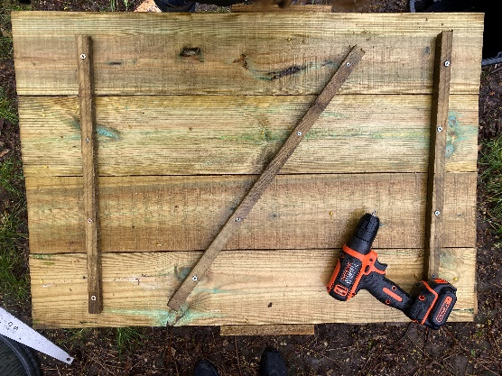

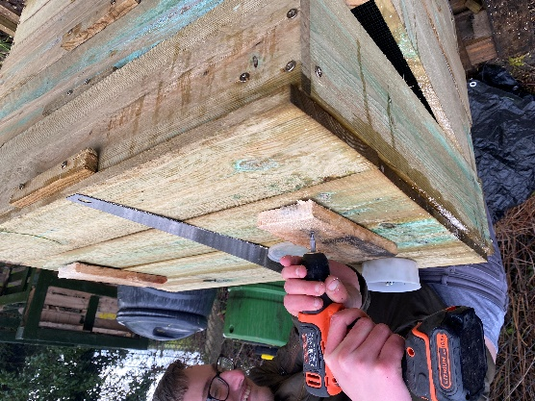

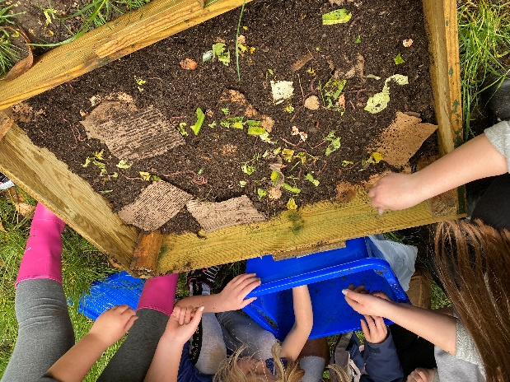

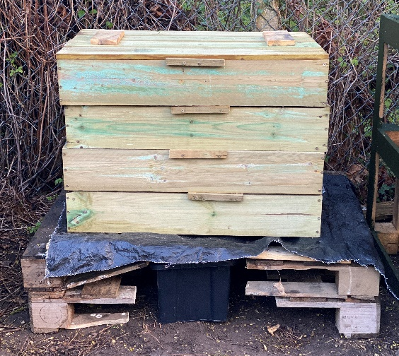

33

Design a Poster for Your Wormery!

Wormeries work best with food and light garden waste. That is because the worms can process this easily! Design a poster to make sure people put the right things in the right bin!

Do add:
- Raw Fruit and vegetables
- Cooked Fruit and vegetables
- Stale or mouldy bread (in small amounts)
- Crushed eggshells
- Coffee grounds and paper filters
- Tea bags
- Garden waste like grass clippings and leaves (in small amounts)
- Shredded paper waste.

Don’t add:
- Meat, fish and bones
- Citrus fruit peel
- Garlic and onion
- Dairy products (cheese, butter, yoghurt, etc.)
- Gloss or colour-printed paper
- Ash from coal fires
- Cat or dog poop
- Autumn leaves.

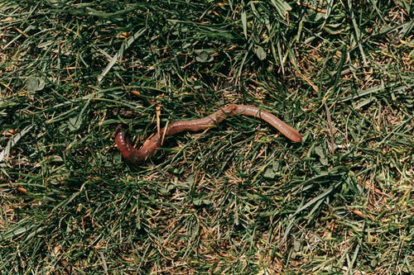

34
It’s Getting Hot in Here: Build your own compost bin

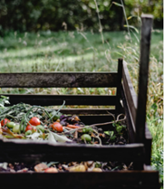

Did you know that compost bins can reach a whopping 49-77 degrees centigrade in a matter of days? As the microorganisms set to work breaking the organic material down, they create energy in the form of heat. Seems a bit of a waste letting all that heat go to waste, even if compost is being made, doesn’t it? Well, it doesn’t have to. With a bit of ingenuity, many people use this heat to warm their greenhouses in winter, sometimes even their homes. In this activity, we will show you how to build a compost heap, but the challenge … can you find a way to go that one step further and maximise that heat generated? If you can, then you’re a true bioeconomist!

What exactly is a compost heap?
A compost heap, or compost bin, is a place to put kitchen and garden waste, instead of putting it in the general waste bin and it ending up in landfill. Instead, when done correctly, a compost bin turns that waste material into nutritious compost for your garden and plants.

They work best with an even mix of carbon-rich (brown) and nitrogen-rich (green) waste, and really are very simple to make. Here are the instructions to make one out of four old pallets. Additionally, have a look at the instructional video*.

35
*https://www.youtube.com/watch?v=m3snOG7Cpxw
To get started, you will need:

- 4 wooden pallets (You can usually pick these up for free on local selling pages, or at garden centres and hardware stores - check you’re using certified pallets that haven’t been treated with chemicals that could leach into your compost and damage the environment. Look for a Heat Treated (HT) or Kiln Dried (KD) stamp
- Selection of screws
- Screwdriver
- Saw
- Pencil.

- Take two of your four pallets, making sure they are the same way around and the same height. Decide which part of the pallet will form the outside, and connect them together to form a right angle. Secure at several points using a screw long enough to go through the two pallets and a drill. This will be a lot easier if there are two people - one to hold the pallet in place and another to secure the screws. Make sure you distribute the screws along the length of the fixed joint, to ensure a tight fix.

- On the other side of the pallet, that will become the back of the compost bin, secure another pallet, ensuring again that it is the right way around with the same side facing outwards, and running parallel to the other side. Secure once again with the drill and screws.

- With the final pallet, we recommend you cut this in half, to allow easier access to the compost! This will form the front of the bin. Mark out where you will cut the pallet on each plank of wood, and saw through.

- Fix to the two sides using the drill and screws, putting the cleanest cut edge towards the top.
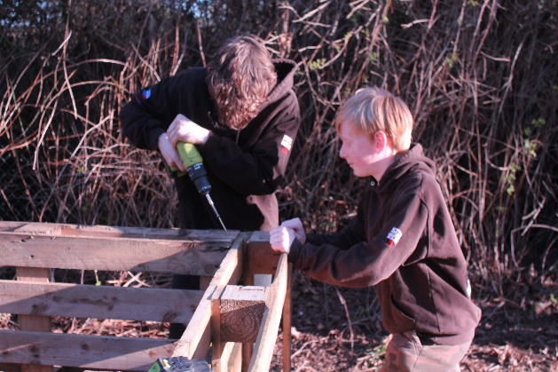
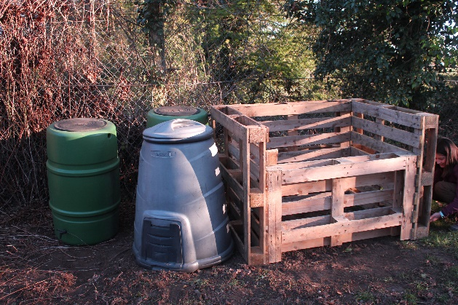
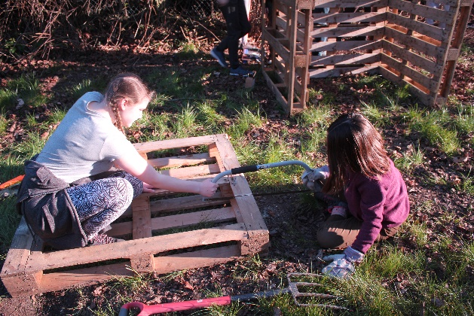

36
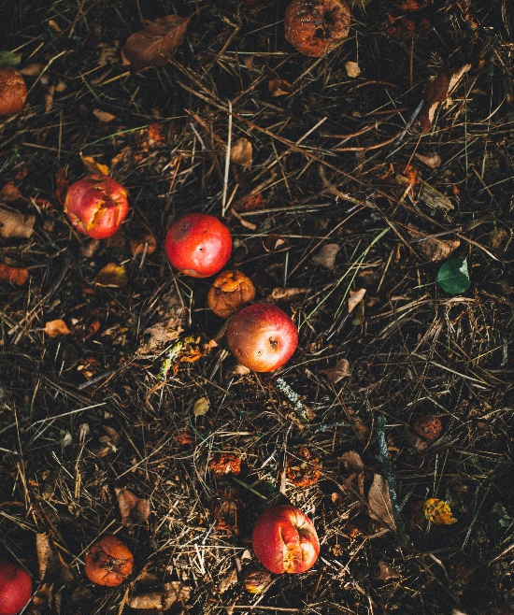
- You can decorate your compost heap if you have specialised eco-friendly outdoor paints, but only on the outside! Don’t paint the inside as this might leach into the compost.

- Move the compost heap to a shady spot in the garden, and consider cutting a piece of tarpaulin or old carpet down to cover the top of the heap, particularly during the rainy months. This will prevent the heap from getting too wet!

- Well done – you’ve made your compost bin and are now ready to start filling it up … but there are a few rules.



The Dos and Don’ts

Do Add:
- Veggie peelings
- Fruit waste
- Used coffee and teabags (so long as they aren’t plastic teabags – make sure you check)
- Grass cuttings
- Leaves
- Twigs
- Egg boxes (with any plastic removed)
- Paper.

Do Not Add:
- Any meat or dairy
- Cat or dog poop
- Diseased plants
- Plastic, glass or metals (they need to go elsewhere for recycling).

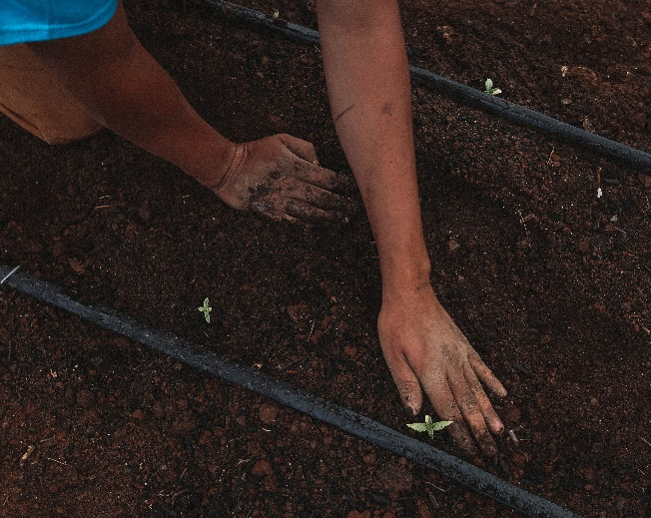

Make sure to:

- Keep a good balance between green and brown waste
- Not go overboard on grass cuttings, only a little of this otherwise you’ll end up with a slimy, smelly heap!

- ‘Turn’ the materials in the bin every now and again. This is best done with a pitchfork, by inserting the fork into the pile and ‘turning’ it over, to move the inside out and the outside in. This gives the heap well needed air, and ensures that the microbes keep doing their job and breaking down the organic waste at a fast pace. Use this opportunity to measure the temperature of your compost heap!
- Give it time! It takes a while for the organic materials to break down,
but if you’re patient, it certainly pays off!

37
Why Wildflowers?
Bees, Butterflies and the Bioeconomy

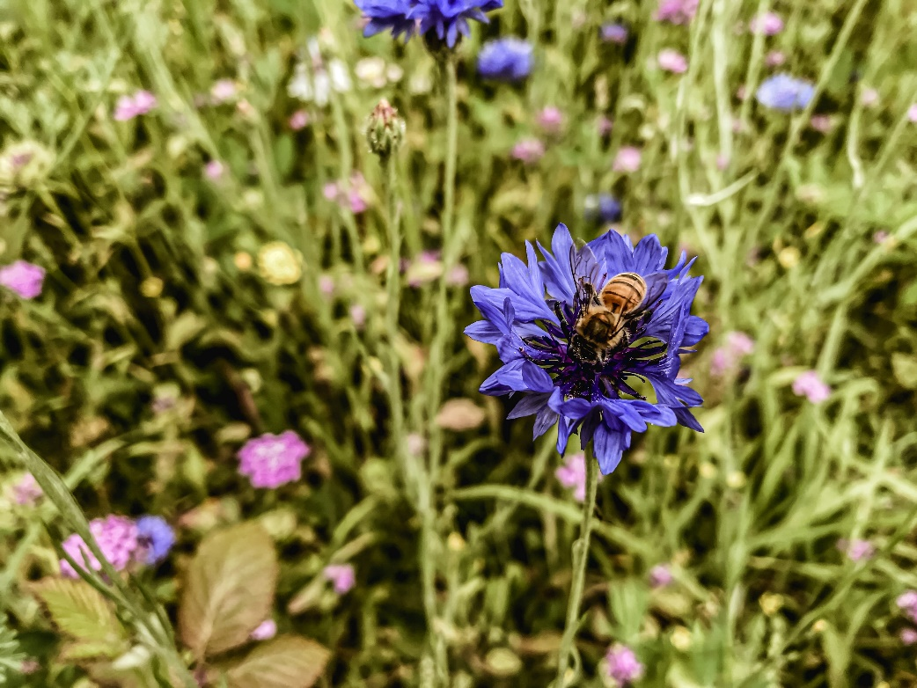

Wondering how wildflowers can contribute to the Bioeconomy? Aren’t they just pretty weeds? Nope! Wildflowers are essential in providing pollinators with food, nectar, shelter and a place to breed.

But why are these creatures so important? Well, Bees in particular, underpin most ecosystems. That is because, along with many other insects, they pollinate plants. Around one third of the food consumed on Earth relies on pollination – as do many of the plants we grow and use as a part of the Bioeconomy – not to mention the habitats and food sources of many other animals – big and small – all throughout the world. Though only small in size, the importance of bees and insects in the functioning of a sustainable world, should not be underestimated.

Unfortunately, humans keep destroying a lot of the natural and wild habitats that these creatures depend upon, instead replacing it with concrete, plastic and manmade landscapes. Lots of urban gardens now have fake grass and plants, so even these once safe heavens within cities are going scarce. For the success of both pollinators and plants, we need to increase wild and green spaces throughout the world, and you can be a part of this!

3838
You will need:
Wildflower seeds Water Garden fork Tent Pegs
Spade Tarpaulin Watering can

Though it’s not hard as such to plant wildflowers, it does require some preparation and maintenance. Here’s a few things you need to do/consider:

- You need to first check the type of soil you have, and adjust it as necessary (you may need to add some sand). Wildflowers tend to like poor quality, low nutrient soil, as this means weeds are less likely to grow and take over. There’s no need to add compost or topsoil here. Make sure you pick a sunny spot too, and bear in mind that wildflowers fair best in a pH of 7!

- Wildflowers are best sewn between late March and late October.

- Prepare the area first by clearing the land in which you wish to plant the seeds. Once it is cleared, cover the area with tarpaulin and peg it down so it doesn’t blow away. Keep this on for a few weeks, to prevent anything else from growing.

- If needed, mix in some sand to the soil, and loosen it up with a garden fork. Pick out any weeds that have grown in between you clearing the land.

- Make sure you buy wildflowers that are most suited to your conditions, and spread them according to the packet’s instructions.

- If you have an annual mix, you should see

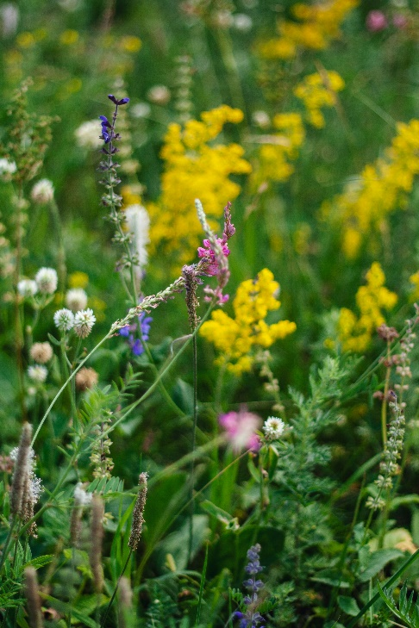

colour in the first year, whereas perennials (simply a plant that lasts more than one year) will become much more colourful the second year.

- To maintain your wildflowers, it is often recommended that, once all the plants have finished flowering, you cut them down and clear the debris.

- Like all seeds, wildflower seeds require moisture to germinate. Gently water your wildflower seeds every other day – and more in hot weather. Water them outside of the main heat of the day, otherwise they might burn! Maintain this for 4-6 weeks, after which you can slowly reduce the amount of water.

Ecosystem: A geographic area where plants, animals and other organisms, as well as weather and landscape, work together to form a bubble of life (definition taken from National Geographic)

Pollinate: Fertilisation of a plant via the transfer of pollen

Germinate: When a seed, bulb or spore begins to grow out shoots.

39
Hügelkultur:
Making mountains (of food) out of molehills

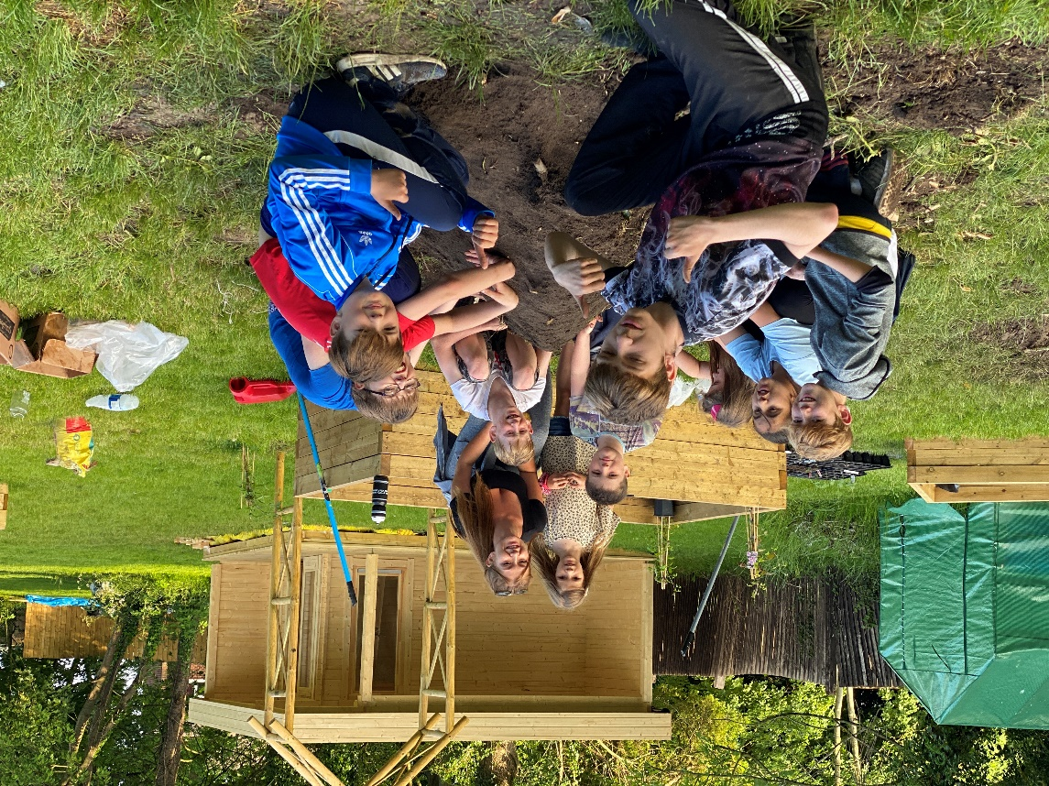

One of the biggest things we can do at home or school to improve the Bioeconomy is to grow our own. By growing our own food, we not only guarantee ourselves the freshest produce, but we reduce the food’s carbon footprint as we no longer rely on travel and packaging.

Hügelkultur has been around for centuries, and is a great way of ensuring waste wood from trees and bushes is reused. Simply, it is the gardening practice of burying carbon and nitrogen rich wood and waste greens, and piling them into a mound, covering this with dirt and soil, and planting on that instead of a flat surface.

By burying the logs, they decompose much faster than if just left on the surface. As the logs and organic materials break down, they release the carbon that’s bad for the air but good for plants into the soil, along with lots of other nutrients. This in turn helps the new plants on the surface grow. It’s much better than burning the wood, which releases carbon and nasty pollutants into the air! Also, because Hügelkultur beds are raised, it means more surface area for planting, so it’s great if you’ve not got much room in your garden! By planting upwards, you can double your growing power!

Here’s a step by step guide on how to do it yourself and instructional video*!

*https://www.youtube.com/watch?v=u2IlM13RJdo
40
Step by Step

- Mark out an area to the desired size of your Hügelkultur bed. This can be as big or as small as you like, and you should make the decision according to the size and number of logs and amount of organic waste that you have, as well as how much you want to plant on the bed.

- Once the area is marked out, dig down and clear the trench. You need to dig around 20cm deep – again – more or less depending on how big your logs are. Don’t discard any of the soil you’ve dug up… as you’ll need it again in the final stages.

- Arrange your logs in the trench parallel to one another. Do this along the length on the trench, with the bigger logs and branches at the bottom. Start to pile on the other materials, filling in the gaps with grass cuttings or other smaller organic waste.

- Layer on twigs and branches, making sure they are running parallel to the original logs. Keep on piling high, layering up the organic waste (like a lasagne), until it reaches the desired height.

- Fill in the gaps with soil, grass cuttings, egg shells, etc. Try keep it an even height along the length of the bed.

- Cover the organic materials with the soil you dug earlier, ensuring the mound is fully covered and all gaps filled. If you have turf, lay this over the bed upside-down (you may need to use some extra soil from elsewhere to ensure that you have a substantial layer).

- Compact this down.

- You can start planting right away, but some gardeners recommend waiting a few months, so the organic material starts to break down and nourish the soil.

You Will Need:
- Shovel
- Leftover wood from tree/bush cuttings
- Other organic material
- Soil.

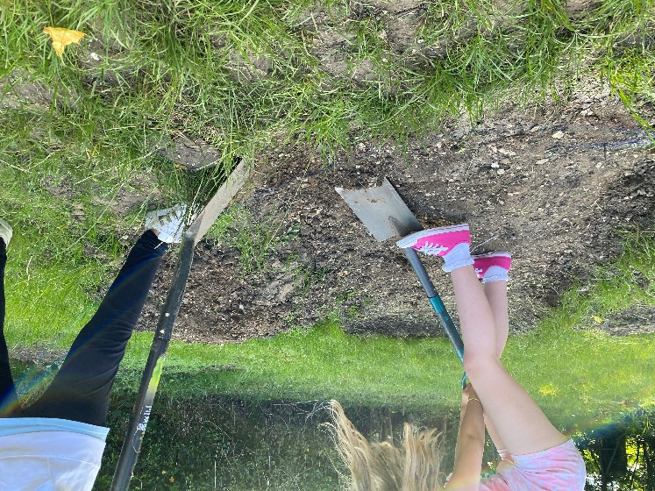

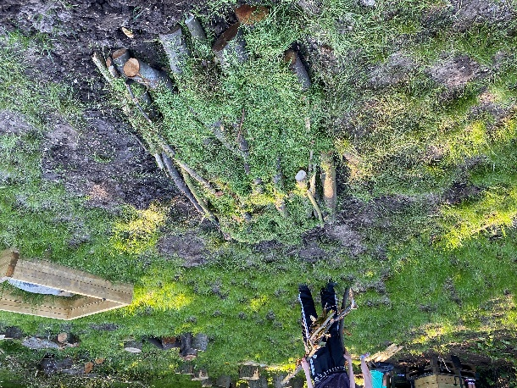

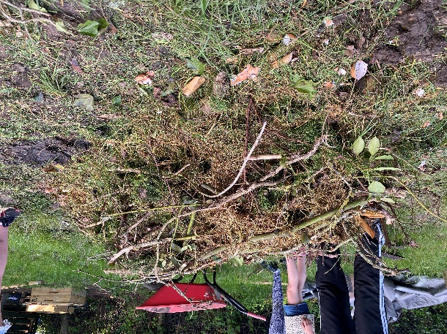

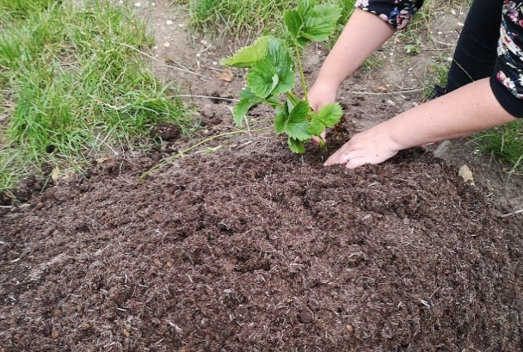

41
Food for thought

Remember that you still need to consider what will grow best in the Hügelkultur bed. Go back to the Making Informed Decisions – what works best where table (pages 27-29) to support your decisions!

Hügelkultur is reliant on the organic material breaking down. As it does this, it will shrink. If you leave it to fully decompose, you’ll be left with a pile of highly nutritious material that can be spread throughout your garden, and you can start the process again from scratch. Alternatively, you can add logs to the bed on a seasonal or annual basis, to ensure that there’s always something to break down and that the height is retained.

Refer back to the Making Informed Decisions – what works best where table to ensure you get the most from what you grow! And make sure to compost your waste to be a truly circular Bioeconomy!

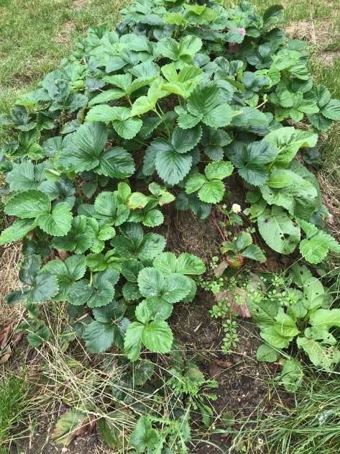

42

Fart in a Bottle:
Homemade Biogas

Making Biogas from Waste

Have you ever been travelling through the countryside and spotted what looks like huge domed tanks?

If yes, then you’ve probably seen an anaerobic digester (AD) plant. There are around 500 anaerobic digester plants in the United Kingdom and they are making biogas, a renewable fuel from waste.

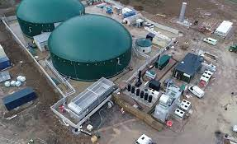

So how do AD plants work?

AD plants take organic waste (food waste, animal manure, crop residues and waste water) and place it into air-tight tanks. The operators then use the power of microbes (bacteria), heat and lots of mixing and stirring to break down the waste, very much like the way a cow digests its food - We all know that cow’s produce lots of sludgy, solid waste and lots of gas called methane!

In an AD plant, the biogas produced is used to power generators to make electricity and the remaining solid waste is used as a fertiliser for crops.

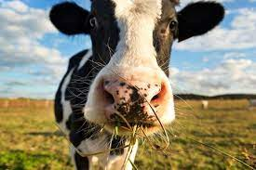

In the following experiment you will create your own miniature anaerobic digester, testing if it is possible to produce biogas by degrading food
waste in an air-tight container - (a bit like the way your body
releases farts as a result of digesting food!)

Anaerobic simply means
“without air”

What do you know about methane?

43
Step by Step

You Will Need:
- 5 used and cleaned plastic bottles
- (around 250ml will work best, all the same shape/size)
- 5 Labels
- Marker
- Blender/ food processor
- ½ a cup of 5 different foods/organic matter (fruit or vegetables –preferably the waste of those you’ve grown yourself
- 5 Small bowls
- Pouring funnel
- Balance
- A cup of soil from outside
- 5 balloons
- Duct tape
- A ruler and a length of string.
- )
- 1 cup of water

Read through the instructions below before doing anything. Use this and your existing knowledge to make a prediction. What do you think will happen?

- Prepare your bottles by rinsing them clean and labelling each with one of the corresponding foods/organic matter. Draw a line with a marker round ¾ of the way up on each bottle – make sure this is in the same spot on each bottle.
- Chop each of your food items up separately, and keep in a separate bowl.
- Using the blender/food processor, puree each of the foods individually, mixing with some water as needed. Make sure you clean the blender after each use to prevent cross contamination. Your results will not be accurate otherwise.
- Weigh out the pureed food items using a balance. Make sure each bowl has the same weight in. Add each item to its correspondingly labelled bottle using the pouring funnel. Think: Why is this important?
- If you have collected some soil from outside, you may wish to weigh a large spoonful of soil and add to the bottles using the pouring funnel. Think: Why is this important?
- Fill the bottles up with water to the fill line that you drew in step 1. Ensure you fill it consistently.
- Place a balloon over the top of each bottle, and secure it with duct tape. Make sure no oxygen can get in to the bottle.
- Place all the bottles in a warm place. Observe and record your findings over the coming days/weeks.
  - Measure the distance between the black line and the bottom of the bottle
  - Use the string to find the circumference of the widest part of the balloon

44
Step by Step continued…

As you are conducting the experiment and analysing the results, think:

- What are the variables in this experiment?

- What do the findings tell you?

- How will you record the results?

- What have you learned?

- What would happen if you altered the environment of the bottles? (e.g. changed the temperature)

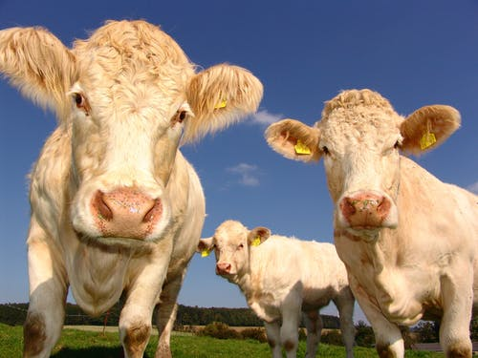

45

Next steps

This is the end of Pack 2, and thus concludes the resources within this portfolio. Your students have learned about Bioeconomy, and how this applies to real world problems. They have explored the social, economic and environmental scales that need to be balanced to ensure sustainable development, and have applied their debating skills to make a case for particular points of view. They have learned about innovative solutions from within the Bioeconomy, and have heard about a broad range of careers that might inspire them to pursue work within the Bioeconomy sector.

However, that does not mean that their learning is over. From this pack, we hope your students feel empowered to make change themselves – in whatever shape or form that might be. Encourage and support them to achieve this. Is there a business venture they could set up inside or outside of school that might support sustainable development? Could they write a persuasive letter to a local MP asking for local or national changes? Is there rationale for a student led lunchtime eco-group? Whatever it is, the possibilities are endless, and this is just the start.

46
47
Acknowledgements

These education resources were created as part of The THYME Project, a collaboration between the Universities of Teesside, Hull and York, funded by the Connecting Capabilities Fund.

They were created following consultation workshops with teachers from a number of schools in Hull and the East Riding of Yorkshire.

Project management and content design:
Florence Halstead, Energy and Environment Institute, University of Hull

Teachers’ panel:
Sarah Harris, Linda Taylor, Ashleigh Clarkson, Clare Powell, Annabella Halstead

Thanks to Dr Jenny Spear, Katie Parsons, Freija Mendrik, Amy Richardson and Tilly Costigan of the University of Hull for their input.

Additional thanks to Leconfield Youth Group for trialling many of these resources and providing photographic and video footage of them in action.

For more information on the THYME Project, including downloadable education resources please visit:

https://www.hull.ac.uk/work-with-us/research/institutes/energy-and-environment-institute/our-work/thyme-education-resources

https://thyme.biovale.org/resources/schools-resources/

