Practice Assessor/Practice Supervisor guidance for MYE PAD

Contents
Logging onto PebblePad 3
Recommended Web Browsers 4
Required Web Browser Components 5
What if I already have a PebblePad Account? 5
I am a Practice Assessor, how do I see my student’s MYE PAD? 6
I am a Practice Supervisor, do I need access to the MYE PAD? 6
How do students ‘share’ their MYE PAD with you? 6
MYE PAD Key Components 7
Recording Assessor/Supervisor details 8
What does a Practice Assessor do in the MYE PAD? 8
What does a Practice Supervisor do in the MYE PAD? 9
Saving your assessments/contribution to the MYE PAD 9
Guidance for assessment of professional values 10
Assessment of proficiencies 10
Episode of Care 11
Medicines Management 12
Ongoing Achievement Record (OAR) 12
Patient/Service User/Child/Young Person/Carer Feedback 13
Record of Working With and Learning from Others/Inter-professional Working 13
Record of Communication/Additional Feedback 14
Action Plans 15
Guidance for verifying the practice hours/placement absence 15
Hints and tips 16
Help with MYE PAD 17
COMPETENCY FRAMEWORK 18

From September 2020, all four pre-registration nursing field students will use the Midlands, Yorkshire & East Practice Assessment Document (MYE PAD). This guidance explains the key points to enable practice assessors & practice supervisors to access the students’ MYE PAD and how a practice assessor/practice supervisor navigates around and completes the assessments and assessor sections in the MYE PAD.
This guidance should be read in conjunction with the Midlands Yorkshire and East Guide to using the PAD, the University of Hull Practice Assessor/Practice Supervisor Handbook and the guidance for assessment contained in the Students’ MYE PAD.
Remember to remind students and discuss with them the guidelines and policies relating to mobile phones and electronic devices during work hours.

Logging onto PebblePad
When the University registers you onto PebblePad this triggers an automated email to you from ‘PebblePad’ from the email address ‘noreply@PebblePad.co.uk’ with the subject line ‘A new account has been created for you’.
Do check your spam/junk email box, whilst the Trust firewall has been set to accept this email. It may still be filtered to those areas.
Within the email will be a link to PebblePad and your email address –which becomes your user ID and a computer-generated password –to be used to initially log on. In the email click on the link to PebblePad and on the PebblePad login screen type in your username and password as it appears in the email. From this screen you will also have to option of changing your password, which is recommended, to something more memorable.
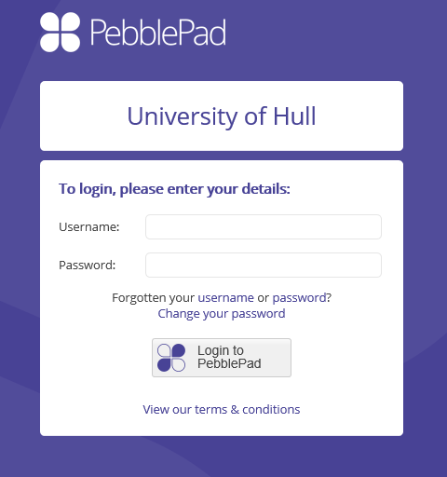
Type in the password given to you by PebblePad
Type in your trust/work email
Once logged on you can use the change your password button
The username and password are personal to you and must never be shared with a colleague or a student. Your personal login acts as your signature, so whenever you complete assessor fields in the MYE PAD your ‘digital signature’ is visible and acts as your own handwritten signature.
You are now set up as an external assessor and will be able to view your student’s PAD once the ‘share’ it with you (see page 5).
The University of Hull uses single sign on for platforms such as PebblePad. This means that you shouldn’t need to type in your login details every time. However, as very often trust/organisation computers are shared with multiple users it may not recognise your login details each time. Click the ‘I have a guest account for PebblePad’ radio button NOT ‘I have an IT account at this organisation, add your login details and click Login to PebblePad for access:

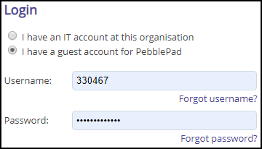
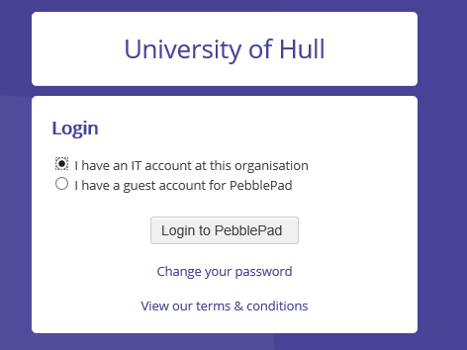

Recommended Web Browsers
PebblePad runs on Windows, Mac, Linux, iOS, Android and any device with a modern web browser. However, it is highly recommend updating to the newest version of the browser you are using.
These are the minimum web browsers for PebblePad:
- Google Chrome 59
- Mozilla Firefox 53
- Opera 46
- Internet Explorer 11
- Microsoft Edge 41
- Safari 9
On a search engine (on a trust/organisation computer it is recommended to use google chrome or Firefox), type in pebblepad@hull. This will take you to the PebblePad login page where you enter the username and password that you have been given by PebblePad.
You can access PebblePad via a mobile device such as a tablet or mobile phone. However, remember that the screen size will be considerably reduced which can make viewing the student’s MYE PAD difficult.

Required Web Browser Components
Cookies
Cookies need to be enabled on your browser to use PebblePad. This will help us to remember your settings, which will make your next visit to PebblePad easier and the site more useful to you.
Pop-Ups
If your browser has a pop-up blocker that is preventing you from using certain PebblePad tools, you can either disable the popup blocker completely or configure it so that it allows pages from PebblePad to open.

What if I already have a PebblePad Account?
If you have an existing student PebblePad account, you will still have access to use this account but to access your assigned pre-registration nursing student’s MYE PAD you will need the new username and password from PebblePad. You will not be able to use your own student PebblePad account to do this.
If you already have an existing NHS/work email PebblePad account you may not have received an email with details of this external assessor account; you will need to ensure that you have access to your student’s MYE PAD which will require you to contact the University using the pebblepad@hull.ac.uk help email address.

I am a Practice Assessor; how do I see my student’s MYE PAD?
As a Practice Assessor your student will ‘share’ their MYE PAD with you so that you can complete the assessments and practice assessor sections for the practice placement and the Ongoing Achievement Record (OAR). As this ‘share’ action is a student responsibility you will have to ensure that you remind students to share their MYE PAD for the purposes of assessment with you on the first day of placement. It is recommended that you ask a student to do this when they contact you before the placement begins.

I am a Practice Supervisor; do I need access to the MYE PAD?
To comply with the NMC Standards for Student Supervision and Assessment (2018) it is essential that students share their PAD with their nominated Practice Assessor. It is not necessary for every practice supervisor to need access to the student’s MYE PAD as they are contributing to the assessment process by providing feedback on the student’s performance. However, there are some Practice Supervisors who may need access e.g. to complete the initial interview; in these cases it is perfectly acceptable for a student to share their MYE PAD with a practice supervisor. Practice assessors are responsible for completing the MYE PAD and conducting all the assessments for the placement. Students will have to maintain records of when they worked with other professionals so that these people can contribute to the student’s assessment. The student has access to paper pdf version of the Practice Supervisor feedback form as well as access to a mobile phone app with an off-line attendance and an offline assessment form so that they can provide evidence of achievement of proficiencies, skills, and practice hours.
How do students ‘share’ their MYE PAD with you?
For the student to share their MYE PAD you will need to give them you work email address. Please note your email address is the email address that is the username for your own external assessor account. Make sure you give them the correct details otherwise they will not be able to share. This must be in the exact format – e.g. correct capitalisation, spacing etc. Students have to search for their practice supervisor/practice assessor by adding the email exactly and any variation will mean that that they will not be able to find them: for example, if the practice supervisor/practice assessor’s username is annie.mentor@nhs.net and they search for Annie.mentor@nhs.net, they will not be able to find them.
Students can do multiple shares, so if you need additional practice supervisors/practice assessors to have access to the student’s MYE PAD you will need to ask your student to share with them as well.
Students can only share their MYE PAD using the ‘Share with an external assessor’ option from their own PebblePad account. If the student tries to share it by any other of the share options, it won’t let them do this.
When the student has shared their MYE PAD, this triggers an automated email from PebblePad (noreply@PebblePad.co.uk) with the subject line ‘Asset share (With external assessor permissions)’ informing the external assessor that they have been given access to the MYE PAD and including a link to the asset. Practice assessors/practice supervisors can login in subsequently to view and/or assess the MYE PAD by following the login instructions on page 3.
You need to avoid having access to multiple MYE PADs after a student has finished the placement. Students have been told to delete any ‘shares’ before they start their next placement. If the share is still visible when a new placement period begins you will need to ask the student to delete the share. If you are unable to contact the student, you will have to ask the University to delete the share.

MYE PAD Key Components
The MYE PAD is divided into tabs across the screen:
There is guidance on each page in the MYE PAD which you can access by clicking the pdf links.
The MYE Pad has been designed around the following key component of assessment:
Professional Values: professional values reflect a number of proficiency statements and are captured under the 4 sections of The Code. All must be achieved by the end of each placement.
Proficiencies: these reflect aspects of the 7 platforms, communication and relationship management skills and nursing procedures (NMC, 2018). These can be assessed in a range of placements but must be achieved at least once by the end of the Part.
Episode of Care: this is a holistic assessment(s) to facilitate the student progress and must be achieved by the end of the Part. For University of Hull students, they will have to undertake an episode of care in each placement.
Medicines Management: there is one assessment included in each part and each must be achieved by the end of the Part.
Patient/Service User/Carer Feedback Form: feedback will be sought in relation to how the student cared for the person receiving care. Although this is not formally assessed it will contribute to overall student feedback. Obtaining such feedback is considered good practice and helps to prepare student for life as a qualified nurse and meeting professional and revalidation requirements. Practice supervisors and Practice assessors are expected to encourage students to obtain this feedback.
Recording Additional Experiences and Feedback: these additional pages for the student to record reflections on their own learning and pages to record communication and additional feedback from all those supporting learning and assessment.
Peer Feedback: these records can be completed by the student’s peers (parts 2 & 3 only).
Ongoing Achievement Record: the OAR summarises overall achievements and provides a comprehensive record of student development and overall performance.

Recording Assessor/Supervisor details
If you have access to a student’s MYE PAD either as a Practice Assessor or a Practice Supervisor, you must record your details by completing the Assessor/Supervisor list in the relevant part. There is space to record up to 12 practice assessors and 12 practice supervisors.
It is likely that a student will have more than 12 practice supervisors in each part; therefore, if needed and/or where Practice Supervisors do not have a PebblePad account, Practice supervisors can record their details by completing a pdf form. Students can provide this form by downloading it directly from their MYE PAD or alternatively, practice supervisors can download a copy from the University of Hull Placement Team website:
CLICK HERE TO GO TO THE PLACEMENT TEAM WEBSITE

What does a Practice Assessor do in the MYE PAD?
As a Practice Assessor you will responsible for completing all the assessments in your student’s MYE PAD.
You will also have the 3 interviews: initial, mid-point and final; and you have a placement and practice supervisor/practice assessor details page to record your Practice Assessor details. You will also need to verify that the placement orientation has taken place. These sections need to be completed within certain timeframes i.e. orientation on the first day and the initial interview by the end of the first week. In the MYE PAD all these forms are in the tab called Practice Assessment. These are identified by ‘Part’ (year of the programme). If you are completing a year 1 student’s MYE Pad for example, you will find all the interview forms in PART 1 Practice Assessment under the section called Placement 1 or 2 (depending on which placement the student is on for that part).
As a Practice Assessor you will verify the student’s weekly attendance form and in the OAR at the end of the placement confirm the number of hours that the student completed.
MYE PAD has an incorporated OAR so you will need to complete assessments in the Part sections and then a summary in the OAR at the end of each placement. If you are the Practice Assessor at the end of a Part, you will also need to complete the End of Part confirmation in the OAR.
As the MYE PAD is designed to support students in collecting ongoing evidence of their performance and achievements, students should be uploading evidence, testimonies, feedback during each placement. The term PebblePad uses to describe this evidence is ‘assets’. You will need to look at these assets during the student’s placement with you and you should also be encouraging your students to upload evidence of their achievements and performance especially if they are going to work with another professional to meet proficiencies and skills. To enable students to do this they have access to pdf versions of the Practice Supervisor feedback form, Record of Working With and Learning from Others/Inter-professional Working, and patient testimonies. They also have access to a mobile phone app (PebblePocket) with an off-line attendance and an off-line assessment form so that they can provide evidence of achievement of proficiencies and skills, practice supervisor feedback and, if necessary, practice hours.

What does a Practice Supervisor do in the MYE PAD?
As a practice supervisor (and other registered health or social care professionals) within their scope of practice you can contribute towards the assessment of proficiencies, however the practice assessor will assess proficiency and will have responsibility for confirming that proficiencies have been met at the final interview. As a practice supervisor you can provide feedback in a number of ways to the practice assessor about a student’s achievement of/towards proficiencies.
Complete the Record of Working With and Learning from Others/Inter-professional Working form and/or the record of communication/additional feedback form.

Saving your assessments/contribution to the MYE PAD
Once you have assessed something or completed assessor fields in your student’s MYE PAD you must click ‘save’. In your view of the MYE PAD the ‘save’ button is at the bottom of the screen so you will have to scroll down to find it.
Clicking ‘save’ enables your digital signature to appear next to these fields so you and your student will know the date and time that something was assessed. The student will also receive an email telling them that their workbook has ‘new feedback’.

Guidance for assessment of professional values
This assessment must be completed by the practice assessor.
Professional conduct is an integral part of the students’ role and as qualified practitioners, students must work within the Code, Professional Standards of Practice and Behaviour for Nurses and Midwives (NMC, 2018). The practice assessor has responsibility for assessing the professional values shown in the professional behaviours in practice section in the MYE PAD at the mid-point and final interviews on each placement. If there are any issues/areas for concern, these must be recorded, and any professional values assessed as ‘Not Achieved’ must trigger an action plan. This must involve liaison with the academic assessor.

Assessment of proficiencies
The practice assessor will assess proficiency and will have responsibility for confirming that proficiencies have been met at the final interview. A practice supervisor can contribute towards the assessment of proficiencies by providing feedback about a student’s achievement of/towards proficiencies (see page 10), but it is the Practice Assessor’s responsibility to confirm the proficiencies have been met.
This incorporates Platforms 1-7 and Annexe A: Communication and Relationship Management Skills and Annexe B: Nursing Procedures. There are approximately 30 proficiencies for each part.
The principle for assessment of proficiencies in each part is that the individual completing the assessment should draw on a range of observed experiences in which the students demonstrates the required knowledge, skills, attitudes and values to achieve high quality person/family-centred care in an increasingly confident manner, ensuring all care is underpinned by effective communication skills.
Assessment of Proficiencies are undertaken across the Part and these can be assessed in a range of placements. You will notice that there are up to 4 opportunities for achievement of each proficiency, for example:
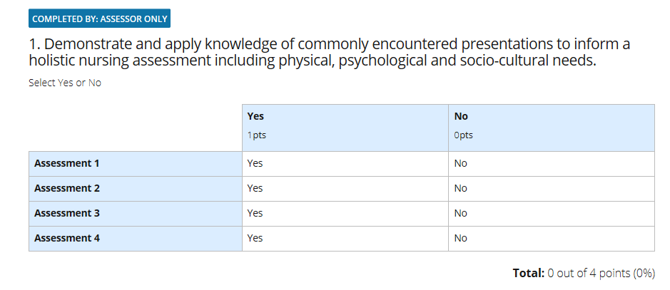
However, the student only needs to be assessed as Achieved (YES) at least once by the end of the Part. If a proficiency is assessed as Achieved (YES) early in the Part, it is expected that the student maintains that level of competence and can be re-assessed in subsequent placements at the practice assessor's discretion. Should competency not be maintained than the student will have to demonstrate to their practice assessor that they are able to achieve the proficiency through reassessment.
Record the assessment of proficiencies as follows:
YES = Achieved; NO = Not Achieved
If any proficiency has not been assessed or is not applicable to the Practice area, please leave blank.
To support the student in progressing effectively through the programme and in utilising the valuable opportunities available across a range of placements a flexible approach to assessment is required. To achieve this there are certain proficiencies that can be met in either Part 2 or Part 3.
In parts 2 and 3 there are proficiencies marked with an *. Those marked with an * can be assessed in Part 2 or Part 3. Please record achievement of these in the OAR as well.
By the end of the final placement in Part 2 the practice assessor confirms which of the identified proficiencies have been met in Part 2 (some of these may be Part 3 proficiencies) to enable the student to plan which proficiencies need to be assessed in Part 3.
Some of the proficiencies may be met within simulated learning as per the university’s policy.

Episode of Care
This assessment must be completed by the practice assessor.
Episodes of care are holistic assessments which enable the student to demonstrate their progression across a number of platforms. An episode of care is assessed by the practice assessor who will witness the student carrying out elements of the nursing role. These increase in complexity as the student progresses through the programme. The details of the episode of care for each part are contained in the MYE PAD.
Episodes of care are discrete assessments which take place on an agreed date agreed. There are two episodes of care in each year and one episode of care will be carried out in each placement in each part. Students’ performance in Episode of Care assessments are assessed against a series of proficiencies that are linked to the platforms of care and require the student to demonstrate a range of knowledge, skills and attitudes. The practice assessor should identify with their student an appropriate placement and episode of care to complete this assessment. Planning should be taken into consideration to maximise the learning for the student.
The student is also required to complete a reflection on each episode of care undertaken. The practice assessor is responsible for confirming the assessment and providing feedback
In part 1 there is a formative episode of care which takes place in placement 1 and a summative episode of care which takes place in placement 2. The formative assessment allows the student to gain confidence in the assessment and receive feedback before attempting the summative episode of care.

Medicines Management
This assessment must be completed by the practice assessor.
Students are required to undertake a medicines management assessment in each part. There is just one medicines management assessment in each part. The practice assessor should identify with their student an appropriate placement to complete this assessment. The student should be given opportunities to practice medicines administration under supervision prior to the assessment taking place.
Please note that in the MYE PAD for Parts 2 and 3 it states that the assessment must be completed where the student safely administers medicines to a group of patients/service users or a caseload of patients/service users in community settings. With the emphasis on the OR…, this means that it can take pIace in an ‘acute setting’ or in community settings (for example, a caseload).

Ongoing Achievement Record (OAR)
This must be completed by the practice assessor.
The OAR summarises the student’s achievements in each placement and Part. The practice assessor must complete the OAR at the end of each placement. In addition, a Practice Assessor who is the nominated assessor in the placement period at the end of each part (Practice 2, 4 and 6) must also complete the OAR at the end of each part and complete the progression statement.

Patient/Service User/Child/Young Person/Carer Feedback
This section allows the student to upload evidence of feedback from patients and carers. There is the option for the patient/service user to provide the feedback directly into the students MYE PAD and there are four different forms for the patient/service user to choose from. The form they select is entirely up to them as the service user. Prior to providing feedback the student nurse's practice supervisor or practice assessor must gain the patient/service user’s consent. If the patient/service user is under the age of 16, parental consent will be needed. Once the feedback has been provided the practice supervisor or practice assessor will review it, and sign and date it.
If preferred, students can download and print a paper copy of any of the four feedback forms from the links to pdf copies in the MYE PAD. If using the paper forms, students will need to ‘tag’ these feedback forms so that they appear in this section in their MYE PAD. Instructions on how to do this are contained in the student’s MYE PAD.
Please Note: The Patient/Service User/Child/Young Person/Carer should not sign this form.

Record of Working With and Learning from Others/Inter-professional Working
When a student has spent time in an outreach/short placement, with other members of the multi-disciplinary team or other agencies they are expected to reflect on their learning and document this in this section in their MYE PAD. The practice supervisor should discuss the student’s reflection and make comments about the learning/practice experience. The Practice supervisor should discuss the student’s reflection and provide relevant feedback to the Practice Assessor. As part of the practice assessment process the Practice Assessor will review these records and incorporate the feedback when making assessment decisions about the student at the mid-point and final interviews.
If the practice supervisor has access to the students MYE PAD as an external assessor, students should complete their reflection directly in to the MYE PAD page; this will enable the practice supervisor to enter their comments/feedback into the box below:
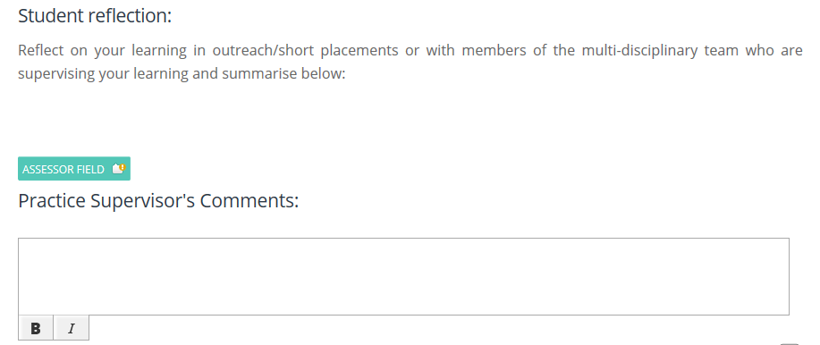
If the practice supervisor does not have access to PebblePad, students should download the Record of Working With and Learning from Others/Inter-professional Working form for the practice supervisor to complete or use the equivalent form on the PebblePocket app. Once the Practice Supervisor has completed the paper form return it to the student or completes the PebblePocket form, the student will upload the form to their MYE PAD. These uploaded forms will be available to Practice Assessors in this evidence box:
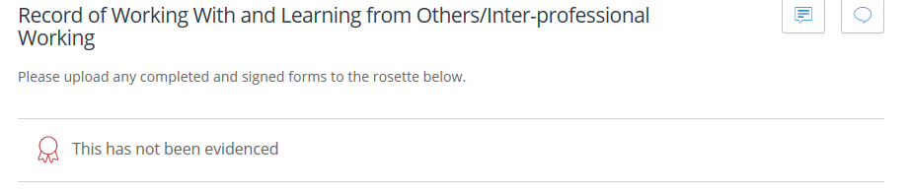

Record of Communication/Additional Feedback
These records can be completed by practice supervisors, practice assessors, academic assessors or any other member of the team involved in the supervision and/or assessment of the student. This form is to record additional feedback that has not already been documented in the student’s MYE PAD.
If you have access to the students MYE PAD, you can enter the feedback into this page. If you do not have access to the student’s MYE PAD, your student can download the Record of communication/additional feedback form for you or you can access the equivalent form on the PebblePocket app.
Once complete, your student will upload the form to their MYE PAD: see page 14.

Action Plans
An action plan is required when a student’s performance causes concern. The nature of the concern should refer to the components of assessment in the MYE PAD (Knowledge, Skills and/or Attitude) i.e. Professional Value(s), Proficiency and/or Episode of Care.
If a student requires an action plan, the Practice Assessor MUST liaise with the Academic Assessor (via the Link Lecturer) and the trust/organisation practice support team. The Practice Assessor is also responsible for reviewing the student’s progress against the agree action plan(s) and ensuring that support and learning resources are available.
The SMART principles should be used to construct the action plan.
If the student does not achieve the objectives within the action plan by the stated review date, the Practice Assessor will need to document their decision regarding whether the student has failed the placement and communicate the outcome with the Academic Assessor. If necessary, the student will need to undertake an additional retrieval placement in order to meet outstanding objectives or assessments.

Guidance for verifying the practice hours/placement absence
The attendance records that the student will complete can be found in the section called worked hours. There is a separate worked hours section for each part.
Students must maintain a daily record of their practice hours/shifts. In MYE PAD it is not possible for a practice supervisor/practice assessor to verify each daily shift worked by the student. Instead the student’s nominated Practice Assessor will be required to verify the total number of hours a student has worked in each week. The practice assessor will need to this at the end of each week worked by your student by entering the total number of hours worked by the student in this box:
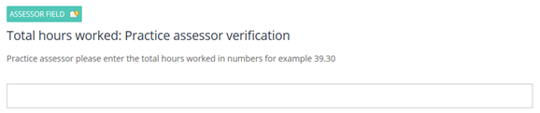
The student must complete the timesheet daily and the student must provide evidence to you of all the hours they worked whether this is with you or if they have worked with another professional. They can do this by completing and uploading either an electronic form on the PebblePocket app or a paper version of an attendance form. Students have access to the paper form in pdf version on their University CANVAS site. If they complete and upload these forms for you as evidence, you will find them in this section on the daily timesheet:
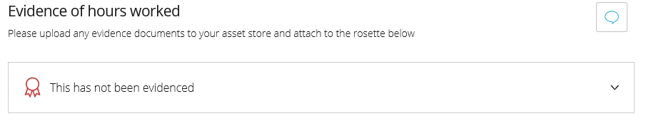
The rosette shows when evidence has been attached, if no evidence had been attached this would be red: but if the student has attached any evidence it will look something like this:
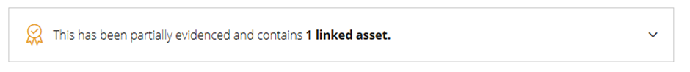
Remember, as a practice assessor you can only verify hours that the student and you can account for. When it comes to verifying the weekly attendance record, ensure that the student has all the evidence in their MYE PAD for you. Do not verify the attendance record in ‘good faith’ as the student will be asked by the University to account for ANY variation in their hours. If needed, allow the student a ‘grace’ period to upload evidence of hours worked before you verify the hours. If you are concerned about the hours a student is claiming for, discuss this with your trust/organisation practice support team or link lecturer.
The student must also record any absences from placement. Please ensure that your students are recording these hours correctly using the absence form template in MYE PAD.

Hints and tips
- Next to each assessor field is a history button that enables you and any subsequent assessor to look at what has been recorded in that field. This is important because as an assessor you may have to indicate that an initial assessment of the student has changed. Even if you deleted text that a previous practice supervisor/practice assessor had written, although it will disappear from the box, the original text will remain in the history. This also applies if you as practice assessor or practice supervisor subsequently change text in a comment or feedback box that you had previously written.

- You may find it is easier to navigate around MYE PAD by using the ‘Contents’ button on the left of the banner.
- The student will only be able to access the forms and sections they need for the part they are in. Once the student progresses to the next part the previous part’s documentation will remain open so that you as a practice supervisor/practice assessor can have access to all previous documentation which supports ongoing assessment of practice and record of achievement.
- You can use MYE PAD to provide you with evidence for your NMC revalidation. You can do this by holding down Ctrl + Alt + PrtScn buttons on the keyboard; open a blank word document; right click on the page and press the paste option. Or you can use the snipping tool to copy selected sections of the page. Find the snipping tool by using the magnifying glass (usually on the bottom left of the screen) to search windows; start typing snipping tool into this search function; when snipping tool appears click on the found search; click new on the dialogue box that will have opened on the screen and using the cross shaped cursor ‘snip’ the section you want to take as evidence; when you have highlighted the section you want you can save this to your computer or chosen file location. Remember to anonymise any evidence that you are using.
- You can search within web pages including the MYE PAD using a browser’s own integrated ‘find’ function to take you instantly to a key word, phrase or number. In windows hold down the Ctrl and F keys together; on a Mac Cmd and F keys, this opens a search box (usually at the top of the screen) where you can search for words or numbers. Handy if you want to find a particular proficiency or testimony!
- If students use the off-line mobile app you will have to check the information they have entered into the form before you sign it.

Help with MYE PAD
If you experience IT issues with PebblePad, for example not being able to log onto PebblePad, your student has problems sharing their workbook with you or assessor/student fields don’t work, contact the university for assistance. You will need to email your query or issue to pebblepad@hull.ac.uk.
For non-IT related queries, for example if you are having difficulty with completing assessor fields or you have concerns about your student’s progress in practice, please follow the established process for supporting students on placement; in the first instance this should be the organisation’s practice support team and the University Link Lecturer.
There is a canvas site that contains guidance for using PebblePad; this site can be accessed by students and practice staff by clicking on this link: PEBBLEPAD GUIDANCE FOR EXTERNAL ASSESSORS
There is an in-depth guidance document for using the Pan Midlands, Yorkshire and East Practice Assessment Document. This can be accessed on the University of Hull Placement Team website by clicking on this link: PLACEMENT TEAM WEBSITE

COMPETENCY FRAMEWORK
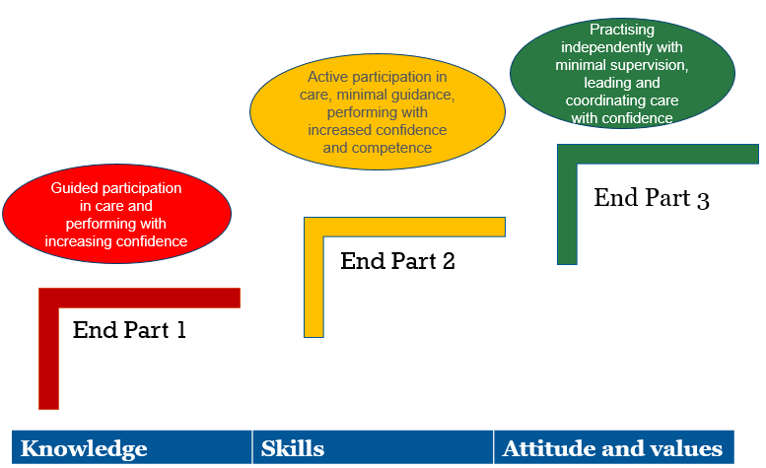
References
NMC (2018) The code. Professional standards of practice and behaviour for nurses, midwives and nursing associates. London: Nursing and Midwifery Council.
This guidance has been written by Tony Chambers Academic Lead for Placement Learning: Faculty of Health Sciences, University of Hull. March 2020.

