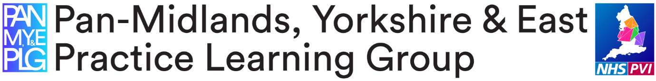
Workbook for Transition - mentors to practice supervisor and practice assessor roles.

This resource has been developed in March 2020, to replace face to face teaching sessions in light of Coronavirus.
The PAN Midlands, Yorkshire, North East and East Practice Learning Group (MYNEE PLG) started in 2016 with an original core aim to develop a common practice assessment document (PAD). Since inception, it has now grown to represent 32 universities across the Midlands, Yorkshire, East of England and more recently North East of England, hence the name change to MYENEE PLG. We collaborate to provide practice learning resources and support across all our member universities and work with other regional groups too.
This workbook is aimed at existing mentors who need to transition into the new roles of practice supervisor and practice assessor, in line with the NMC Standards for Student Supervision and Assessment (SSSA) (NMC 2018). These new standards set out the NMC expectations for the learning, support and supervision of students in placements. These standards replace the 2008 mentor standards and change the role of mentoring significantly.
The podcasts and activities in this workbook are designed for you to use at your own pace and so you can move faster through elements you already know about, spending more time on the ones that are new for you. That means the amount of time you take will be variable, but the maximum time is about 3 hours. There is a completion page to send to your mentor/supervisor/assessor register holder to show you have completed this. For NHS staff that will be their employer, for private, voluntary and independent staff, that will be their local university. Details are at the end of the workbook.
We hope you find this resource interesting and useful.
Any queries or feedback, please email Tony Chambers at the University of Hull: anthony.chambers@hull.ac.uk
Activity 1:
Listen to the podcast below for an overview of the NMC SSSA standards and how they will impact on you as an existing mentor. This podcast is 27 minutes long so you might want to sit comfortably and get a coffee, before pressing start. You may want to make some notes as you listen to the presentation. Please note all functions of the Panopto software may not show to you as described on the podcast, dependant on the device you use for access.

SSSA overview podcast 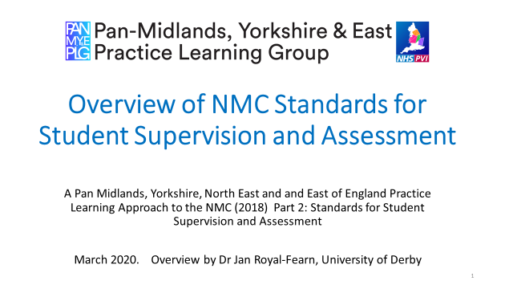

When you have listened to the podcast you might want to read through the NMC SSSA standards and they are linked below.

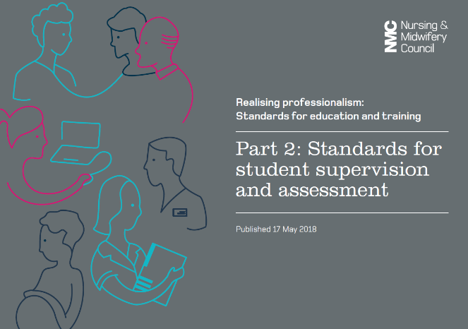 NMC SSSA link

Now take a few moments to consider the impact this will have on your workplace and when you are ready, move onto activity 2.
Activity 2:
When supporting a range of students, you will need to be aware of their individual learning needs. This may be the way they each like to learn, sometimes referred to as their learning preference and it may be that some students have additional learning needs. Read through the slides below to consider the issues you may encounter with some students and how you should provide equity in your support for a diverse range of students who may have additional needs.
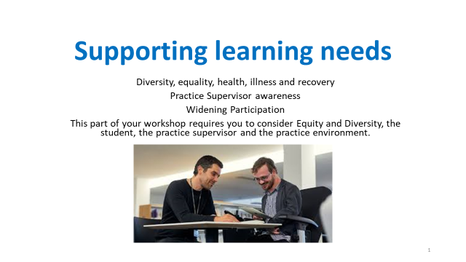
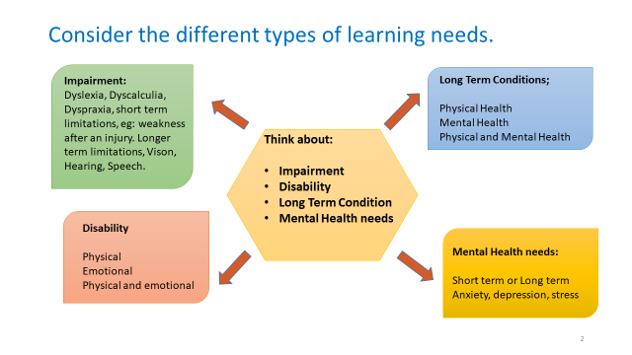

Take some time to read the RCN case studies, click on the links below.
Case study 1

Case study 2

Reflect on;
- Please think about yourself as a learner, what are you feeling or thinking when asked whether you have a disability? Would you be happy to disclose this?

- Now think about the role you will have as a practice supervisor; what you may be feeling or thinking when asking a student you are supporting, whether they may have a disability?

- As a practice supervisor, what would be your role and responsibility to a student (who has declared a disability) in terms of patient care delivery, patient safety, working within your organisation and to the standards of the Code (NMC, 2018)?

- Would you know when to seek assistance in supporting a student with a disability and whom to refer to?

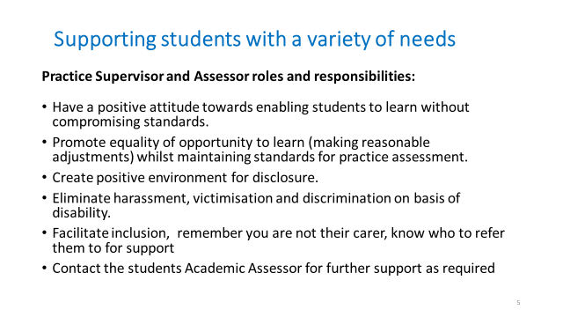

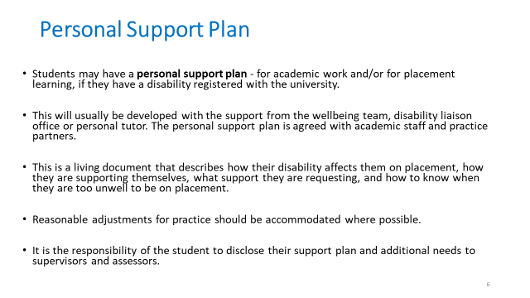

For further information and support;
- Contact the student’s Academic Assessor
- Contact the university disability support services.
- Access your local university website.
_____________________________
Activity 3:
The Midlands, Yorkshire and East Practice Assessment Document (MYE PAD) has been developed by the Pan London Practice Learning Group in collaboration with practice partners, mentors, academic staff, students and service users across London, the Midlands, Yorkshire and the East of England regions to support nursing students to achieve the criteria set out in the Future Nurse: Standards of proficiency for registered nurses (NMC 2018). Some of our universities in the MYNEE PLG started using the MYE PAD in September 2019 and it will continue to be implemented in our universities from September 2020. Some Universities have a paper based MYE PAD and some are using an electronic PAD.
The University of Hull will be using an electronic version of the MYE PAD hosted on PebblePad™ from September 2020. Until September 2020, The University of Hull will continue to use the current West Yorkshire and Humber ePAD. Guidance for using the ePAD can be found on the University of Hull Placement Team website via this link UNIVERSITY OF HULL PLACEMENT TEAM WEBSITE
If you want to know more about the new practice assessment document (MYE PAD) you can watch an introduction to the MYE PAD in a podcast below. This presentation introduces the MYE PAD as a paper-based document and although the electronic version looks slightly different, the principles and guidance are the same. Please watch the following podcast and make notes as required. You can pause and rewind the podcast while you view. It is 17 minutes long. Click on the link below:

MYE PAD Podcast

All sections of the MYE PAD can be found to view at https://www.myeplg.ac.uk/pan-midlands-practice-document.aspx (and the link to the MYEPAD podcast is there too, if the above link doesn’t work for any reason)
Activity 4:
In 2018 the NMC also made changes to the standards pre-registration nurses needed to achieve. This is called the Future Nurse curriculum. Each university that delivers
pre-registration nursing programmes have been busy redeveloping their curriculum. Many universities launched the new future Nurse Curriculum in September 2019 and some will start in September 2020.
The University of Hull will be launching their new nursing programmes in September 2020 using the new Future Nurse curriculum. Until September 2020 all pre-registration nursing programmes at The University of Hull are continuing with the current curriculum which uses the same practice standards, skills log and medicine standards which are in the ePAD. Please take some time to familiarise yourself with the current curriculum. You can access a pdf version of the current ePAD on the University of Hull Placement Team website via this link: UNIVERSITY OF HULL PLACEMENT TEAM WEBSITE
Summary:
This is the end of the content. At this point please use the certificate of completion to add to your training records and then write a short reflection using the NMC template on the following page. Please send these 2 pages to your employer or supervisor / assessor register holder (depending on your organisation this will be your PLF, CST, PEF, LEM), as evidence you have completed this workbook resource.
For details of where to send the certificate of completion and reflection as evidence of completion please click on the following link where you will find the contact names and addresses of all our local practice learning partners:
PRACTICE LEARNING SUPPORT TEAM

This certificate confirms that

Name___________________________________________

Has completed a transition from mentor to practice supervisor and practice assessor roles through a virtual training resource workbook

The content of the workbook covered;
Information on the standards to support student supervision and assessment
NMC programme education standards,
Programme specific practice assessment document
Equality and diversity issues for placement learning
Supervisor and assessor roles

Date ___________________________________________

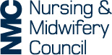
Use this form to record a written reflective account of your workshop learning and the new roles in practice and how this relates to the Code. Please make sure you do not include any information that might identify anyone.
Reflective account:
What was the nature of the CPD activity and/or practice-related feedback and/or event or experience in your practice?
What did you learn from the CPD activity and/or feedback and/or event or experience in your practice?
How did you change or improve your practice as a result?
How is this relevant to the Code?
Select one or more themes: Prioritise people – Practise effectively – Preserve safety – Promote professionalism and trust

