Academic Framework
Classification: | Procedure
Version Number: | 1-00
Status: | Approved
Approved by: | Education Committee
Approval Date: | NA
Effective from: | Immediate
Next Review Date: | 01/10/2025
Document Author: | Quality Manager
Document Owner: | Quality Support Service
Department/Contact: | Quality Support Service
Collaborative provision: | Mandatory
Related documents: | QAA UK Quality Code. Framework for Higher Education Qualifications (FHEQ)
Published location: | Quality and Standards Website.
All printed or downloaded versions of this document are classified as uncontrolled.
A controlled version is available from the university website.
This document is available in alternative formats from
policy@hull.ac.uk

Academic Framework

Table of Contents
1. Introduction 3
2. Qualifications and Credit Accumulation 3
3. Credits required for Qualifications 3
4. Programme Structures 3
5. Apprenticeships 4
6. The Standard Academic Year 4
7. The Modular Structure 5
8. Module Enrolment 6
9. Appendix 1 – PGT Models 7
Model A 7
Model B 8
Model C 9
Model D 10
Model E 11
Model F 12
Model G 13
Model H 14

Academic Framework

Introduction
  - Higher Education in the UK has gone through considerable change over recent years and this is expected to continue in the future. The aim of this academic framework is to ensure that students continue to receive an excellent education with a strong focus on employability whilst allowing sufficient flexibility to allow new modes of learning now and in the future.

Qualifications and Credit Accumulation
  - The University of Hull admits students onto the following qualifications:
- Bachelors Degree
- Integrated Masters Degree
- Foundation Degree
- Undergraduate Diploma
- Undergraduate Certificate
- Taught Masters Degree
- Postgraduate Diploma
- Postgraduate Certificate
- Apprenticeship Degree.

Credits required for Qualifications
  - The total credit value of qualifications awarded by the University are as follows:
Integrated Masters Degrees with a Post-Diploma Level: 600 credits
Integrated Masters Degrees: 480 credits
Honours Degrees: 360 or 480 credits
Ordinary Degrees: 300 credits
*Undergraduate Diplomas in Higher Education: 240 credits
*Undergraduate Certificates in Higher Education: 120 credits
**Foundation Certificates in Higher Education: 120 credits.

* Foundation Certificates in HE can only be awarded following the Pre-Certificate level.
**Certificates and Diplomas – applicable here only in the event of non-progression or withdrawal. Programmes leading directly to a Certificate or Diploma are governed by the Regulations for Undergraduate Certificates and Undergraduate Diplomas respectively.
  - Any other credit value shall be subject to the approval of the Education Planning Committee and shall be as specified in the relevant programme specification.

Programme Structures
  - Bachelor Degrees are structured in three or four levels reflecting the inclusion of a placement year/year abroad or otherwise. These levels are:
- Level 3: Preliminary-certificate* - 120 credits (at least 100 credits at Level 3 and the remaining credits at Level 3 or Level 4)
- Level 4: Certificate - 120 credits (at least 100 credits at Level 4)
- Level 5: Diploma - 120 credits (at least 100 credits at Level 5)
- Placement year/year abroad - 120 credits (at least 120 credits at Level 5 or Level 6)
- Level 6: Honours - 120 credits (at least 100 credits at Level 6)
- Level 7: Masters – 120 credits at Level 7 - to be used only in Integrated Master Degrees.
  - * A Preliminary Certificate offers an opportunity to students who would not normally meet the requirements for direct Level 4 entry onto Bachelor Degrees, either through failing to meet the required tariff or through lacking one or more pre-requisites. It also offers an ideal entry point to higher education for students who have been away from formal education for some time and for overseas students transitioning to the UK system. Completion of a Preliminary Certificate should place progressing students on an equal footing with their direct entry peers.
  - The Preliminary Certificate must include at least 40 credits of core modules. Included within the core modules should be specialist subjects normally required for entry onto the associated degree at Level 4.
  - Foundation Degrees:
- Level 4: Certificate - 120 credits (at least 100 credits at Level 4);
- Level 5: Diploma - 120 credits (at least 100 credits at Level 5).
  - Undergraduate Diplomas:
- Level 4: Certificate - 120 credits (at least 100 credits at Level 4);
- Level 5: Diploma - 120 credits (at least 100 credits at Level 5).
  - Undergraduate Certificates:
- Level 4: Certificate - 120 credits (at least 100 credits at Level 4).
  - Taught Masters:
- Level 7: Masters - 180 credits (120 taught credits and 60 credits for the dissertation. The dissertation must be at Level 7 whereas the 120 taught credits may include 30 credits at level 6).
  - Postgraduate Diploma:
- Level 7: Masters - 120 taught credits (at least 100 credits at Level 7).
  - Postgraduate Certificate:
- Level 7: Masters - 60 credits (at least 40 taught credits at Level 7).

Apprenticeships
  - Apprenticeships are employer-led, that focus on occupational competence and require significant employer consultation and planning to design. All apprentices are employed, usually full time, and spend a minimum of 20% of their time on off the job training activities. Apprenticeships must be relevant and contextualised to an individual apprentice’s workplace and typically this can be achieved using the University’s Work Based Learning Framework. Apprenticeships are not simply an existing/new degree with some additional requirements.

The Standard Academic Year
  - Normally, a maximum of two years’ study will be given to completing a level. This period does not include breaks in study. Credits will remain valid for nine years.
  - The academic year is based upon a calendar year being partitioned into trimesters, designated as trimester 1 (T1), trimester 2 (T2) and trimester 3 (T3). The standard academic year for undergraduate degrees remains as T1 and T2 (see Figure 1).
  - PGT models of delivery are noted within Appendix 1.

 | T1 | T2 | T3
Year 1 | Level 4  - 3 x 20 credit modules in T1.  - 3 x 20 credit modules in T2.
Year 2 | Level 5  - 3 x 20 credit modules in T1.  - 3 x 20 credit modules in T2.
Year 3 | Level 6  - 3 x 20 credit modules in T1 and T2.  - 1 x 20 credit module and 1 x 40 credit in T1 and 3 x 20 credit modules in T2  or vice versa.  - 2 x 20 credit modules in T1 and T2 and 1 x 40 credit module across both T1 and T2.
Figure 1.

The Modular Structure
  - A credit value is assigned to each module indicating the total learning time, including assessment, which a candidate might expect to spend in achieving the learning outcomes associated with the module. Each credit shall nominally represent 10 hours of learning.
  - The standard module size is 20 credits, with 40 credits available for dissertation or projects, and 60 credits available for trimester placements. For year-long placements 20, 40, 60 and 120 credit modules are available. The placement is normally conducted at the Post-Diploma level but may be undertaken after the Honours level (but before classification).
  - For collaborative provision, 10 credit modules are also permissible.
  - For taught masters degrees, 10 and 30 credit modules are also permissible.
  - For PGCE, a 40 credit School / Setting Experience module is permissible.
  - Modules must be designated as core, compulsory, optional or elective, according to their importance in enabling students to achieve the learning outcomes for the as a whole and, where applicable, to meet professional body requirements.
- CORE MODULE: This module is fundamental to the degree and must be studied. It cannot be compensated or condoned.
- COMPULSORY MODULE: This is a module, which must be studied to successfully complete a particular degree. It can be compensated or condoned, subject to regulations.
- OPTIONAL MODULE: This is a module that a student may choose to study as part of their degree. It can be compensated or condoned, subject to regulations.
- ELECTIVE MODULE: This is a module that a student may choose to study as part of their degree. It cannot be compensated or condoned.
  - There should be no optional modules at Level 4 (unless an exemption request has been approved by the Education Planning Committee (EPC)).
  - Optionality should be minimised throughout the duration of study.
  - Faculty Education and Student Experience Committee (FESEC) is the final arbiter of any disagreements regarding the level of optionality.
  - Levels of optionality should be clearly linked to the number of students taking the module.
  - Modules will not normally run with less than 15 students (unless PSRB accredited or of a work based learning remit).

Module Enrolment
  - A full-time candidate should normally enrol for modules having a total value of at least 120 credits over a maximum of three consecutive trimesters. Modules undertaken following referral shall be undertaken additionally.
  - A part-time candidate may enrol for modules having a total credit value of no more than 40 credits over each trimester.

Appendix 1 – PGT Models

Model A
Full Time delivery across three trimesters with distinct taught and master’s stages.
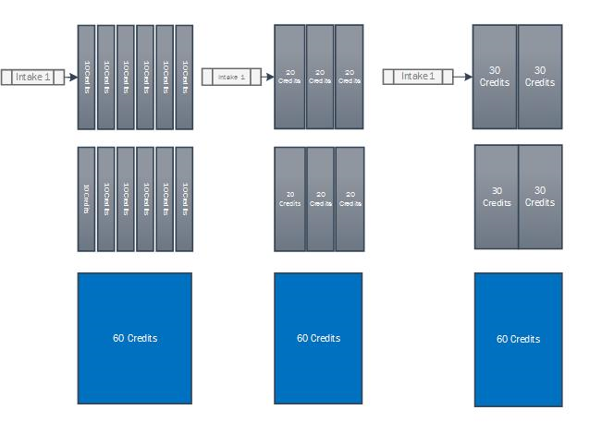
Key:
Advantages;

- Full time - delivered and completed within 12 months.
- All taught modules are structured and contained within trimesters following a standard lecture/tutorial format that creates a balanced workload.
- All taught modules are completed before the master’s stage.
- Potential to create progression and build in reassessment period.
- Masters stage is contained within a single trimester and concludes the study.

Disadvantages;

- Only one intake point (further intakes would require the repeat delivery of a trimester or the extension to a minimum of 4 trimesters).
- Large assessment workload at the end of each trimester.
- Difficult to attract working professionals or part time students.
- Structure does not support on line provision as effectively as block taught modules.

Model B
Full Time delivery across three trimesters with combined taught and master’s stages.
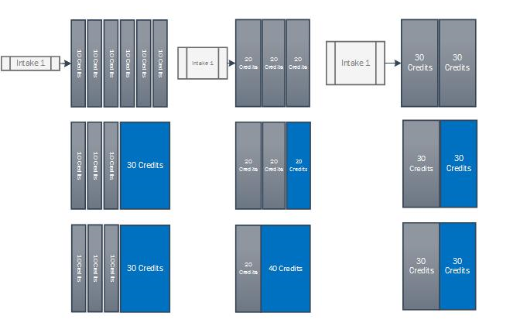

Advantages;

- Full time - delivered and completed within 12 months.
- All taught modules are structured and contained within trimesters following a standard lecture/tutorial format.
- Students remain engaged with the taught stage whilst simultaneously undertaking masters stage.
- The master’s workload is spread over two trimesters.

Disadvantages;

- Only one intake point (further intakes would require the repeat delivery of a trimester, the extension to a minimum of 4 trimesters).
- Large assessment workload at the end of each trimester.
- Difficult to attract working professionals or part time students.
- Requires delivery over trimester 3.

Model C
Full Time Block taught delivery with distinct taught and master’s stages.
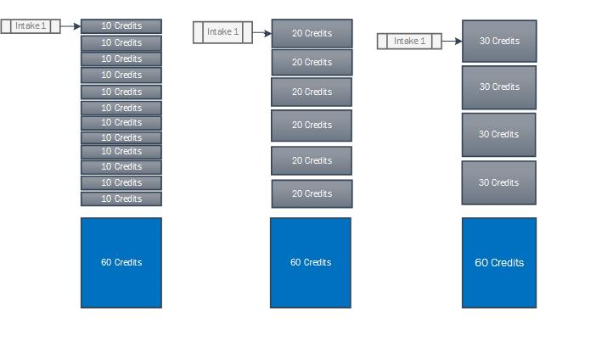

Advantages;

- Full time - delivered and completed within 12 months.
- Block taught delivery (potentially across evenings and weekends for part time provision)
- Potentially attractive to working professionals/part time study.
- All taught modules are completed before the master’s stage.
- Potential to create progression and build in reassessment period.
- Masters stage is separate.
- Workload and assessments constant throughout.
- Block taught modules are more conducive to on-line provision.
- Potential to build work based learning into modules.
- Multiple entry points for PT only (FT one entry point only)

Disadvantages;

- Only one intake point (FT variant only; PT allows for multiple entry points).
- If delivery is during standard teaching times, it may be difficult to attract working professionals or potential part time students.

Model D
Full Time delivery across three trimesters with combined taught and master’s stages.

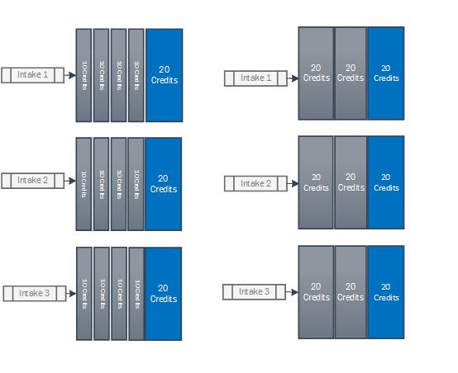
Advantages;

- Potential for up to three intakes.
- Full time - is delivered and completed within 12 months.
- All taught modules are structured and contained within trimesters following a standard lecture/tutorial format.
- Students remain engaged with the taught stage whilst simultaneously undertaking masters stage.
- The master’s workload is spread over three trimesters.

Disadvantages;

- Each intake would require a repeat induction.
- Large assessment workload at the end of each trimester.
- Difficult to attract working professionals or any part time students.
- Requires delivery across all three trimesters.
- Master’s stage may require monitoring to ensure the student workload model is followed and work undertaken across all trimesters.

Model E
Part Time Block taught delivery with combined taught and master’s stages.

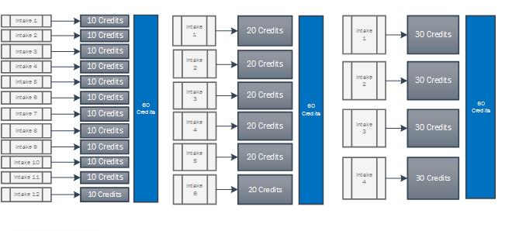

Advantages;

- Multiple entry points
- Block taught delivery (potentially across evenings and weekends)
- Can be delivered part time across either 24 or 36 months.
- Potentially attractive to working professionals and part time study.
- Workload and assessments constant throughout the.
- Block taught modules are more conducive to on-line provision.
- Potential to build work based learning into modules.

Disadvantages;

- Each intake would require a repeat induction.
- If delivery is during standard teaching times, it may be difficult to attract working professionals or potential part time students.
- Requires year round delivery.
- Master’s stage may require monitoring to ensure the student workload model is followed and work is undertaken across all trimesters.

Model F
Part Time block taught delivery with distinct taught and master’s stages.

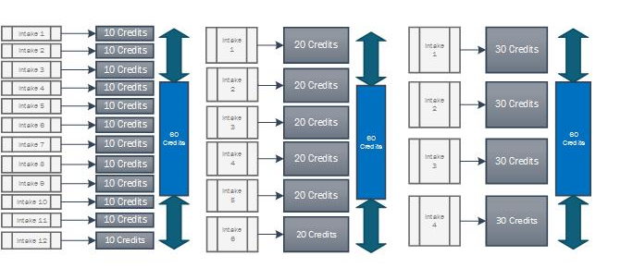

Advantages;

- Multiple entry points, students’ progress to the master’s stage following completion of 120 credits.
- Block taught delivery (potentially across evenings and weekends)
- Can be delivered part time across either 24 or 36 months.
- Potentially attractive to working professionals and part time study.
- Workload and assessments constant throughout.
- Block taught modules are more conducive to on-line provision.
- All taught modules are completed before the master’s stage.
- Potential to create progression and build in reassessment period.
- Masters stage is separate.

Disadvantages;

- Each intake would require an induction.
- If the delivery is during standard teaching times, it may be difficult to attract working professionals or potential part time students.
- Requires constant rolling delivery throughout the year.
- Reassessments offered at the end of the taught stage, potentially a number of months after the module delivery, this is especially relevant for those modules taken at the beginning of a part time mode of study (an alternative may be to introduce in year reassessment).

Model G
Part Time delivery model across six trimesters with distinct taught and master’s stages.

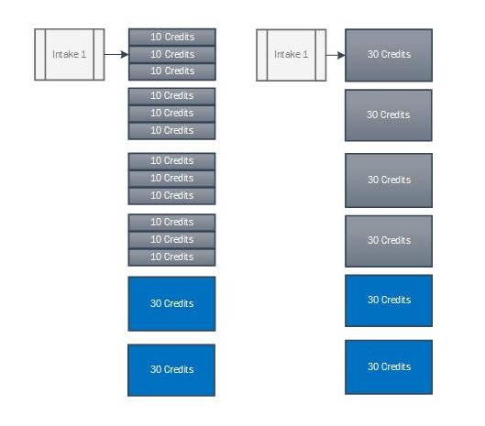

Advantages;

- Part time - delivered across 24 or 36 months.
- Block taught delivery (potentially across evenings and weekends for part time provision)
- Potentially attractive to working professionals/part time study.
- All taught modules are completed before the master’s stage.
- Potential to create progression and build in reassessment period.
- Masters stage is separate.
- Workload and assessments constant throughout.
- Block taught modules are more conducive to on-line provision.
- Potential to build work based learning into modules.

Disadvantages;

- Only one intake point
- If delivery is during standard teaching times, it may be difficult to attract working professionals or potential part time students.

Model H
Full Time delivery across four trimesters with distinct taught, internship and master’s stages.
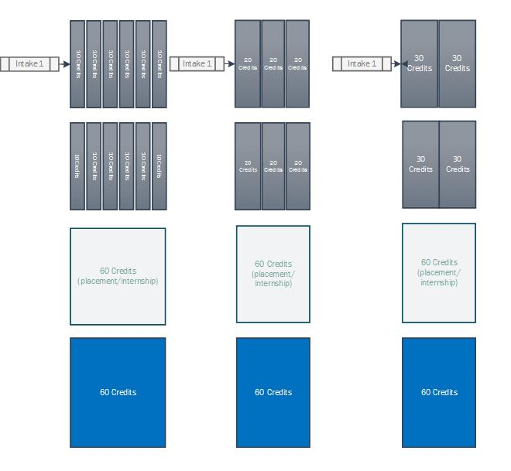

All models (A to F) could be delivered with a placement/internship option, although on models where the masters stage runs simultaneously with taught modules the duration for the master’s credits would be extended.

Version Control
Version | Author | Date approved | Relevant sections
1-00 | Lisa Tees |  | Merged 3 separate academic framework documents into 1.

