Progress Reviews in Apprenticeships
Classification | Code of Practice
Version number: | 1
Status | Approved
Approved by: | Education Committee
Approval date: | 21 July 2026
Effective from: | 01 September 2026
Next review date: | 2029-2030
Document author: | Zach North (Director of Apprenticeships)
Document owner: | Zach North (Director of Apprenticeships)
Contact: | Quality Support Service
Collaborative provision: | Not mandatory
State whether this document is applicable to the University’s collaborative partners
Related documents: | -
University document: | Yes
A University document applies across the institution, is approved by a committee of Council or Senate and is held in the University Policy Directory on SharePoint.
Published location: | https://www.hull.ac.uk/policies-and-information/quality-and-standards-framework

- The University has adopted the principles of Designing for Diverse Learners, and all policy documents should be written with reference to these principles. Further information is available at the Designing for diverse learners website.
- An Equality Impact Assessment (EIA) must be considered for all new and amended policies. Further information is available from the EIA section of SharePoint.
- This document is available in alternative formats from policy@hull.ac.uk.
- All printed or downloaded versions of this document are classified as uncontrolled
Progress Reviews in Apprenticeships
Table of Contents
1 Introduction 3
2 Scope 3
3 Authority 3
4 Progress Review System 4
5 Scheduling and Delivery 4
6 Documentation and Escalation 4
7 Asynchronous Progress Reviews 5
8 Advice and Guidance for Apprentices 5
9 Record-Keeping and Confidentiality 5
10 Training and Support for Progress Reviews 6
11 Allocation of University Staff Completing Progress Reviews 6
12 Apprentices Returning from a Break in Learning 6
13 Monitoring and Enhancement of Progress Reviews 6
14 Version control 7
15 ANNEX A - Expectations of the Progress Review 8
16 ANNEX B – AI-Enabled Narrative Capture for Holistic Ongoing Reviews (ANCHOR) 11
Step 1 – Conduct the Progress Review Meeting 12
Step 2 – Produce a Transcript or Structured Notes 13
Step 3 – Upload the Transcript into the ANCHOR Prompt 13
Step 6 – Record the Final Summary in PebblePad 15
17 ANNEX C – Monitoring and Enhancement of the Progress Reviews 16
18 Purpose and Principles 16
19 Overview of the Assurance Model 16
20 Strand 1 – Monitoring of Compliance and Timeliness 16
21 Strand 2 – Quality Assurance of Progress Review Content 17
22 Tools, Evidence and Records 17
23 Reporting, Governance and Enhancement 18

Progress Reviews in Apprenticeships

Introduction
  - The purpose of this code is to set out the University’s expectations relating to Progress Reviews in Degree Apprenticeship Programmes. The University of Hull is committed to providing apprentices across its provision with regular, effective and impactful Progress Reviews.
  - This Code of Practice outlines the expectations, procedures, and responsibilities for conducting progress reviews for apprentices enrolled in the University of Hull’s apprenticeship programmes. It ensures consistency, quality and compliance with Department for Education, Ofsted and Office for Students requirements. Most importantly, it ensures that each progress review is timely and impactful for every apprentice.

Scope
  - Progress Reviews – A Progress Review is a tripartite meeting that must take place every 10–12 weeks to the day during an apprentice’s programme of study. Progress reviews are distinct from Academic or Personal supervision and must include the following:
  - Portfolio Tutor – An academic member of staff who must:
- Schedule and issue invitations to all attendees
- Chair the meeting
- Document and summarise the meeting in PebblePad
- Monitor the apprentice against agreed goals and apprenticeship standards
  - Apprentice – An apprentice must:
- Attend all scheduled Progress Reviews
- Reflect on progress and contribute to setting future targets
- Raise any concerns, support needs or safeguarding issues
- Declare reasonable adjustments as required
  - Employer Representative – An Employer Representative must:
- Attend all scheduled progress reviews
- contribute to the setting of and provide verbal feedback on apprentice performance towards goals
- Provide feedback on workplace application of knowledge, skills and behaviours
- support agreed actions and targets.

Authority
  - The Apprenticeship Governance Board is the final arbiter of the application and interpretation of this code of practice.

Progress Review System
  - Key Mandatory Requirements:
• Progress Reviews must take place every 10–12 weeks to the day while the apprentice is actively learning.
• Progress Reviews must be tripartite, involving the Apprentice, Portfolio Tutor and Employer Representative.
• Progress Reviews must be documented in PebblePad within two working days, and no later than five working days following the meeting.
• Missed, overdue or incomplete Progress Reviews must be escalated in line with section 6 of this Code.
  - Each apprenticeship programme must provide a structured and purposeful Progress Review system that supports apprentice progression, engagement and achievement.
  - The provision, content and context of Progress Reviews must be consistent across programmes, Schools and Faculties, in line with Department for Education and Ofsted requirements. Mandatory content is set out in Annex A.
  - Additional interim Progress Reviews must be scheduled where:
- There are concerns regarding progression, wellbeing or learner experience
- The apprentice changes employer or Employer Representative
- A break in learning occurs

Scheduling and Delivery
  - The Faculty Apprenticeship Team will support the booking of the first Progress Review only.
  - The Portfolio tutor must assume responsibility for scheduling all subsequent Progress Reviews.
  - The next Progress Review should be scheduled during the current meeting
  - Where Progress Reviews are conducted online, they must be scheduled using Microsoft Teams, and invitations must include:
• The Apprentice
• The Employer Representative
• The Faculty Apprenticeship Team (for assurance and visibility)
  - If any party is unable to attend, the Faculty Apprenticeship Team must be informed to support re-booking and maintain compliance.

Documentation and Escalation
  - Progress Reviews must be documented in PebblePad within two working days, and no later than five working days following the meeting.
  - Completion and timeliness are monitored by Central and Faculty Apprenticeship Teams through a risk-based and proportionate approach, see Annex A – Strand 1.
  - Missed or incomplete Progress Reviews must be escalated to the Programme Director and managed through the Cause for Intervention (CFI) process appropriate.

Asynchronous Progress Reviews
  - Where a Progress Review cannot be arranged as a synchronous meeting, approval to complete the review asynchronously must be obtained from the Director for Apprenticeships.
  - Approval will only be granted in exceptional circumstances (e.g. prolonged absence or significant operational disruption), the Progress Review must be evidenced and recorded in. PebblePad, and does not alter expectations for content, employer contribution or documentation.

Advice and Guidance for Apprentices
  - Progress Reviews provide a key point of contact for academic, practice and workplace advice, and guidance on accessing specialist support services. Where appropriate, apprentices may also contact their Personal Supervisor, Programme Director, the Hubble Centre or the Students’ Union Advice Centre.
  - Progress Reviews encompasses academic and workplace encouragement and advice to enhance Apprentice success and continuation. Portfolio Tutors should provide guidance on progression, career aspirations, professional behaviors as well as the implications of apprentice conduct and action relating to conduct.
  - University Staff and Employers will be able to access information contained in Progress Review documentation in order to inform an early intervention to support success and continuation of apprenticeship study. All contact will include structured and purposeful action planning to enable Apprentices to develop the knowledge, skills and behaviours required to achieve the apprenticeship award.
  - The University, centrally and through each academic unit, will provide comprehensive and accessible information about specialist support and advice services, University regulations, academic progress and associated processes.

Record-Keeping and Confidentiality
  - Portfolio Tutors must use the documentation available on Pebble Pad to record the Progress Review (outlined in Annex A).
  - Progress Reviews conducted online may be recorded with consent from all parties. Consent must be confirmed prior to each recording.
  - Where Generative AI is used to summarise progress review transcripts, staff must follow the AI-Enabled Narrative Capture for Holistic Ongoing Reviews (ANCHOR) guidance set out in Annex B.
  - Any records will be maintained and stored in accordance with the General Data Protection Regulations 2018. The University processes all personal information including sensitive data in accordance with the University Policy on Data Protection.
  - It is important that University Staff respect Apprentice confidentiality in any records that they create. University Staff will be trained in appropriate record keeping and bounds of confidentiality through mandatory training activities.

Training and Support for Progress Reviews
  - The Progress Review Requirements (Annex A) identify key points to guide University Staff in the development and implementation of a purposeful and structured Progress Review system.
  - The University provides training for University Staff. All University Staff conducting Progress Reviews must undertake training prior to completing a Progress Review:
- Existing programmes: this training should be provided by the Programme Director.
- New programmes: this training must be provided by the Director for Apprenticeships in conjunction with Central and Faculty apprenticeship teams.
  - Staff may be required to attend additional training where quality assurances have identified risk to the quality or compliance of Progress Reviews.

Allocation of University Staff Completing Progress Reviews
  - The academic unit responsible for an Apprentice’s programme of study must ensure that a named university member of staff is identified as a Portfolio Tutor. Programme Directors should oversee this process.
  - Where staff absence or departure occurs, a replacement Portfolio Tutor must be identified.

Apprentices Returning from a Break in Learning
  - Apprentices who are on a Break in Learning must be added to the Cause for Intervention register and identified for a Progress Review on their return to studies.
  - Academic units must be made aware of the returning apprentices via the Cause for Intervention process, and the progress review should be arranged by Faculty Apprenticeship Teams on their return to studies.

Monitoring and Enhancement of Progress Reviews
  - The Central Apprenticeships Team must ensure that regular audits are undertaken of progress review completion and must ensure appropriate escalation as outlined in section 6 of this Code of Practice.
  - Progress Reviews must undergo quality assurance activities bi-annually in the first and third trimesters of study (see Annex C). To include:
- Cross Programme peer review of progress review documentation
- Cross Programme peer review of progress review recordings (if used)
- Reporting to the Faculty Apprenticeship Quality and Compliance Committee

Version control
Version | Author | Date approved | Relevant sections
1 | Rachael Smith & Zach North | 21 July 2026 | New

ANNEX A - Expectations of the Progress Review

  - Each Progress Review must include discussion of the following:
- Review of Previous Goals: Learning and work activity since last meeting (including status of previously set SMART targets).
- Academic Progress and Work Based Learner Progression: Progress against module/programme milestones and discussion of agreed SMART targets with mapping to apprenticeship standards/KSBs.
- Theory to practice and evidence application: Off-the-job (OTJ) training, planned vs. delivered learning with evidence, any variance/mitigation and employer feedback/feedforward on development.
- Any areas of concern: concerns of progression, attendance, achievement or wellbeing raised by either Apprentice, Employer Representative or Portfolio Tutor including reasonable adjustments as appropriate
  - Each Progress Review should include a discussion of the following, when appropriate in the apprentice’s academic programme:
- English and Math function skills: progress towards these (where applicable).
- Safeguarding and Prevent: check-in and any actions as appropriate.
- Changes in circumstances: hours, role, employer, breaks in learning.
- Gateway/EPA readiness indicators: discussions of EPA readiness and the requirements of this as transitioning into the final year of study.
- Career Aspirations: discussion of career aspirations including support available.

12.2 Progress Reviews provides apprentices with opportunities to review and reflect on their achievements and take ownership of their progress throughout their apprenticeship. University Staff and the Employer will work with apprentices to plan their future development to achieve their personal goals for academic success, personal development, career progression and progression to End Point Assessment.
12.3 University Staff must:
- Understand their own limitations and be prepared to refer Apprentices to specialist support and advice services.
- Commit to engaging with relevant training and continual improvement of their individual practice as a Portfolio Tutor.
- Oversee their apprentice’s engagement and attendance, providing support as a point of contact.
- Make it clear to all apprentices how they can be contacted (through email, telephone, etc.).
- Assume responsibility for scheduling and arranging subsequent Progress Review meetings after the first and communicate the arrangements for these to Apprentices (or the relevant Faculty Support Team if applicable).



- Maintain a record of Progress Reviews in Pebble Pad.
- Record attendance at Progress Review meetings.
- Pro-actively contact apprentices who miss meetings in co-operation with Faculty Apprenticeship Teams, to encourage participation and ensure that the apprentice is not experiencing any issues which may affect their academic success and continuation with their apprenticeship.
- Answer emails within three working days.
- Provide appropriate out of office information and signposting.

  - University Staff should:
- Commit to providing advice and support to their Apprentices.
- Establish a good rapport and relationship of trust with Apprentices and Employers.
- Set expectations of Progress Reviews by explaining the purpose of the process to Apprentices and Employers, setting appropriate ground rules and boundaries.
- Offer guidance or advice on university processes and options (e.g. disciplinary procedures, additional considerations, suspension of study/ Break in Learning).
- Work with Apprentices to enable them to take ownership of their success by formulating agreed action plans.
- Assist Apprentices in interpreting the feedback they have from employers within the Progress Review, offer advice on how to improve their performance and help them understand general areas for improvement.
- Ensure Apprentices are aware of the specialist support and advice services available to them from the University.

12.5 University Staff cannot
- Know everything.
- Be a counsellor or advisor on health, wellbeing, financial, accommodation or immigration matters, and must signpost Apprentices to specialist support and advice services.
- Make changes to the Progress Review template but can provide feedback via the Faculty Director for Apprenticeships.
- Provide detailed curriculum/ subject-specific guidance but can provide generic guidance to Apprentices and Employers and should signpost to the respective Programme Director.
- Provide specific feedback on each assessment/ SMART Goal for Apprentices but can provide generic feedback on recurrent themes and should signpost to the respective Module Leader(s) or Employer.

ANNEX B – AI-Enabled Narrative Capture for Holistic Ongoing Reviews (ANCHOR)

  - Purpose and Principles
The University of Hull recognises that progress review documentation must be clear, consistent and timely in order to support apprentice progression and provide an accurate record of tripartite discussions.
This AI-Enabled Narrative Capture for Holistic Ongoing Reviews (ANCHOR) framework guidance supports the appropriate use of generative artificial intelligence tools (Microsoft Copilot) to support staff in drafting progress review summaries from meeting transcripts.
ANCHOR has been developed to support:
- consistency and clarity in progress review documentation
- timely completion of records following progress review meetings
- structured capture of apprentice progress and employer feedback
- improved administrative efficiency for staff while maintaining professional standards of documentation
The use of AI within this process is assistive only. The responsibility for the accuracy, completeness and professional appropriateness of the final progress review record remains with the Portfolio Tutor.
The ANCHOR framework supports the University’s approach to strengthening the consistency and quality of apprenticeship documentation as part of continuous improvement activity across the apprenticeship provision.
  - Appropriate Use of ANCHOR
Staff must use ANCHOR to assist with the drafting of progress review documentation where:
- a transcript from a genuine tripartite progress review meeting exists
- the AI tool used is the AI-Enabled Narrative Capture for Holistic Ongoing Reviews
- outputs must treated as draft summaries only
ANCHOR must be used to assist with summarising discussions relating to:
- progress since the previous review
- academic progress and work-based learning progression
- application of theory to practice
- employer feedback on workplace performance
- off-the-job training activity
- professional behaviours and values
- agreed actions and SMART goals
The use of ANCHOR must not replace the requirement for a genuine tripartite discussion, nor does it replace the professional judgement of the Portfolio Tutor.
  - Human Oversight and Professional Accountability
All AI-generated outputs must be reviewed, amended where needed and approved by the Portfolio Tutor before being recorded in PebblePad.
Portfolio Tutors must ensure that:
- the summary accurately reflects the discussion that took place
- employer feedback has been captured appropriately
- apprentice contributions are represented fairly
- SMART goals are clear, realistic and aligned to programme milestones
- any risks to progression, wellbeing or engagement are clearly identified
AI-generated summaries must not be copied directly into PebblePad without review and editing. The Portfolio Tutor remains professionally responsible for the final progress review record.
  - Data Protection and Confidentiality
The use of ANCHOR has been built to comply with:
- UK General Data Protection Regulation (UK GDPR)
- the University of Hull Data Protection Policy
- institutional guidance on the use of artificial intelligence tools
Staff must ensure that:
- only ANCHOR is used
- confidential patient information is never included in transcripts or prompts
- unnecessary personal data is not entered into AI systems
- outputs are stored only within PebblePad or approved University systems
The consent of all participants must be obtained prior to recording.
  - Using the ANCHOR Framework – Staff Guide
The steps below outline how staff should use the ANCHOR framework to support progress review documentation.

Step 1 – Conduct the Progress Review Meeting
The progress review meeting must be recorded using Microsoft Teams and conducted in accordance with the expectations set out in below:
Each Progress Review must include discussion of the following:
- Review of Previous Goals: Learning and work activity since last meeting (including status of previously set SMART targets).
- Academic Progress and Work Based Learner Progression: Progress against module/programme milestones and discussion of agreed SMART targets with mapping to apprenticeship standards/KSBs.
- Theory to practice and evidence application: Off-the-job (OTJ) training, planned vs. delivered learning with evidence, any variance/mitigation and employer feedback/feedforward on development.
- Any areas of concern: concerns of progression, attendance, achievement or wellbeing raised by either Apprentice, Employer Representative or Portfolio Tutor including reasonable adjustments as appropriate
Each Progress Review may include a discussion of the following, when appropriate in the apprentice’s academic programme:
- English and Math function skills: progress towards these (where applicable).
- Safeguarding and Prevent: check-in and any actions as appropriate.
- Changes in circumstances: hours, role, employer, breaks in learning.
- Gateway/EPA readiness indicators: discussions of EPA readiness and the requirements of this as transitioning into the final year of study.
- Career Aspirations: discussion of career aspirations including support available agreed actions and future goals

Step 2 – Produce a Transcript or Structured Notes
A transcript must be produced to support the drafting of the progress review summary. In order to do this:
- The Progress Review Meeting must be recorded, please see How to Record a Meeting in Microsoft Teams for more information.
- The transcript must be downloaded to a University issued laptop/desktop, to do this:
- Go to Chat in Teams or your Calendar
- Select the Progress Review
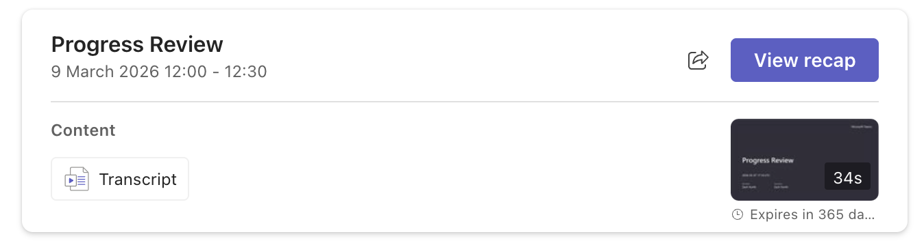
- Find and select the recording thumbnail.
- Select Transcript
- Save the transcript to your University issued device by selecting the download button:
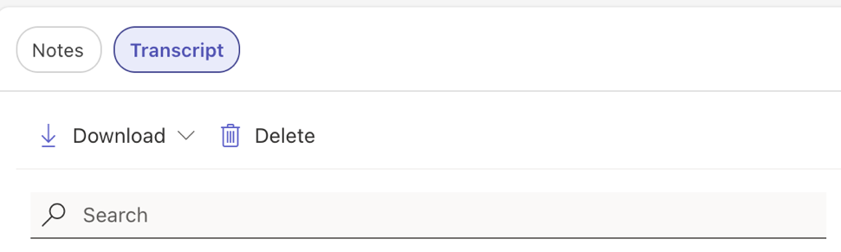

Step 3 – Upload the Transcript to the ANCHOR Framework
The transcript or meeting notes should be uploaded into the approved ANCHOR Framework within Microsoft Copilot. ANCHOR will then instruct Microsoft Copilot to structure the summary of the Progress Review transcript according to the University’s progress review expectations. To do this:
- Navigate to the ANCHOR Framework within Microsoft Copilot Select the Progress Review
- Select the + symbol and add work content
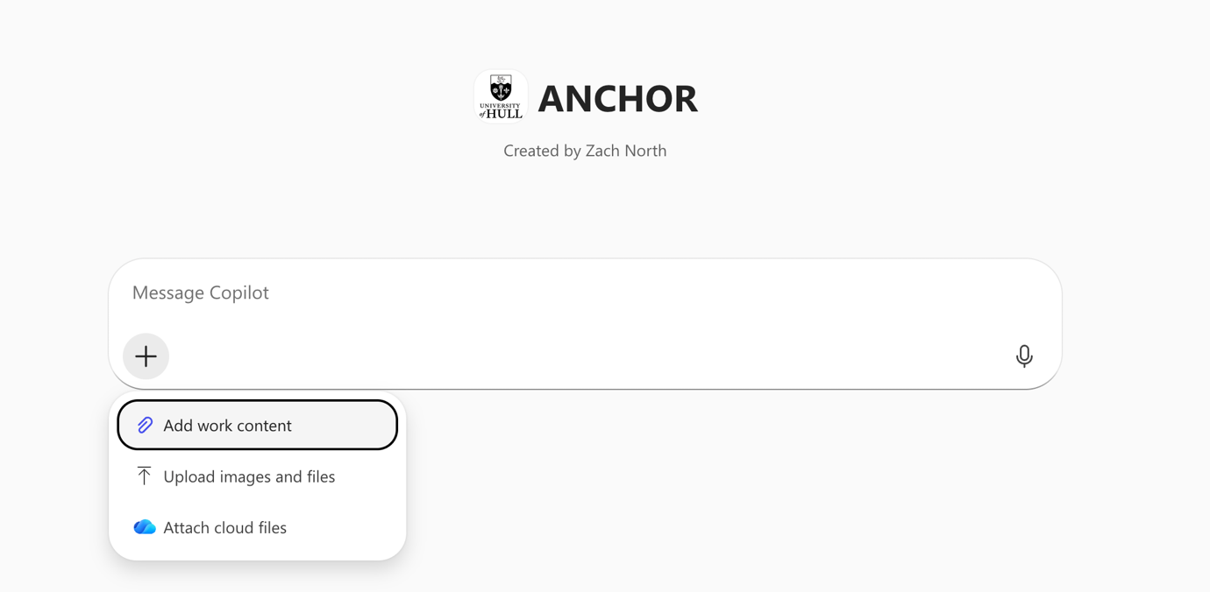
- Locate the Progress Review transcript on your device, and click the blue arrow button:
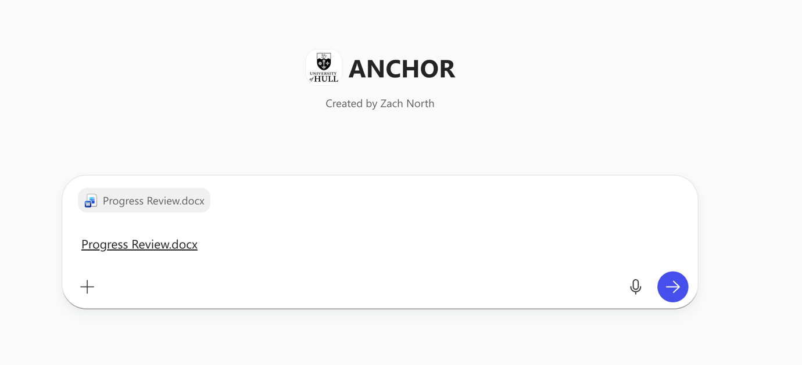
- Copilot will generate a structured draft summary of the meeting.
- The output should include sections relating to:
- progress since the last review
- academic and workplace development
- employer feedback
- theory to practice
- agreed goals and actions
Step 5 – Review and Edit the Draft
The Portfolio Tutor must review the generated summary carefully to ensure that:
- the summary accurately reflects the meeting discussion
- employer contributions are correctly represented
- apprentice voice is reflected where appropriate
- agreed SMART goals are clear and measurable
- any concerns relating to progression or wellbeing are recorded
The text should be edited where necessary to ensure it meets professional documentation standards.

Step 6 – Record the Final Summary in PebblePad
The final reviewed summary must be recorded in PebblePad in accordance with the requirements of the apprenticeship standard. Documentation must be completed:
- within two working days of the meeting, and
- no later than five working days following the review
Once the final review summary is saved to PebblePad, the transcript must be deleted from your University issued device.
  - Monitoring and Review of the ANCHOR Framework
The use of the ANCHOR framework will be monitored through the University’s AI Steering Group (AISG@hull.ac.uk) and the Faculty Apprenticeship Quality and Compliance Committee, reporting to the Apprenticeship Governance Board.
Monitoring may consider:
- consistency and clarity of progress review documentation
- accuracy of summaries generated using AI tools
- adherence to the principles outlined in this guide
- any data protection or governance considerations
Findings from monitoring activity will inform:
- staff development and training
- updates to institutional guidance
- continuous improvement of the progress review process.

ANNEX C – Monitoring and Enhancement of the Progress Reviews

Purpose and Principles
  - This Annex sets out the University of Hull’s approach to the systematic monitoring, quality assurance and continuous enhancement of apprenticeship Progress Reviews. It ensures that Progress Reviews are:
- compliant with Education and Skills Funding Agency (ESFA) requirements
- consistent and high quality across Faculties and programmes
- impactful in supporting apprentice progress, retention and achievement
- aligned to the Ofsted Education Inspection Framework (EIF)
  - Monitoring and enhancement of Progress Reviews are underpinned by the following principles:
- Consistency: apprentices receive a comparable experience regardless of programme or Faculty
- Quality and impact: reviews support progress against knowledge, skills and behaviours (KSBs) and planned learning
- Early intervention: risks to progression, engagement or wellbeing are identified and addressed promptly
- Continuous improvement: findings inform staff development and programme enhancement
- Proportionality: assurance activity is risk-based and improvement-focused, not compliance alone

Overview of the Assurance Model
  - The University operates a two-strand assurance model:
- Strand 1 – Monitoring: Focused on compliance, completion and timeliness
- Strand 2 – Quality Assurance: Focused on the quality, effectiveness and impact of Progress Reviews

Strand 1 – Monitoring of Compliance and Timeliness
  - Monitoring activity is risk-based and proportionate and does not involve routine review of every individual Progress Review record. The Central Apprenticeship Team, working with Faculty Apprenticeship Teams, must monitor:
- completion of Progress Reviews within the required 10–12 week cycle
- timeliness of documentation, ensuring records are completed within five working days
- identification of missed, overdue or incomplete Progress Reviews
  - Where issues are identified:
- missed or incomplete reviews must be escalated to the Programme Director
- persistent (more than 2) non-completion or disengagement must be managed through the Cause for Intervention process
- risks with potential funding, quality or compliance implications must be escalated to the Faculty Apprenticeship Quality and Compliance Committee (FAQCC)

Strand 2 – Quality Assurance of Progress Review Content
  - Formal quality assurance activity must take place bi-annually, normally in:
- Trimester 1
- Trimester 3
  - Quality assurance activity must include a cross-programme peer review of a sample of Progress Review records, considering:
- clarity and quality of SMART targets
- evidence of employer contribution
- alignment to apprenticeship standards and KSBs
- discussion of off-the-job training (planned versus delivered)
- identification and management of risk
- appropriateness of action planning and follow-up
Where Progress Reviews are recorded, a sample may also be reviewed to evaluate:
- quality of tripartite engagement
- effectiveness of questioning and challenge
- apprentice voice and ownership of progress
- employer feedback on workplace performance
- professional conduct and safeguarding awareness

Tools, Evidence and Records
  - Quality assurance activity relating to Progress Reviews must be undertaken using the approved Progress Review Quality Assurance Tool, delivered via Microsoft Forms. Completion of the tool constitutes the formal quality assurance record and captures evidence relating to:
- compliance with mandatory Progress Review requirements
- quality and effectiveness of tripartite engagement
- evidence of impact on apprentice progression and outcomes
- quality of documentation, action planning and follow-up
- identification and management of risk, including escalation
Data captured through the Quality Assurance Tool is recorded centrally and analysed to identify:
- effective practice
- common issues or risks
- staff development and training needs
- consistency of quality across programmes, Schools and Faculties

Reporting, Governance and Enhancement
  - Findings from monitoring and quality assurance activity must be reported to:
- Faculty Apprenticeship Quality and Compliance Committee (FAQCC)
- Faculty Student Education Committee (FSEC)
Reports should include:
- headline compliance data
- key strengths and areas for improvement
- risks and mitigation actions
- examples of effective practice
An aggregated institutional summary must be reported to the Apprenticeship Governance Board to provide assurance relating to:
- apprentice progress and experience
- employer engagement
- funding and regulatory compliance
- readiness for external inspection or audit

