Support, Progression and Achievement in Apprenticeships and Apprenticeship Units
Classification | Code of Practice
Version number: | 1
Status | Approved
Approved by: | Education Committee
Approval date: | 21 July 2026
Effective from: | 01 September 2026
Next review date: | 30-202
Document author: | Zach North (Director of Apprenticeships)
Document owner: | Zach North (Director of Apprenticeships)
Contact: | Academic Quality and Standards
Collaborative provision: | Mandatory
State whether this document is applicable to the University’s collaborative partners
Related documents: | -
University document: | Yes
A University document applies across the institution, is approved by a committee of Council or Senate and is held in the University Policy Directory on SharePoint.
Published location: | https://www.hull.ac.uk/policies-and-information/quality-and-standards-framework

- The University has adopted the principles of Designing for Diverse Learners, and all policy documents should be written with reference to these principles. Further information is available at the Designing for diverse learners website.
- An Equality Impact Assessment (EIA) must be considered for all new and amended policies. Further information is available from the EIA section of SharePoint.
- This document is available in alternative formats from policy@hull.ac.uk.
- All printed or downloaded versions of this document are classified as uncontrolled
Support, Progression and Achievement in Apprenticeships
Table of Contents
1 Introduction 3
2 Purpose 3
3 Scope 4
4 Regulatory and Inspection Context 4
5 Principles of Support, Inclusion and Proportionality 5
6 Tiered Support Framework 6
7 Level 1 – Triage, Early Monitoring and Inclusive Support 7
8 Level 2 – Formal University Support 8
9 Level 3 – Critical Intervention and Tripartite Escalation 9
10 Support, Progression and Achievement Group (SPAG) 10
11 Documentation, Record-Keeping and Data Protection 12
12 Monitoring, Review and Continuous Improvement 12
13 Annex 1 – Support, Progression and Achievement Record 14
14 Annex 4 – Support, Progression and Achievement Group Process Map 18
15 Version control 19

Support, Progression and Achievement in Apprenticeships

Introduction
  - The University of Hull delivers apprenticeship provision within a regulated and inspected environment. Apprenticeships are founded on a tripartite partnership between the Apprentice, the Employer and the University. The University is committed to ensuring that this partnership supports high-quality education and training, enables meaningful progress from starting points, and secures successful achievement of occupational competence and End Point Assessment.
  - This Code of Practice sets out the University’s structured approach to safeguarding apprentice support, progression and achievement. It establishes a graduated and proportionate framework through which emerging concerns are identified early, appropriate support is implemented, and escalation occurs where necessary to protect learner outcomes, funding compliance and contractual integrity.
  - The University recognises that effective support and progression arrangements are central to inspection frameworks and regulatory expectations. External scrutiny evaluates not only the existence of policy, but how effectively leaders know their learners, identify those at risk, monitor the progress of disadvantaged apprentices, and intervene to secure improvement. This Code therefore emphasises impact, accountability and evidence-based decision-making.
  - This Code forms part of the University’s wider apprenticeship quality assurance framework and operates alongside related Codes of Practice. All staff engaged in apprenticeship and apprenticeship unit delivery and oversight must be familiar with, and operate in accordance with, this Code of Practice.

Purpose
  - The purpose of this Code of Practice is to establish a clear, consistent and proportionate framework for identifying, monitoring and responding to risks that may affect an apprentice’s support, progression or achievement.
  - This Code is designed to ensure that the University:
- identifies emerging concerns at the earliest opportunity;
- implements timely and appropriate support interventions;
- monitors the progress of apprentices, including those with declared disabilities, additional learning needs or other disadvantage;
- applies graduated escalation where required;
- engages employers at appropriate thresholds within the tripartite model;
- protects compliance with funding, contractual and regulatory requirements;
- secures successful apprentice completion and occupational competence.
  - The Code provides clarity regarding roles, responsibilities and decision-making authority at programme, faculty and institutional level. It ensures that intervention is evidence-based, documented and subject to appropriate governance oversight.
  - The primary purpose of this Code is not disciplinary in nature. Its central objective is to protect learner success and achievement through structured, supportive and inclusive processes. Escalation and contractual action are applied only where necessary, proportionate and justified by risk.
  - Activity undertaken under this Code must inform institutional self-assessment, quality improvement planning and governance reporting, ensuring that leaders maintain an accurate and current understanding of apprentice progress and risk across the portfolio.

Scope
  - This Code of Practice applies to all degree apprenticeships and apprenticeship units delivered by the University of Hull, whether delivered directly or through collaborative or subcontracted arrangements.
  - The Code applies to all apprentices enrolled on apprenticeship programmes from the point of enrolment through to completion, End Point Assessment or formal withdrawal.
  - The provisions of this Code apply to all Faculties, academic units and professional service teams engaged in the delivery, oversight or governance of apprenticeship provision.
  - This Code governs concerns relating to apprentice support, engagement, progression, achievement and funding compliance. It does not replace or supersede other University policies where specific procedures apply. Where appropriate, this Code operates alongside, and in conjunction with:
• Fitness to Practise procedures;
• Academic Misconduct regulations;
• Student Complaints procedures;
• Break in Learning processes;
• Safeguarding and Prevent procedures;
• Apprenticeship contractual documentation.
  - Where matters fall within the remit of another formal University procedure, that procedure must take precedence. However, where such matters have implications for funding and compliance, they must also be considered separate from the remit of other codes of practice.
  - Application of this Code must be proportionate and risk based. The level of monitoring and intervention will reflect the nature and severity of identified concerns, with escalation applied in a graduated manner.

Regulatory and Inspection Context
  - Apprenticeships and Apprenticeship Units delivered by the University of Hull are subject to external regulation, funding requirements and inspection. This includes inspection under the Ofsted Further Education and Skills inspection framework, which evaluates the quality and impact of education and training.
  - This Code of Practice is aligned to relevant regulatory and inspection frameworks, including:
- the Ofsted Further Education and Skills inspection framework and associated handbooks;
- funding and compliance requirements set by the Department for Education (DoE) and other relevant government bodies
- contractual requirements governing apprenticeships and apprenticeship units.
- the Equality Act 2010 and the Public Sector Equality Duty.
  - External inspection and regulatory activity evaluate not only the existence of policies and processes, but how effectively they are implemented, monitored and used to secure improvement. As such, activity undertaken under this Code focuses on the impact of support and intervention on learner progress, engagement and achievement, rather than procedural compliance alone.
  - Leaders must maintain an accurate and current understanding of learner progress, including the progress of disadvantaged learners and those with additional needs. This includes ensuring that:
- learners are identified early where support is required;
- reasonable adjustments are implemented effectively;
- barriers to learning are understood and addressed;
- intervention is timely, proportionate and impactful.
  - This Code adopts inspection-recognised principles of intent, implementation and impact. The emphasis throughout remains on ensuring that support arrangements are well designed, consistently applied and demonstrably effective in enabling learners to progress and achieve.

Principles of Support, Inclusion and Proportionality
  - The University adopts a graduated, supportive and inclusive approach to safeguarding learner progression and achievement. Intervention under this Code is underpinned by the principle that concerns should be identified early and addressed at the lowest appropriate level before escalation is considered.
  - All activity undertaken under this Code must be learner-centered, with a primary focus on enabling apprentices and and learners to succeed, progress and achieve their intended outcomes.
  - Support and intervention must be applied in a proportionate and risk-based manner. The level of response will reflect the nature, severity and persistence of the concern, with escalation applied only where necessary and justified.
  - The University is committed to ensuring equitable outcomes for all learners. Particular consideration must be given to learners who:
- have declared disabilities or additional learning needs;
- require reasonable adjustments;
- are identified as disadvantaged;
- present with wellbeing or safeguarding concerns.
In all cases, staff must ensure that barriers to learning are understood and that appropriate and reasonable support is implemented and reviewed.
  - Prior to escalation to the highest level of support, the University must be satisfied that:
- appropriate support strategies have been implemented;
- reasonable adjustments have been considered and, where appropriate, applied
- the learner has been given sufficient opportunity to respond to support and intervention.
  - The University recognises that effective apprenticeship provision relies on the strength of the tripartite relationship. Employer involvement is therefore introduced at the appropriate stage within the escalation process, ensuring that engagement is timely, purposeful and proportionate to the level of risk.
  - All decisions made under this Code must be:
- evidence-based;
- clearly documented;
- consistent across programmes and Faculties;
- subject to appropriate governance oversight.
  - The University is committed to a culture of continuous improvement. Patterns, trends and outcomes identified through the application of this Code must inform self-assessment, quality improvement planning and leadership decision-making.

Tiered Support Framework
  - The University operates a structured, tiered framework to support learner progression and achievement. This framework enables concerns to be identified early, addressed through appropriate levels of support, and escalated in a proportionate and transparent manner where necessary.
  - The framework consists of three defined levels of intervention:
Level 1 – Triage, Early Monitoring and Inclusive Support: Focused on early identification, initial review, inclusive monitoring and preventative intervention.
Level 2 – Formal University Support: Focused on structured, university-led intervention where concerns persist or increase in severity.
Level 3 – Critical Intervention and Tripartite Escalation: Focused on significant risk to progression, achievement, funding compliance or contractual obligations, requiring employer involvement and formal oversight.
  - Learners should enter the framework at Level 1, either through identification of emerging concerns or through recognised additional support needs, including those relating to disability, reasonable adjustments or other disadvantage.
  - In some exceptional cases, learners may be highlighted as requiring a critical intervention, in this case the referral will be directed urgently to the Chairs of SPAG for urgent consideration.
  - Movement between levels must be based on evidence and professional judgement, taking account of:
- the nature and severity of the concern;
- the learner’s response to previous support and intervention;
- the impact on progression, achievement or funding compliance;
- any relevant contextual factors, including reasonable adjustments or safeguarding considerations.
  - Escalation between levels is not automatic and must be justified by risk. Where appropriate, learners may remain within a level while support is reviewed and strengthened or may be de-escalated where improvement is demonstrated.
  - De-escalation must be considered where:
- agreed actions have been successfully completed;
- the learner demonstrates sustained improvement;
- identified risks to progression or compliance have been mitigated.
  - At all stages, the University must ensure that intervention is timely, proportionate and focused on securing positive outcomes for the learner.
  - The Support, Progression and Achievement Group (SPAG) provides institutional oversight of the tiered framework. SPAG monitors learners at all levels.
  - All activity undertaken within the tiered framework must be clearly documented and recorded to ensure transparency, consistency and effective governance oversight.

Level 1 – Triage, Early Monitoring and Inclusive Support
  - Level 1 is the entry point to the tiered support framework and functions as the triage stage for all identified concerns, risks and additional support needs.
  - The purpose of Level 1 is to ensure that concerns are identified at the earliest opportunity, reviewed in a timely manner, and responded to through appropriate and proportionate support. This includes determining whether the learner can be supported within Level 1, requires escalation to Level 2, or can be de-escalated from the framework.
  - Level 1 applies where there are emerging concerns relating to learner engagement, participation, progress or achievement, or where a learner is identified as requiring additional monitoring or support in order to succeed.
  - Level 1 may include, but is not limited to:
- early attendance or engagement concerns
- initial missed submissions or incomplete learning activity
- emerging concerns regarding academic progress
- the need for additional academic or pastoral support
- declared disability or additional learning need
- the implementation or review of reasonable adjustments
- additional considerations
- safeguarding or wellbeing concerns requiring monitoring
- identification of disadvantage or barriers to learning.
  - Entry to Level is through completion of the Support, Progression and Achievement in Apprenticeships and Skills Based Learning – Fill out form, it is not disciplinary in nature. Its purpose is to ensure that emerging concerns and support needs are recognised and addressed through early, supportive and inclusive intervention.
  - At Level 1, the relevant staff must ensure that:
- the concern or support need is identified and recorded in progress reviews
- the learner is informed of the concern and engaged in the process
- appropriate support, guidance or intervention is offered
- reasonable adjustments and additional support needs are considered and reviewed where relevant
- clear actions are agreed, where appropriate
- the learner’s progress is reviewed within an appropriate timeframe.
  - For apprentices, Level 1 activity should normally be discussed and recorded through established mechanisms, including Progress Reviews where appropriate. For Apprenticeship Unit learners, Level 1 activity must be recorded through the agreed programme-level support and monitoring arrangements.
  - Following review at Level 1, outcomes may include:
- no further action, where the concern has been resolved;
- continued monitoring and support at Level 1;
- Referral to University support services (academic, mental health, occupational health etc)
- escalation to Level 2 where concerns persist, intensify, or present a greater risk to progression, achievement or compliance.
  - SPAG reviews learners at Level 1 as part of its oversight of the tiered support framework, ensuring that early intervention is timely, appropriate and consistently applied, and that patterns relating to disadvantage, reasonable adjustments and learner risk are identified and addressed.

Level 2 – Formal University Support
  - Level 2 represents a formal stage of university-led intervention where concerns identified at Level 1 have not been resolved, or where the nature of the concern requires structured monitoring and support.
  - The purpose of Level 2 is to implement a clear and coordinated support plan to enable the learner to re-engage, progress and achieve, while maintaining appropriate oversight of risk.
  - A learner may be escalated to Level 2 where there is evidence of:
- failure to respond to or engage with Level 1 support;
- repeated or persistent non-attendance or disengagement;
- ongoing concerns regarding academic progress or achievement;
- emerging risk to timely progression or planned end date;
- concerns regarding professional behaviours or conduct (non-critical);
- developing risk to funding compliance, including off-the-job training requirements (for apprentices);
- failure to meet agreed targets or actions set through Progress Reviews or equivalent processes.
  - At Level 2, a formal support process must be initiated. This may include:
- completion of the approved Support, Progression and Achievement (Annex 1) documentation;
- the development of a structured Academic Support Plan (Annex 2), including clear, measurable actions;
- defined timescales for review and expected improvement;
- clear communication with the learner regarding expectations and consequences of non-engagement.
  - At this stage, intervention remains university led. Employer involvement is not routinely required but may be considered where appropriate to support the learner’s progress.
  - Where the learner has identified additional needs, staff must ensure that:
- reasonable adjustments are reviewed and remain appropriate;
- barriers to learning are clearly understood;
- additional or specialist support has been considered or implemented where required.
  - Level 2 cases must be subject to named review through the Support, Progression and Achievement Group (SPAG), which will:
- monitor progress against agreed actions;
- ensure that intervention is appropriate and proportionate;
- provide oversight and challenge where required;
- determine whether escalation, continuation at Level 2, or de-escalation is appropriate.
  - Learners should normally be given a defined period in which to demonstrate improvement. Where sufficient progress is made, the learner may be de-escalated to Level 1. Where concerns persist or intensify, escalation to Level 3 must be considered.
  - All actions, decisions and outcomes at Level 2 must be clearly documented to ensure transparency, consistency and effective governance oversight.

Level 3 – Critical Intervention and Tripartite Escalation
  - Level 3 represents the highest level of intervention within the tiered framework and is applied where there is a significant and sustained risk to learner progression, achievement, funding compliance or contractual obligations.
  - At Level 3, ongoing review of the learner’s progress must be undertaken through regular University and employer review meetings for apprenticeship provision. The frequency of these meetings must be proportionate to the level of risk and sufficient to ensure timely monitoring, intervention and review of agreed actions.
  - A learner may be escalated to Level 3 where there is evidence of:
- failure to respond to or comply with Level 2 support plans;
- significant or sustained non-engagement;
- serious concerns regarding professional behaviours, conduct or fitness to practise.
- academic misconduct or other serious breach of university regulations.
- suspension from employment or workplace investigation (for apprentices).
- significant risk to funding compliance, including failure to meet off-the-job training requirements (for apprentices) or progress review compliance.
- risk to timely completion, apprenticeship assessment readiness or programme integrity.
- breakdown in the tripartite relationship.
  - An Academic Support Plan (Annex 2) and Notice of Concern / Warning Letter must be issued, which clearly sets out:
- the nature and severity of the concern;
- actions required by the learner and, where appropriate, the employer;
- defined timescales for resolution;
- the potential consequences of failure to achieve the required improvement.
  - All Level 3 cases must be subject to formal review by the Support, Progression and Achievement Group (SPAG), which will:
- review the evidence and context of the case;
- ensure that intervention is appropriate, proportionate and consistent;
- confirm that all reasonable support measures have been implemented;
- determine the appropriate outcome, including continuation, de-escalation, break in learning or escalation to contractual action.
  - Prior to any recommendation relating to withdrawal, termination or break in learning, SPAG should be satisfied that:
- reasonable adjustments have been appropriately considered and implemented where required;
- the learner has been provided with sufficient opportunity to engage with support;
- any relevant safeguarding, wellbeing or contextual factors have been taken into account;
- decisions are evidence-based and proportionate to the level of risk.
  - Learners should normally be given a defined period in which to demonstrate improvement. Where sufficient progress is made, the learner may be de-escalated to Level 2. Where concerns remain unresolved, further action may be taken in line with contractual and regulatory requirements.
  - Outcomes at Level 3 may include:
- continuation at Level 3 with enhanced monitoring.
- de-escalation to Level 2;
- recommendation of a Break in Learning.
- recommendation of withdrawal or termination in line with contractual arrangements.
  - All actions, decisions and outcomes at Level 3 must be clearly documented to ensure transparency, consistency and effective governance oversight.

Support, Progression and Achievement Group (SPAG)
  - The University operates a Support, Progression and Achievement Group (SPAG) to provide institutional oversight of learner support, progression and achievement across apprenticeship and apprenticeship unit provision.
  - SPAG is responsible for ensuring that the tiered support framework is applied consistently, proportionately and effectively across Faculties and programmes, and that risks to learner progression, achievement and compliance are identified and addressed in a timely manner.
  - SPAG will meet on a scheduled basis, normally bi-monthly, to ensure regular and structured oversight of learner progress and risk.
  - SPAG is jointly chaired by:
- the Director of Apprenticeships of the relevant Faculty / Academic Unit
- the Head of Apprenticeships (Funding and Compliance).
  - Membership of SPAG will must include:
- Programme Apprenticeship Leads or nominees
- representatives from Apprenticeship Funding and Compliance
- Quality and/or Academic Governance representatives

  - Additional membership of SPAG may include:
- Programme Directors, Portfolio Tutors or Personal Supervisors, as required for case discussion
  - SPAG is responsible for reviewing learners at all levels of the tiered support framework. The depth and format of review will vary according to the level of intervention, but all learners within the framework must be subject to oversight.
  - At Level 1, SPAG undertakes a triage function, reviewing learners to:
- confirm that concerns have been appropriately identified and recorded;
- ensure that early, proportionate and inclusive support has been implemented;
- determine whether learners should remain at Level 1, be de-escalated from the framework, or be escalated to Level 2.
  - At Level 2, SPAG undertakes a structured review of learners to:
- monitor progress against agreed support plans;
- ensure that intervention is appropriate, proportionate and effective;
- provide oversight and challenge where required;
- determine whether continuation at Level 2, escalation to Level 3, or de-escalation is appropriate.
  - At Level 3, SPAG undertakes formal review in partnership with the employer for apprenticeship provision, supporting joint consideration and decision-making. This includes:
- reviewing the evidence and context of the case
- ensuring that all reasonable support measures have been implemented
- confirming that intervention is proportionate and consistent
- working with the employer to determine appropriate outcomes, including continuation, de-escalation, break in learning or progression to contractual or regulatory processes.
  - In all cases, SPAG must ensure that decisions relating to learner progression, escalation and outcome are:
- evidence-based
- clearly documented
- consistent across programmes and Faculties
- mindful of equality, inclusion and reasonable adjustment requirements.
  - SPAG is responsible for identifying patterns, trends and systemic risks across the provision, including the progress and outcomes of disadvantaged learners and those requiring reasonable adjustments.
  - SPAG provides assurance through reporting to appropriate governance structures, including Faculty-level quality committees and institutional apprenticeship governance boards. Reporting must include:
- key themes, risks and trends
- actions taken and outcomes achieved
- areas requiring further monitoring or escalation.
  - SPAG contributes to the University’s wider quality assurance and improvement arrangements. Findings from SPAG activity must inform:
- self-assessment processes
- Quality Improvement Plans
- leadership decision-making and resource allocation.

Documentation, Record-Keeping and Data Protection
  - All activity undertaken within the tiered support framework must be clearly documented to ensure transparency, consistency and effective governance oversight.
  - Records must provide a clear and accurate account of:
- the nature of the concern or identified support need;
- actions agreed with the learner (and employer where applicable);
- progress against agreed actions;
- decisions relating to escalation, continuation or de-escalation;
- outcomes of review at each level of the framework.
  - Documentation must be completed using approved University systems and templates outlined in the Annexes of this Code of Practice.
  - For apprenticeship provision, documentation should align with existing processes, including Progress Review records, to ensure a consistent and coherent record of learner progress, support and intervention.
  - For apprenticeship units, documentation must be recorded in line with agreed programme-level processes and systems, ensuring that learner support and progression are appropriately evidenced.
  - All documentation must be completed in a timely manner. Records should normally be updated as soon as practicable following any review, meeting or decision, and must be sufficiently current to support effective monitoring and oversight.
  - Records must be clear, factual and professional, and must reflect an evidence-based approach to decision-making. Documentation should demonstrate that intervention has been appropriate, proportionate and aligned to this Code of Practice.
  - All personal data must be processed in accordance with the General Data Protection Regulation (GDPR) and the University’s Data Protection policies. Staff must ensure that:
- confidentiality is maintained;
- information is shared appropriately and only where necessary;
- sensitive information is handled in line with University guidance.
  - Where meetings or discussions are recorded, appropriate consent must be obtained

Monitoring, Review and Continuous Improvement
  - The University is committed to the continuous improvement of learner support, progression and achievement across apprenticeship and apprenticeship unit.
  - The effectiveness of this Code of Practice, and the application of the tiered support framework, must be subject to regular monitoring and review to ensure that it is implemented consistently, proportionately and in line with regulatory and inspection requirements.
  - Monitoring activity must be undertaken through the Support, Progression and Achievement Group (SPAG) and appropriate governance structures, providing oversight of learner progress, intervention and outcomes across all levels of the framework.
  - This Code of Practice must be reviewed annually to ensure that it remains effective, proportionate and aligned to regulatory, funding and inspection requirements. Any revisions must be approved through the appropriate University governance processes.
  - The University will ensure that staff involved in apprenticeship and apprenticeship unit delivery and oversight are supported to understand and apply this Code effectively, including through appropriate training, guidance and ongoing development.

Annex 1 – Support, Progression and Achievement Record

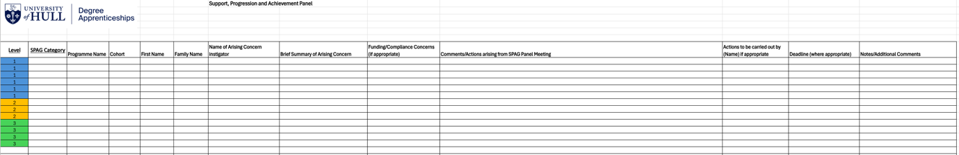
Annex 2 – Academic Support Plan

Academic Support Plan

Student Name:
Student Number:
Personal Supervisor:

Reason for academic support plan:
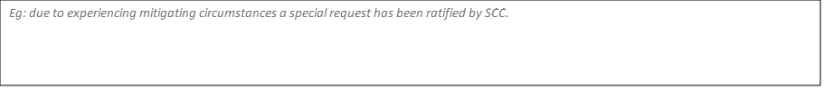

Goal of Academic support plan – include assessment details & deadlines

Goal: eg completion of outstanding level 4 modules to allow progression to level 5

Module number | Assessment Details | Deadline date
Eg 1234 contemporary fiction | 2000 essay | 31st august

Additional support needs

Identified need | Identified action | responsibility
Eg mental health issues  Issues with referencing technique | -referral to mental health support team  Book into study skills workshop by x date | Supervisor  student

Weekly/Monthly plan
date | actions | date | Actions
Eg. 1.1.21 | Complete research & detailed essay plan for contemporary fiction  Book referencing workshop

Progress monitoring

Date | action | Date
eg | Student to provide completed plan via email -PS will provide feedback by x date

I agree that I have been given the opportunity to collaborate in the creation of this plan and agree to endeavour to follow it to the best of my ability.

Student:

I agree to provide the support as outlined in the above plan. If I have further concerned regarding progression, I will discuss this with (Student) and may also discuss with …………

Personal supervisor:

Identity any other parties with whom this plan should be shared:

Within the faculty | Outside of the faculty
Eg: Head of programme | Eg: Disability inclusion team

Guidance notes

The aim of this support plan is to ensure, where a student has been identified as experiencing significant barriers to progression, that a clear and realistic plan of academic support has been collaboratively agreed between the student, the personal supervisor, and any other involved stakeholders. The rationale behind the creation of this document is that it has been identified that a large volume of special cases are being sent through to SCC without due consideration being given to a realistic and achievable plan for the student to achieve the requested outcomes. The resulting burden of assessment without appropriate planning and support has significant impact on retention and also on the welfare of the students involved.

Reason for academic support plan. In collaboration with the student, identify and document what led the student to requiring additional support . Identify the barriers to progression, any mitigating factors and also strengths and resources available to aid progression. Please also note if the student has reasonable adjustments in place and/or a declared disability or learning need

Goal of academic support plan - Clearly document and identify ALL of the tasks/assessments which need to be completed in order to ensure progression.

Additional support needs – identify any additional needs, for example health and wellbeing-based or study skills needs and agree responsibility for actions. It is important for the student to take the responsibility to address identified actions where appropriate.

Weekly plan – set weekly tasks/goals in collaboration with the student and consider how progression will be monitored. This may involve the student seeking input from other academic staff and the student should take the responsibility to do this. Student should also take responsibility for ensuring the planned tasks are realistically achievable given their personal circumstances and that they are able to plan and manage their time to achieve each week’s task.

Progress monitoring – agree dates for monitoring progress. This might be in the form of a face-to-face meeting, an email of a draft or evidence of attendance at a workshop for example. Progression monitoring should provide adequate time to address issues should they arise.

Both student and personal supervisor should sign to agree that the plan has been developed collaboratively and any concerns addressed. Personal supervisor should also make the student aware what steps they will take should progress be deemed unsatisfactory. The plan should be shared within the faculty as deemed appropriate by the personal supervisor and following faculty/department policy and process. Please note; If the plan has been requested as part of an SCC case, the committee may ask to see a copy before accepting any requests.

If the student is currently in receipt of non-academic support from student services, please share a copy of this plan with them.
Mental health team – mentalhealthsupport@hull.ac.uk
Learning support Team – spld@hull.ac.uk
Disability Inclusion Team - Disabilitysupport@hull.ac.uk
Student life team – Studentlife@hull.ac.uk

If the student discloses financial issues or requires impartial advice regarding academic options, please signpost to HUU advice centre - huu-advice-centre@hull.ac.uk

Annex 4 – Support, Progression and Achievement Group Process Map
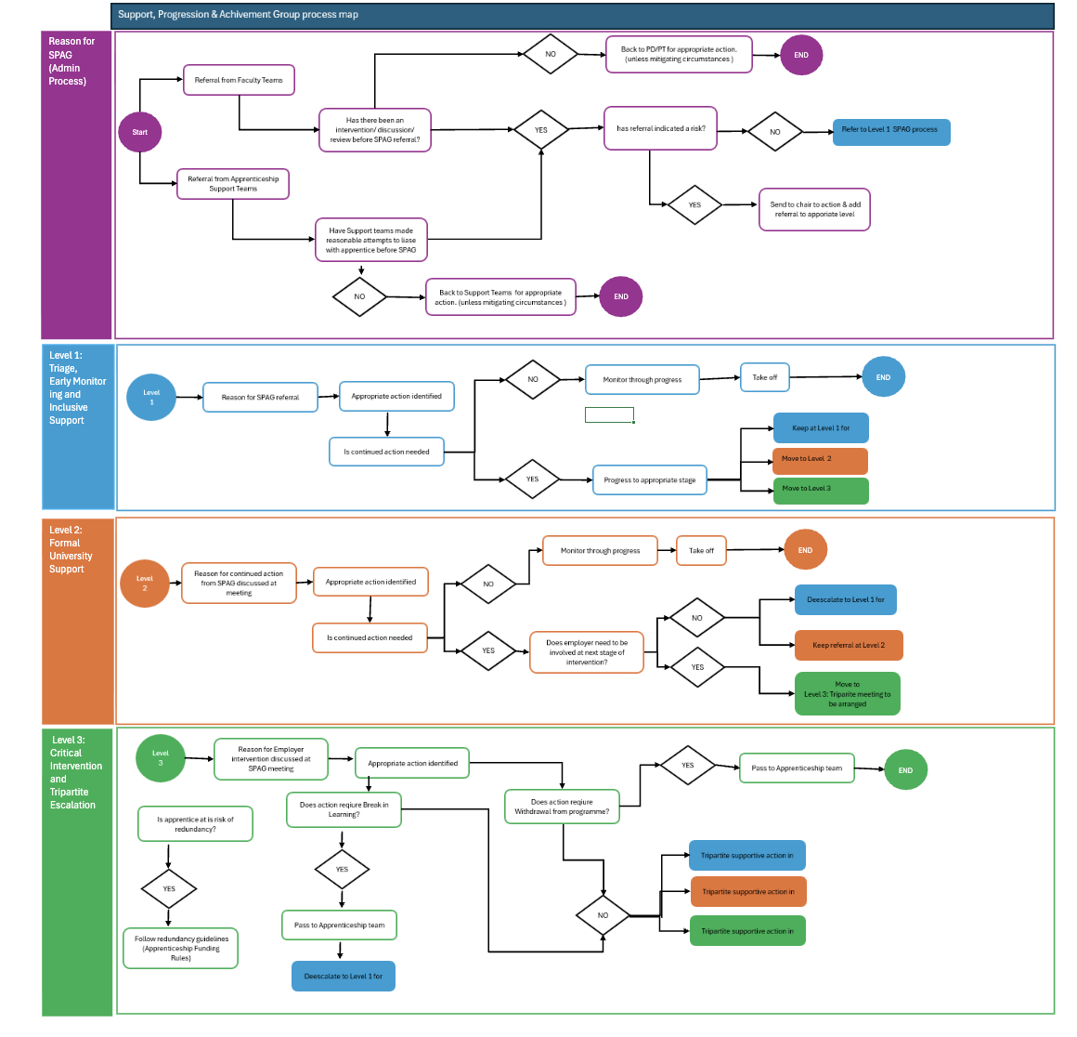

Version control
Version | Author | Date approved | Relevant sections
1.0 | Director of Apprenticeships | 21 July 2026 | New

