Standard Operating Procedure

Making a DBS Referral as part of a Fitness to Practise Process

Introduction

Purpose
The purpose of this document is to set out the procedure to be followed when a referral must be made to the Disclosure and Barring Service (DBS) as one outcome of a Fitness to Practise process.
It aims to set out clearly the role and responsibilities of those involved in the DBS referral.

Scope
This procedure should be used only when a referral must be made to the DBS as one outcome of a Fitness to Practise process. This procedure does not apply to referrals to the DBS as a result of other processes of the University of Hull (for example as a result of a Student Misconduct process).

Related Documents
This document should be read in conjunction with the University of Hull’s Investigation and Determination of Concerns about Fitness to Practise regulations.

Responsibilities
Submitting a referral is an online task and takes about an hour. The task should be completed by the relevant Professional Lead academic i.e. the Professional Lead for the programme which the student participated in at the time of their fitness to practise case.

Procedure
Context
Referrals should be made to DBS when an employer or organisation believes a person has caused harm or poses a future risk of harm to vulnerable groups, including children.
The University has a legal obligation to refer to the DBS and failure to do so may result in an institutional fine of £5,000.
Further guidance is provided at: https://www.gov.uk/guidance/making-barring-referrals-to-the-dbs#who-has-a-legal-duty-to-refer
Completing the online form
The online form cannot be partially completed, saved and re-opened. It must be completed in one session. If you move away from the form or you do not add any information for 90 minutes, your session will end, your answers will not be saved, and you will need to start the referral again.
The online form has 9 sections to complete plus a final section allowing a review of the information given and submission as shown below in Fig 1.

Fig.1
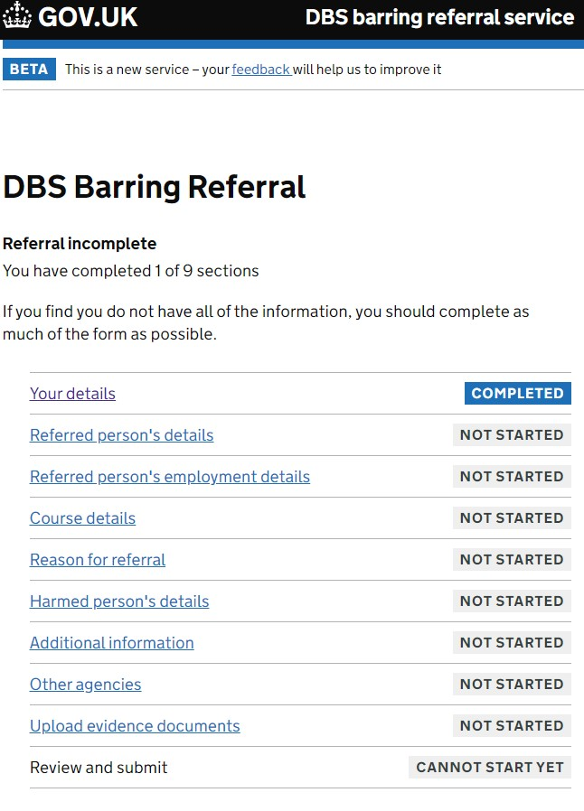

When preparing to complete the form – you’ll need:
- your contact details
- details of the person being referred (including their name, address, date of birth and national insurance number)
- contact details for any other agencies involved in investigating the relevant conduct
- details of the risk of harm or harm suffered (where this is not possible a University Referral will often note instead that the referral is… ‘a result of the outcome of a Fitness to Practise process’.
- documents in support of your referral (for example, statements, reports, meeting minutes and other evidence)
If you find you do not have all the information sought, you should complete as much of the form as possible.
You are allowed to provide this information under UK General Data Protection Regulation (UK GDPR) and the Data Protection Act (DPA). For more information see: DBS referral guide: data protection and security - GOV.UK (www.gov.uk)

The ‘Your Details’ Section
(See also Annex 1: Section 1 Screenshots).
The ‘Your Details’ section has 10 sub-sections which are:
- What type of referrer are you? Select: ‘Educational Training provider (for individuals on placement)’
- What is your name? Add your name.
- What is your role or job title? Add your role (e.g. Professional Lead for xx)
- What sector do you work in? Select: Education (Independent) and for the subsector: Teacher Further Education.
- What is the name of your organization? Add: University of Hull.
- Find your organization’s address. Add the University postcode of HU6 7RX and click ‘Look up address’ which will populate the box below with University of Hull, Cottingham Road
- What telephone numbers can you be contacted on? Add your work number.
- What is your email address? Add your email address. Note: this must not be a shared email address.
- What is your professional or working relationship with the person that you are referring? Add summary details to explain.
- DBS Barring Referral. This is a summary of the sections of the form (which shows you that you have completed section 1 (Your Details) and gives you the opportunity to complete the remaining 8 sections of the form, then review the information provided and submit.

- Response from the DBS
Upon submission of a completed form, you will get a confirmation email from the DBS with:
- a Referral Reference Number (see Annex 2 – example of confirmation email)
- an attached Summary Report, holding the details of your submission (see Annex 3 – example of Summary Report)
You may also receive an email from the DBS asking for more information.

- Sharing the Referral Reference Number
You must share the Referral Reference Number and Summary Report with the University Student Conduct and Complaints team at: conductandcomplaints@hull.ac.uk
You should also:
- email the relevant Faculty Curriculum Team manager to alert them to the DBS referral and to give them the Referral Reference Number;
- email LADO if appropriate to confirm the DBS referral and to give them the Referral Reference Number.

- Additional advice
Additional advice may be sought from the DBS Regional Adviser for Yorkshire and Humber.

Summary
- The University has a legal obligation to inform the DBS when a student on a University of Hull programme is found, as an outcome of a Fitness to Practise process, to have caused harm or pose a risk of harm, fulfils the harm test, has received a caution or conviction for a relevant offence, has or might in future wok in regulated activity. Failure to do so may result in an institutional fine of £5,000.
- A referral is submitted online, see: Barring Referral Service - GOV.UK (submit-a-barring-referral.service.gov.uk). Completing the online form will take around 1 hour and all sections must be completed in one session.
- Upon submission of a completed form, you will get a confirmation email from the DBS with i) a Summary Report recording the details of your submission and ii) a Referral Reference Number. You may also receive an email from the DBS asking for more information.
- You must share the Referral Reference Number and the Summary Report with the University Student Conduct and Complaints team at conductandcomplaints@hull.ac.uk
- You should also i) email the relevant Faculty Curriculum Team manager to alert them to the DBS referral and to give them the Referral Reference Number, ii) email LADO if appropriate to confirm the DBS referral and to give them the Referral Reference Number.

Version Control
Version 1.2. Created on 21/07/25. Originator: Process Improvement Team, Academic Services.
Annex 1: Section 1 of the online DBS Referral Form - screenshots

Question 1
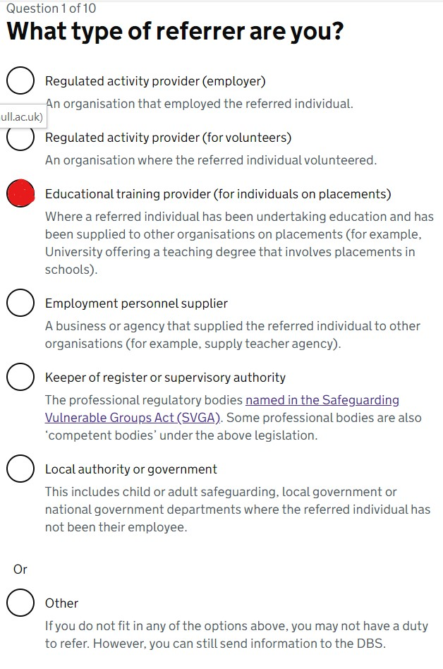
Question 2
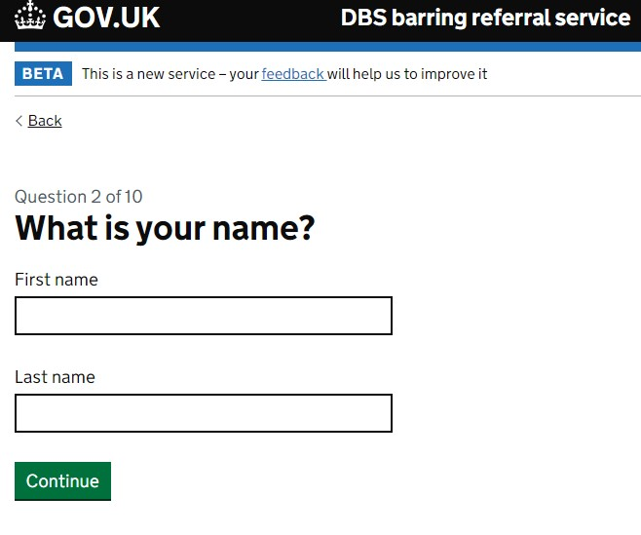
Question 3
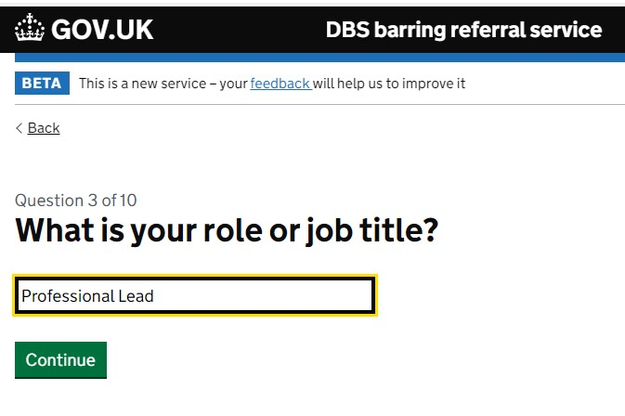
Question 4a
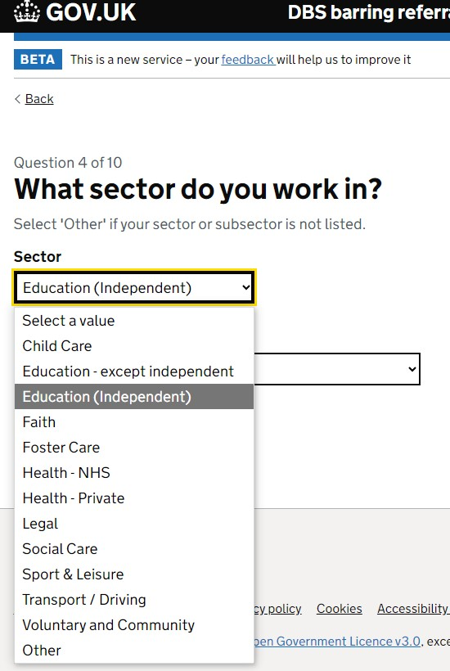
Question 4b
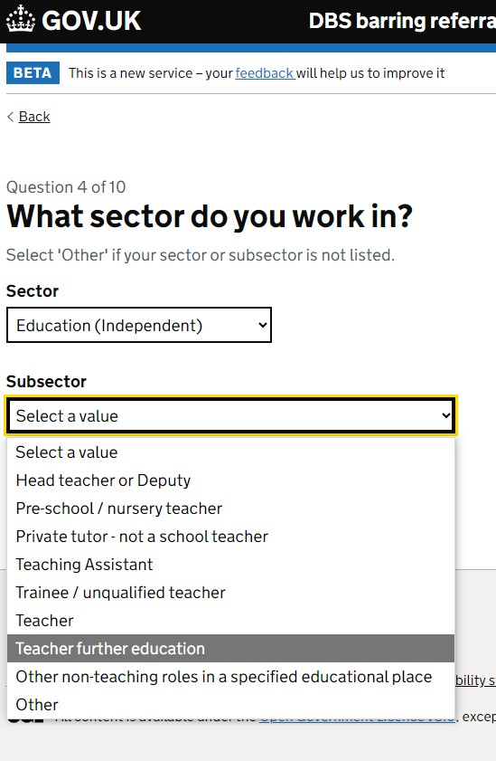
Question 5
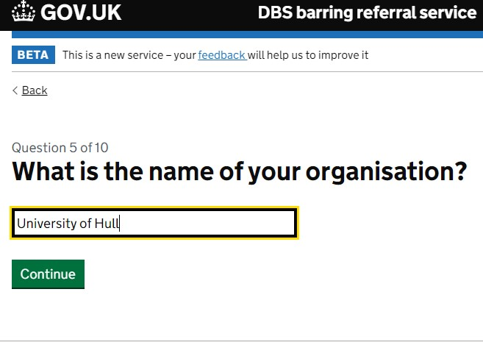
Question 6
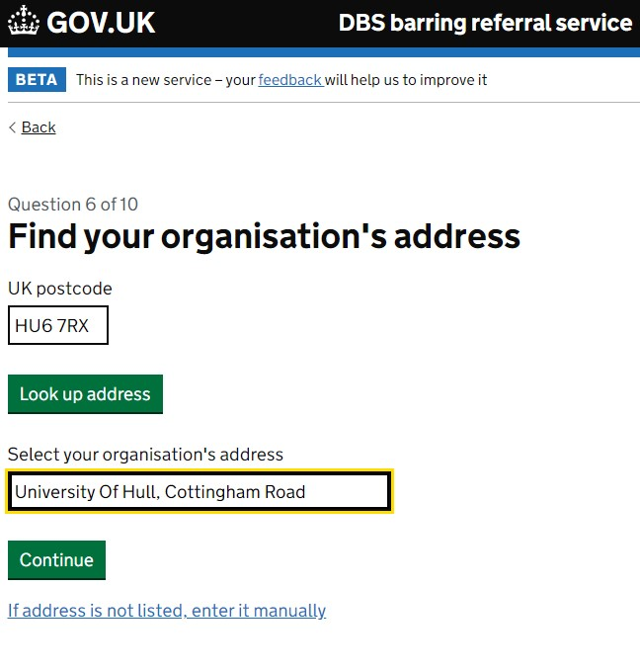
Question 7
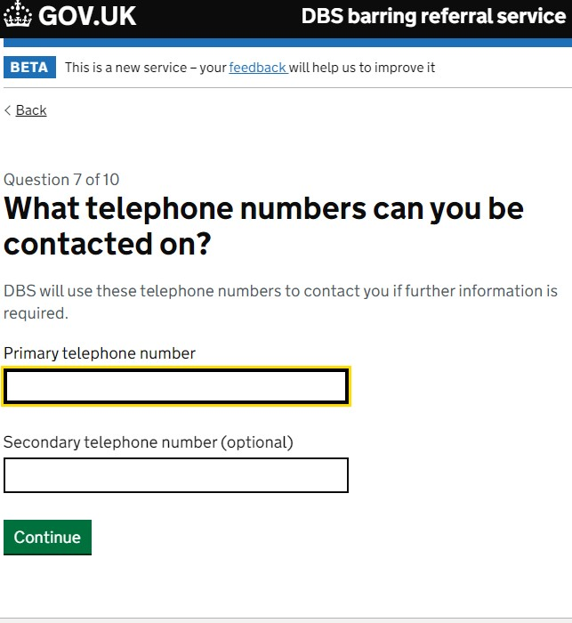
Question 8
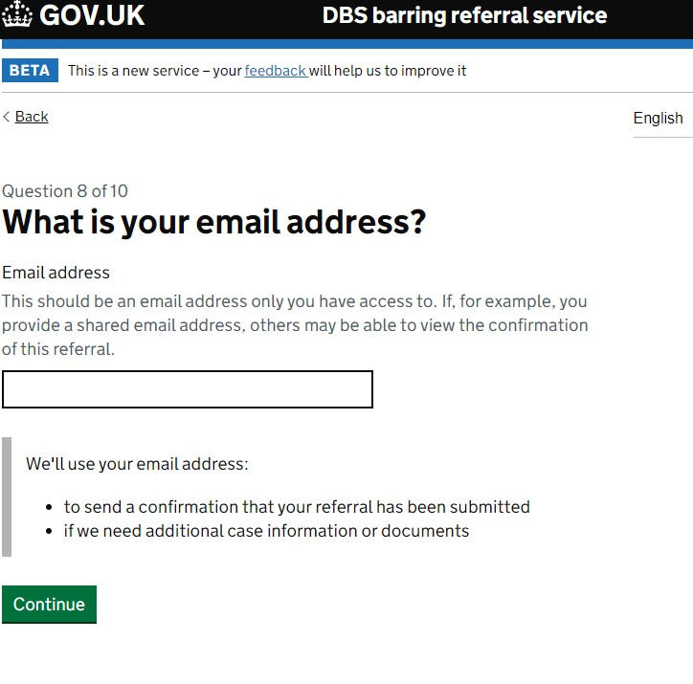
Question 9
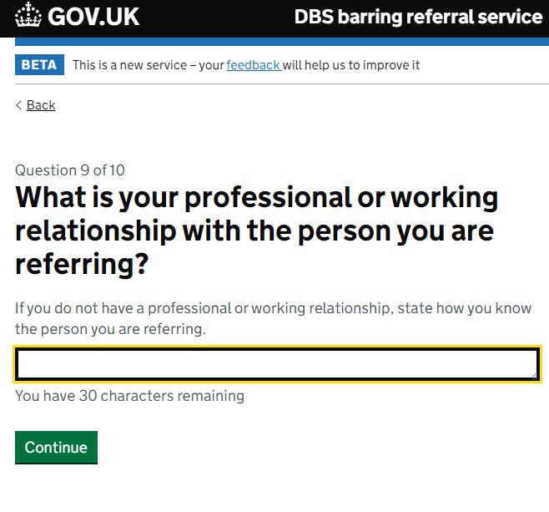

Question 10

Annex 2: DBS confirmation letter - received once a Referral Form is submitted online

GOV.UK

Dear xx
Your barring referral has been submitted to the Disclosure and Barring Service (DBS).
Date submitted: 20 xxx 2024 10:34:57 GMT
Your reference number: 0xxxxxxxxxxx
If you need to send more information
If you need to send more documents to support your barring referral submission, you can do this by post or email. Your documents must reach the DBS within five days of this submission
Send us as much evidence as you can from the list below:
- Statement(s) made by the referred individual
- Witness statements
- Victim impact report(s) or statement(s)
- Evidence used in the investigation (for example, medical charts, body maps)
- Minutes of investigation meetings (for example, internal investigation, social services case conference, LADO meeting, and Persons in a Position of Trust meeting)
- Investigation report
- Minutes of disciplinary meetings
- Dismissal, resignation or redeployment letters
- File notes concerning previous conduct, behaviour or attitude
- Documentation of any past disciplinary action and complaint(s)
You can also send any other information that has not been listed above but you believe needs to be provided to help DBS make a timely decision.
How to send your supporting documents to the DBS
By email
- Send your supporting documents by email to contactus@dbs.gov.uk, quoting the reference number shown above.
- The total size of your email should be less than 15MB.
- Do not send password protected documents or emails because they will be blocked from reaching the DBS mailbox.
What to do with large documents
- If your supporting evidence or your email exceeds 15MB, you can send the evidence to us by post.
- Print your documents or save the evidence to any removable storage media available to you, such as USB flash drives and external hard drives.
- If you are sending encrypted removable media, please email the password to contactus@dbs.gov.uk with the case reference number.
Posting your documents
To send your supporting documents by post, you need to:
- Print this email
- Include this email with any supporting documentation, and send to the following address:
Disclosure and Barring Service
PO Box 3963
Royal Wootton Bassett
SN4 4HH
You must ensure the supporting documentation reaches the DBS within five days of this referral submission.
The DBS cannot accept responsibility for any supporting evidence sent by post before it has reached us. Please note that evidence materials will not be returned to you.
You may be contacted by DBS for further information.
Date submitted: 20 May 2024 10:34:57
Your reference number: 01038120599
What did you think of this service?
You can tell us what you think of the service through our feedback form:
https://give-feedback-dbs.service.gov.uk/#/en/barring

Annex 3: Summary Report- provided as an attachment to the confirmation email from the DBS
Below is an example of the format of the Summary Report which will be generated upon submission of an online Referral form and which will be provided to the referrer by email by the DBS. This Report is based on an actual University of Hull referral to the DBS, Elements have been anonymized or changed.
Your details
Referrer type
Educational institute
Name
xx
Role or job title
Senior Lecturer
Work sector
Education (Independent)
Other
Name of your organisation
University of Hull
Organisation's address
University Of Hull, Cottingham Road
Hull
North Humberside
HU6 7RX
Contact telephone number
0148246xxxx
Email address
xx @hull.ac.uk
Relationship to referred person
Professional Lead FtP
Alternative contact
Xx
Programme Lead
0148246xxxx
xxxx@hull.ac.uk
Referred person's details
Name
Xx
Other names previously known by
User does not have this information
Date of birth
Xx September 1994
Sex of referred person
Male
National Insurance Number
User does not have this information
Nationality
British
Referred person's address
Xx
Xx
United Kingdom
(postcode)
Disclosure certificate reference number
User does not have this information
Contact telephone number
xx
Email address
xxx@hotmail.com
Previously worked in Scotland?
I don't know
Referred person's employment details
Role or job title
User does not have this information
Work sector
Health - NHS
Other Health professional - registered
People worked / working with
Both children and vulnerable adults / adults at risk
Registered with professional registration organisation
Name of organisation: Health and Care Professions Council (HCPC)
Professional registration number: Not entered
Date of registration: Not entered
Still employed at your organisation
No
Employment termination details
Termination of Programme -evidence that the concerns raised constituted an abuse of position/trust
Dates of employment
From: xx Feb 2022
To: xx Feb 2023
Course details
Course name
Postgraduate Diploma in xx
Course dates
Start date: xx Feb 2022
End date: xx Feb 2023
Dates the referred person attended the course
Start date: xx February 2022
End date: xx February 2023
Details of work placements
Name of organisation: xxx
Description of placement: xx
Duration: 1 month
If applicable, reason placement ended prematurely
xx
Assessment of course progress
Xx was successful with theoretical aspects of the Programme but did not complete any practice
Reason for referral
Summary of circumstances resulting in referral
The university was contacted by xxx to say that an investigation into xx was ongoing. The conclusion of the investigation was that xxs employment was terminated due xxx.
List of events
Event date: xx xx 2023
Reported by xx who was the employer, to the University and Programme Director
Harmed person's details
Who has been harmed or put at risk of harm?
A group of vulnerable adults/adults at risk
Details of particular vulnerability
The xx
Risk of harm, or harm suffered
xx
Details of risk of harm or harm suffered
Potential harm to the person, family and wider community.
Additional Information
Other work the referred person did with children or vulnerable adults / adults at risk
User does not have this information
Previous misconduct, disciplinary action or complaints
User does not have this information
Other persons connected to this referral
None entered
Other agencies
Contact details for other investigating organisations
User does not have this information
Uploaded evidence documents
Fitness to Practise details

