

**Continual Monitoring, Evaluation & Enhancement**

# Module

# Review Guidance

**Owner:** Quality Support Service

**Version number:**

**Effective date:** September 2020 (Academic Year 2020-21)

**Date of next review:**

*This document is part of the University Quality Handbook, which governs the University’s academic provision.*

|  |
| --- |
| 1. **Overview** |

This guidance document is designed to support Module Leaders in the completion of the Module Review, covering:

* the process for review completion
* key themes and evidence for inclusion
* data sources and related availability
* where to find advice and guidance.

The Module Review is a key part of the University’s Continual Monitoring, Evaluation and Enhancement Process (CMEE). CMEE enables the University to assure the maintenance of academic standards and enhance the quality of learning opportunities for students. As a dynamic process the CMEE facilitates responsive evaluation, feedback and action planning to support ‘real time’ enhancement.

*For further information on where to find information on the overarching approach to CMEE please see Section 4 of this document.*

The Module Review is completed by Module Leaders after the completion of each module, enabling timely reflection, intervention and effective enhancement activity. Module Leaders are invited to record, reflect upon, and respond to the student experience at module level through the referencing of key indicators, results and feedback. It is essential that Module Leaders exercise ownership of this reflection; that they proactively seek relevant data; and that they engage in a constructive way with other colleagues who deliver on the module, with the students on the module and programme, and with relevant services and directorates of the wider university community.

|  |
| --- |
| 1. **Completion of Module Review** |

All undergraduate and taught postgraduate modules should be monitored and enhanced using the Module Review tab in the EvaMetrics Engagement Portal. This can be found in the same location as the Module Reflection tab used to close the loop in the MEQ process.

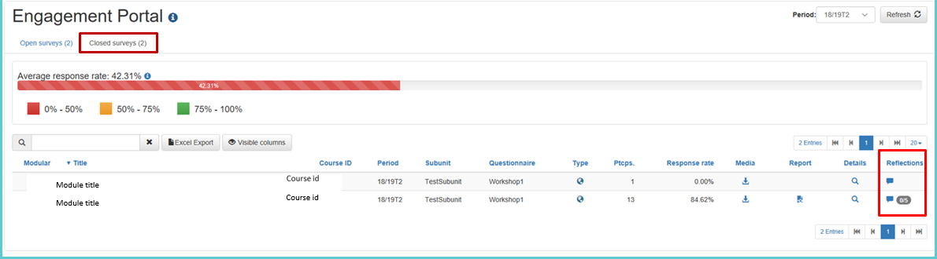

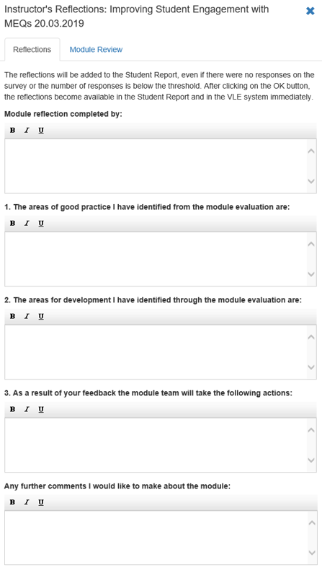

The Review is completed by reflecting on a set of institutional questions provided in the tab and responding to key information and data sets available for each module. Additional questions may be set by the Programme Director or Head of Academic Unit and sent via email to Module Leaders to reflect on. Please note that while the MEQ aspects of this system (i.e. the module reflection tab) can be sent to students in each module, the Module Review tab ***is not*** sent to students at any point.

Completion of this review and any matters for note will be monitored by the owning Programme Director. Therefore, the review will need to be sent to the Programme Director after completion of each module. The owning Academic Unit will monitor completion of this, alongside the Programme Journal this feeds into, with oversight by the Faculty Education and Student Experience Committee. Enhancement themes and actions are discussed at programme team review meetings with in year feedback being provided to students via the usual response mechanisms.

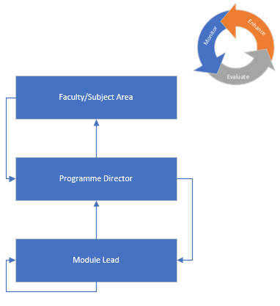Points for escalation or note are shared by Associate Dean’s Education at University level through the University Committee structure. The information is then used to produce the annual Institutional report for Council, (a mechanism by which the University assures itself of the quality and standards of its provision.)

Figure 1: Module Review Process Chart

Please Note: The circular arrow going back to the Module Lead reflects the constant reflection of results and teaching practice, as well as the conversations within the module’s teaching team.

|  |
| --- |
| 1. **Core Questions** |

Below are the five core questions asked in the review for each Module Leader to consider and respond to:

1. Your experience of delivering the module including student engagement (this might also include the learning environment, any steps taken to address barriers to learning, facilities available, etc.)
2. Any additional responses to the MEQ feedback you would like to make (in addition to those already returned to the students)
3. Any previous changes made to the module and their effectiveness (including any examples of good practice you would like to highlight)
4. Student performance on the module, including in relation to marks for the same module in previous years (if available)
5. Any changes that you would like to introduce for the next delivery of the module (please ensure the minor modification process if followed)

When completing the Review, additional evidence should be provided to support cited areas of good practice or innovation.

*Data availability and timeframes are included as appendices to this document.*

|  |
| --- |
| 1. **Further Advice and Guidance Documents** |

* University Code of Practice: Continual Monitoring, Evaluation and Enhancement
* Programme/Portfolio Journal
* Continuing Monitoring, Evaluation and Enhancement Process Chart

*The above documents are available on the University of Hull Quality and Standards webpages under the Monitoring and Enhancement section.*

* For further guidance on how to access the Module Review tab in EvaMetrics, please see



* Please contact relevant Programme Director for queries in relation to additional programme specific questions which may be required.
* Please contact relevant Associate Deans Education/Student Experience for queries in relation to programme journal content and faculty processes.
* Please contact [qss@hull.ac.uk](mailto:qss@hull.ac.uk) with any queries relating to the CMEE process in general and the documents listed above.
* For general advice and guidance on approaches to monitoring and evaluation please see [UK Quality Code - Advice and Guidance - Monitoring and Evaluation](https://www.qaa.ac.uk/en/quality-code/advice-and-guidance/monitoring-and-evaluation)

SEPTEMBER

OCTOBER

NOVEMBER

T1 Mid-module Feedback.

DECEMBER

JANUARY

MEQ results, dashboards, reflections.

FEBRUARY

T1 module marks (after module boards).

MARCH

T2 Mid-Module Feedback.

APRIL

MAY

MEQ results, dashboards, reflections.

JUNE

T2 module marks (after module boards).

Programme Marks/Degree

JULY

T3 Mid-Module Feedback.

EE reports.

AUGUST

MEQ results, dashboards, reflections

T3 module marks (after module boards).

**APPENDIX: DATA AVAILABILITY TIMEFRAMES**

|  |  |  |  |  |
| --- | --- | --- | --- | --- |
| **Data Area** | **Data** | **Obtained from** | **When available** | **Notes:** |
| Student Satisfaction | MEQ Results | Module Leader | End of trimester | Module reflection can also contribute to Review |
| Mid-module feedback | Individual Lecturers | Mid trimester | How this is captured is up to lecturer(s) |
| Retention and Completion | Module marks | eVision (SITS) | End of trimester |  |
| External Examiners | EE reports | Prog Directors | July/August |  |
| Student Engagement | Attendance | SEATS | Ongoing |  |
| Online Engagement | Canvas | Throughout trimester | Statistics on how students are using the module canvas site are available to all lecturers |

Feedback on this document is welcomed and should be sent to [quality@hull.ac.uk](mailto:quality@hull.ac.uk)